#### **Hyperparameter tuning**

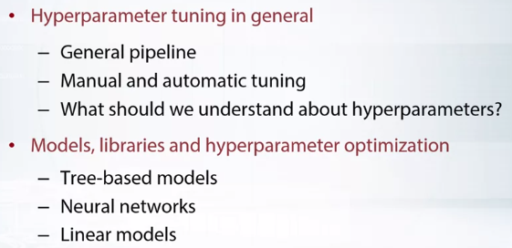

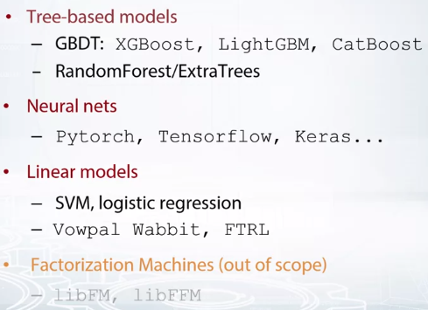

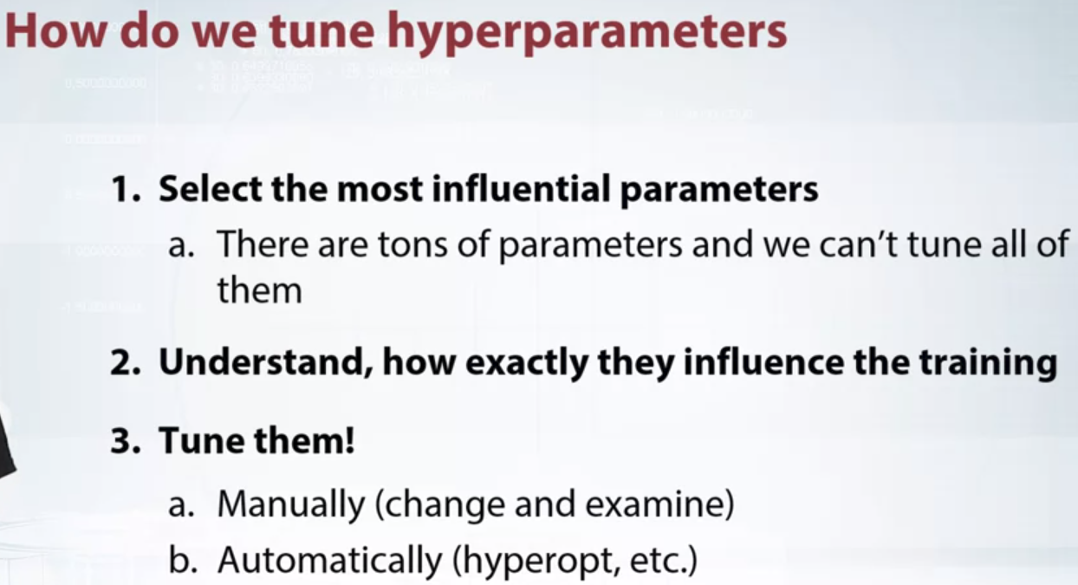

Below are the libraries for automatic hyperparameter tuning, (better to do it manually when you know your model and data well as itll turn out to be faster)

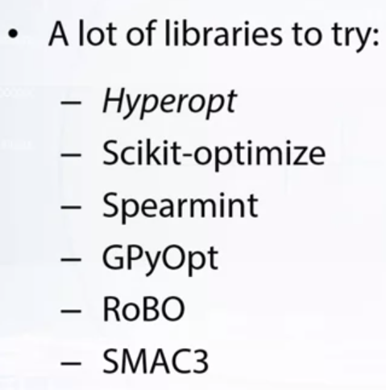

Below is an example of hyperparameter tuning.

You’ll have to define your search space as well.

For example here max_depth is taken between 10 and 30 with a step of 1.

As it takes a lot of time. Its best to run the hyper-optimizer overnight.

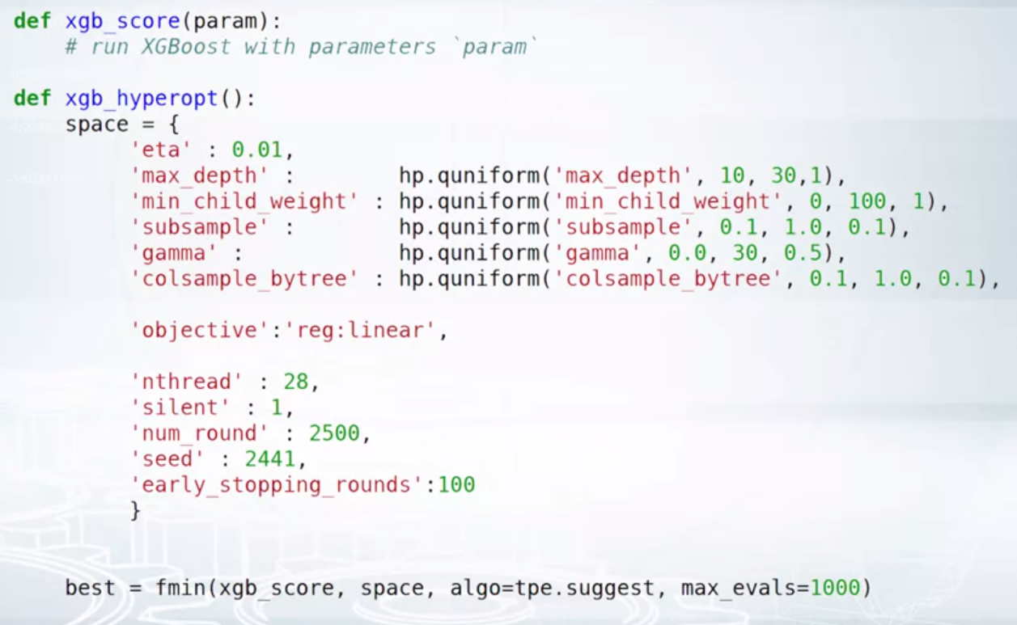

Different values in parameters results in

Underfitting

Good fit and generalization

Over fitting

After finding the absolute important parameters that we want to tune we should divide the parameters into two categories.

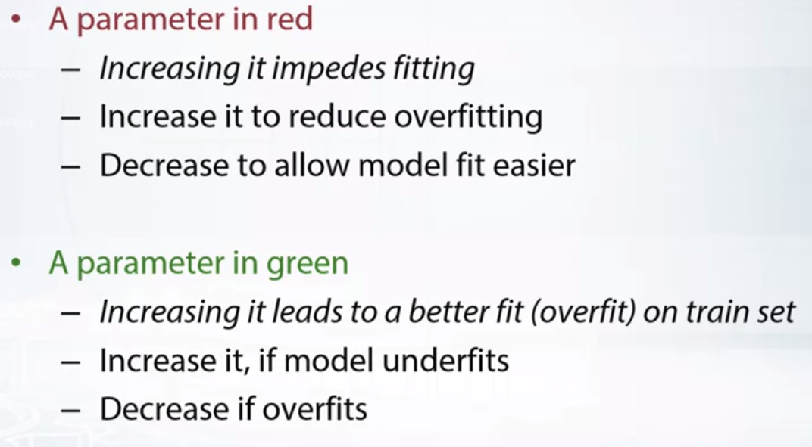

**We will use this GREEN colour and RED colour coding throughout for the type of parameter it is.**

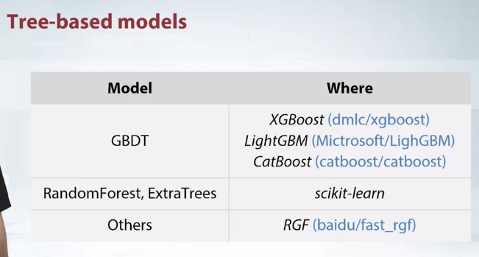

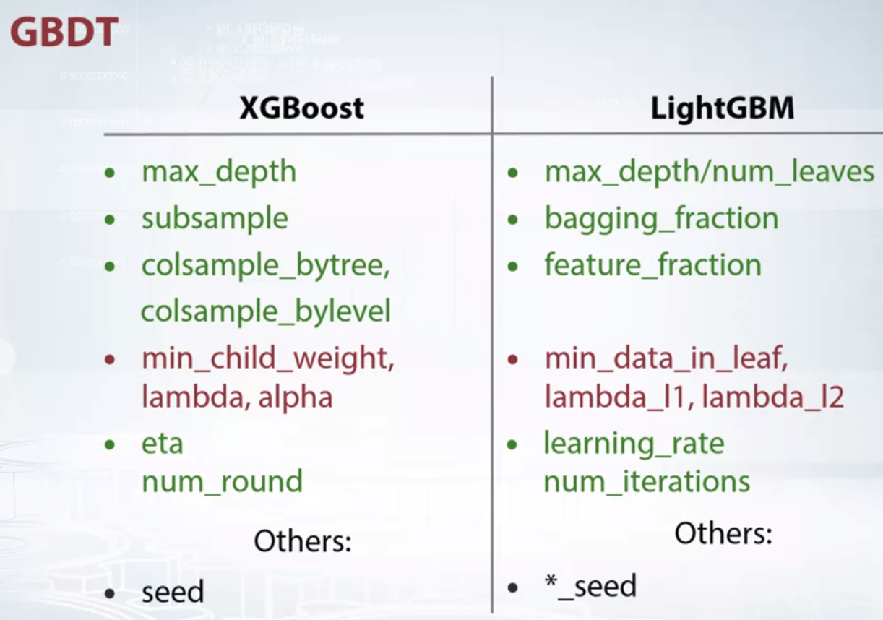

Okay, what important parameters do we have in XGBoost and LightGBM?

The two libraries have similar parameters and we'll use names from XGBoost. And on the right half of the slide you will see somehow loosely corresponding parameter names from LightGBM.To understand the parameters, we better understand how XGBoost and LightGBM work at least a very high level.

What these models do, these models build decision trees one after another gradually optimizing a given objective.

And first there are many parameters that control the tree building process. Max_depth is the maximum depth of a tree.

And of course, the deeper a tree can be grown the better it can fit a dataset.

So increasing this parameter will lead to faster fitting to the train set.

Depending on the task, the optimal depth can vary a lot, sometimes it is 2, sometimes it is 27. If you increase the depth and can not get the model to overfit, that is, the model is becoming better and better on the validation set as you increase the depth.

It can be a sign that there are a lot of important interactions to extract from the data. So it's better to stop tuning and try to generate some features.

I would recommend to start with a max_depth of about seven.

Also remember that as you increase the depth, the learning will take a longer time. So do not set depth to a very higher values unless you are 100% sure you need it. In LightGBM, it is possible to control the number of leaves in the tree rather than the maximum depth.

It is nice since a resulting tree can be very deep, but have small number of leaves and not over fit.Some simple parameter controls a fraction of objects to use when feeding a tree.

It's a value between 0 and 1.

One might think that it's better always use all the objects, right? But in practice, it turns out that it's not.

Actually, if only a fraction of objects is used at every duration, then the model is less prone to overfitting. So using a fraction of objects, the model will fit slower on the train set, but at the same time it will probably generalize better than this over-fitted model. So, it works kind of as a regularization.

Similarly, if we can consider only a fraction of features at every split, this is controlled by parameters colsample_bytree and colsample_bylevel. Once again, if the model is over fitting, you can try to lower down these parameters. There are also various regularization parameters, min_child_weight, lambda, alpha and others.

The most important one is min_child_weight.

If we increase it, the model will become more conservative. If we set it to 0, which is the minimum value for this parameter, the model will be less constrained.

In my experience, it's one of the most important parameters to tune in XGBoost and LightGBM.Depending on the task, I find optimal values to be 0, 5, 15, 300, so do not hesitate to try a wide range of values, it depends on the data.

To this end we were discussing hyperparameters that are used to build a tree.

And next, there are two very important parameters that are tightly connected, eta and num_rounds. Eta is essentially a learning weight, like in gradient descent. And the num_round is the how many learning steps we want to perform or in other words how many tree's we want to build. With each iteration a new tree is built and added to the model with a learning rate eta. So in general, the higher the learning rate, the faster the model fits to the train set and probably it can lead to over fitting. And more steps model does, the better the model fits.

But there are several caveats here.

It happens that with a too high learning rate the model will not fit at all, it will just not converge.

So first, we need to find out if we are using small enough learning rate.

On the other hand, if the learning rate is too small, the model will learn nothing after a large number of rounds.

But at the same time, small learning rate often leads to a better generalization.

So it means that learning rate should be just right, so that the model generalize and doesn't take forever to train.

The nice thing is that we can freeze eta to be reasonably small, say, 0.1 or 0.01, and then find how many rounds we should train the model til it over fits. We usually use early stopping for it. We monitor the validation loss and exit the training when loss starts to go up.

Now when we found the right number of rounds, we can do a trick that usually improves the score. We multiply the number of steps by a factor of alpha and at the same time, we divide eta by the factor of alpha.

For example, we double the number of steps and divide eta by 2. In this case, the learning will take twice as long in time, but the resulting model usually becomes better.

It may happen that the valid parameters will need to be adjusted too, but usually it's okay to leave them as is.

Finally, you may want to use random seed argument, many people recommend to fix seed before hand.

I think it doesn't make too much sense to fix seed in XGBoost, as anyway every changed parameter will lead to completely different model. But I would use this parameter to verify that different random seeds do not change training results much. Say there was a competition, one could jump 1,000 places up or down on the leaderboard just by training a model with different random seeds. If random seed doesn't affect model too much, good.

In other case, I suggest you to think one more time if it's a good idea to participate in that competition as the results can be quite random.

Or at least I suggest you to adjust validation scheme and account for the randomness.

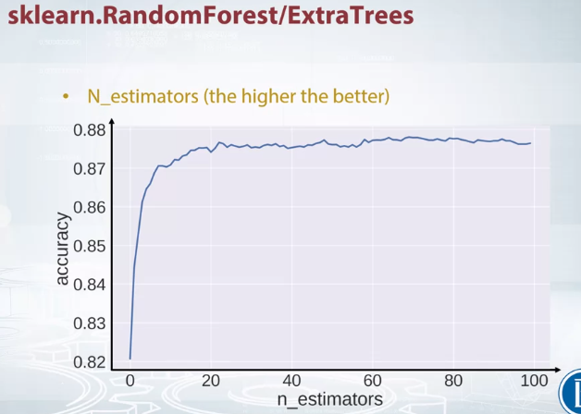

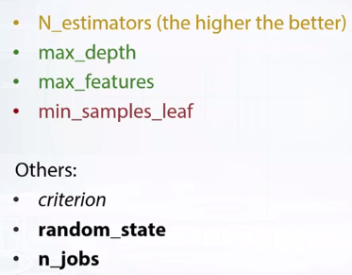

Now let's get to RandomForest and ExtraTrees.

In fact, ExtraTrees is just a more randomized version of RandomForest and has the same parameters. So I will say RandomForest meaning both of the models. RandomForest and ExtraBoost build trees, one tree after another.

But, RandomForest builds each tree to be independent of others. It means that having a lot of trees doesn't lead to overfeeding for RandomForest as opposed to gradient boosting.

In sklearn, the number of trees for random forest is controlled by N_estimators parameter. At the start, we may want to determine what number of trees is sufficient to have. That is, if we use more than that, the result will not change much, but the models will fit longer.

I usually first set N_estimators to very small number, say 10, and see how long does it take to fit 10 trees on that data.

If it is not too long then I set N_estimators to a huge value, say 300, but it actually depends.

And feed the model.

And then I plot how the validation error changed depending on a number of used trees. This plot usually looks like that.

We have number of trees on the x-axis and the accuracy score on y-axis. We see here that about 50 trees already give reasonable score and we don't need to use more while tuning parameter. It's pretty reliable to use 50 trees. Before submitting to leaderboard, we can set N_estimators to a higher value just to be sure.

You can find code for this plot, actually, in the reading materials. Similarly to XGBoost, there is a parameter max_depth that controls depth of the trees. But differently to XGBoost, it can be set to none, which corresponds to unlimited depth.

It can be very useful actually when the features in the data set have repeated values and important interactions. In other cases, the model with unconstrained depth will over fit immediately. I recommend you to start with a depth of about 7 for random forest.

Usually an optimal depth for random forests is higher than for gradient boosting, so do not hesitate to try a depth 10, 20, and higher. Max_features is similar to call sample parameter from XGBoost. The more features I use to decipher a split, the faster the training. But on the other hand, you don't want to use too few features. And min_samples_leaf is a regularization parameter similar to min_child_weight from XGBoost and the same as min_data_leaf from LightGPM.

For Random Forest classifier, we can select a criterion to eleviate a split in the tree with a criterion parameter.

It can be either Gini or Entropy.

To choose one, we should just try both and pick the best performing one.

In my experience Gini is better more often, but sometimes Entropy wins.

We can also fix random seed using random_state parameter, if we want.

And finally, do not forget to set n_jobs parameter to a number of cores you have. As by default, RandomForest from sklearn uses only one core for some reason.

This notebook shows, how to compute RandomForest's accuracy scores for each value of n_estimators without retraining the model. No rocket science involved, but still useful.

**Load some data**

**import** sklearn.datasets

**from** sklearn.model_selection **import** train_test_split

​

X, y = sklearn.datasets.load_digits(10,**True**)

X_train, X_val, y_train, y_val = train_test_split(X, y)

**import** numpy **as** np

**import** matplotlib.pyplot **as** plt

**%**matplotlib inline

**from** sklearn.ensemble **import** RandomForestClassifier

**from** sklearn.metrics **import** accuracy_score

**Step 1:** first fit a Random Forest to the data. Set n_estimators to a high value.

rf = RandomForestClassifier(n_estimators=500, max_depth=4, n_jobs=**-**1)

rf.fit(X_train, y_train)

Out[36]:

RandomForestClassifier(bootstrap=True, class_weight=None, criterion='gini',

max_depth=4, max_features='auto', max_leaf_nodes=None,

min_impurity_decrease=0.0, min_impurity_split=None,

min_samples_leaf=1, min_samples_split=2,

min_weight_fraction_leaf=0.0, n_estimators=500, n_jobs=-1,

oob_score=False, random_state=None, verbose=0,

warm_start=False)

**Step 2:** Get predictions for each tree in Random Forest separately.

predictions = []

**for** tree **in** rf.estimators_:

predictions.append(tree.predict_proba(X_val)[**None**, :])

*# PREDICT_PROBA gives above a tuple of (1, 450, 10) for a single tree.*

*# this whole result is appended in predictions. so length of list is*

*# equal to number of trees = 500.*

*# using np.vstack() as done below gives (500, 450, 10)*

**Step 3:** Concatenate the predictions to a tensor of size (number of trees, number of objects, number of classes).

predictions = np.vstack(predictions)

**Step 4:** Сompute cumulative average of the predictions. That will be a tensor, that will contain predictions of the random forests for each n_estimators.

a = np.ones((4,3))

print(a)

print(a.sum(axis=0))

print(a.sum(axis=1))

[[ 1. 1. 1.]

[ 1. 1. 1.]

[ 1. 1. 1.]

[ 1. 1. 1.]]

[ 4. 4. 4.]

[ 3. 3. 3. 3.]

*# so in cumsum as we keep on coming down with summations,*

*# each time a new tree gets added and the corresponding class*

*# prediction values gets added as well.*

print(np.cumsum(predictions, axis=0).shape)

print(np.arange(1, predictions.shape[0]**+**1).shape)

*# the below changes is to match the shape of cumsum*

print(np.arange(1, predictions.shape[0]**+**1)[:, **None**, **None**].shape)

*# this divides the whole tensor values. So row[4] has total 5 trees summed in*

*# total from above. All values in that row gets divided by 5 (row having a shape of (10, 450)*

*# looking from the top view) giving their avg.*

*# prediction for 450 objects in corresponding 10 classes.*

(500, 450, 10)

(500,)

(500, 1, 1)

cum_mean = np.cumsum(predictions, axis=0)**/**np.arange(1, predictions.shape[0] **+** 1)[:, **None**, **None**]

**Step 5:** Get accuracy scores for each n_estimators value

scores = []

*# pred here gives one whole row at a time.*

*# see how pred doesnt becomes (10, 450) but is actually (450, 10) this is transpose to the*

*# top view imagination we go for and thatswhy argmin here has axis=1*

*# looking from the top view of (10,450) argmax(axis=1) on pred gives the index of the*

*# highest rated probability class for that object which comes out to be the best predicted*

*# class for the object. This is then given to yval to compare and check for accuracy.*

'''

print(pred.shape) (450, 10)

print(y_val.shape) (450,)

print(np.argmax(pred, axis=1).shape) (450,)

'''

**for** pred **in** cum_mean:

scores.append(accuracy_score(y_val, np.argmax(pred, axis=1)))

**That is it!** Plot the resulting scores to obtain similar plot to one that appeared on the slides.

plt.figure(figsize=(10, 6))

plt.plot(scores, linewidth=3)

plt.xlabel('num_trees')

plt.ylabel('accuracy');

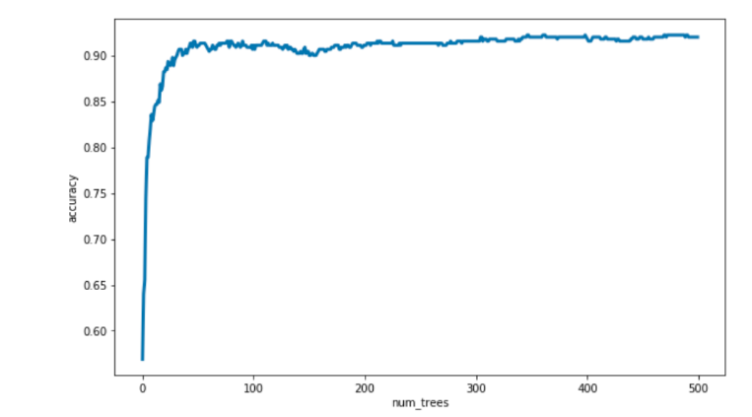

We see, that 150 trees are already sufficient to have stable result.

**HYPERPARAMETER OPTIMIZATION FOR NEURAL NETS AND LINEAR MODELS**

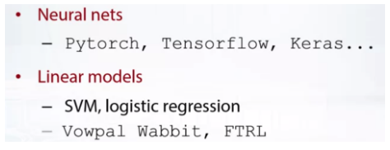

There are so many frameworks, Keras, TensorFlow, MxNet, PyTorch.

The choice is really personal,

all frameworks implement more than enough functionality for competition tasks.

Keras is for sure the most popular in Kaggle and has very simple interface.

It takes only several dozen lines to train a network using Keras.

TensorFlow is extensively used by companies for production.

And PyTorch is very popular in deep learning research community.

I personally recommend you to try PyTorch and

Keras as they are most transparent and easy to use frameworks.

Now, how do you tune hyperparameters in a network?

We'll now talk about only dense neural networks,

That is the networks that consist only of fully connected layers.

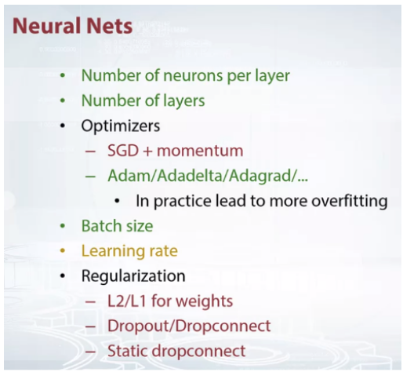

Say we start with a three layer neural network,

what do we expect to happen if we increase the number of neurons per layer?

The network now can learn more complex decision boundaries and

so it will over fit faster.

The same should happen when the number of layers are increased, but

due to optimization problems, the learning can even stop to converge.

But anyway, if you think your network is not powerful enough,

you can try to add another layer and see what happens.

My recommendation here is to start with something very simple,

say 1 or 2 layer and 64 units per layer.

Debug the code, make sure the training and validation losses go down.

And then try to find a configuration that is able to overfit the training set,

just as another sanity check.

After it, it is time to tune something in the network.

One of the crucial parts of neural network is selected optimization method.

Broadly speaking, we can pick either vanilla stochastic gradient descent with

momentum or one of modern adaptive methods like Adam,

Adadelta, Adagrad and so on.

On this slide, the adaptive methods are colored in green,

as compared to SGD in red.

I want to show here that adaptive methods do really allow you

to fit the training set faster.

But in my experience, they also lead to overfitting.

Plain old stochastic gradient descent converges slower, but

the trained network usually generalizes better.

Adaptive methods are useful,

but in the settings others in classification and regression.

Now here is a question for you.

Just keep the size.

What should we expect when increasing a batch size with

other hyperparameters fixed?

In fact, it turns out that huge batch size leads to more overfitting.

Say a batch of 500 objects is large in experience.

I recommend to pick a value around 32 or 64.

Then if you see the network is still overfitting try to decrease

the batch size.

If it is underfitting, try to increase it.

Know that is a the number of outbox is fixed,

then a network with a batch size reduced by a factor of 2

gets updated twice more times compared to original network.

So take this into consideration.

Maybe you need to reduce the number of networks or at least somehow adjust it.

The batch size also should not be too small, the gradient will be too noisy.

Same as in gradient boosting, we need to set the proper learning rate.

When the learning rate is too high, network will not converge and

with too small a learning rate, the network will learn forever.

The learning rate should be not too high and not too low.

So the optimal learning rate depends on the other parameters.

I usually start with a huge learning rate, say 0.1, and try to lower it down till

I find one with which network converges and then I try to revise further.

Interestingly, there is a connection between the batch size and

the learning rate.

It is theoretically grounded for a specific type of models, but

people usually use it, well actually some people use it as

a rule of thumb with neural networks.

The connection is the following.

If you increase the batch size by a factor of alpha,

you can also increase the learning rate by the same factor.

But remember that the larger batch size,

the more your network is prone to overfitting.

So you need a good regularization here.

Sometime ago, people mostly use L2 and L1 regularization for weights.

Nowadays, most people use dropout regularization.

So whenever you see a network overfitting, try first to a dropout layer.

You can override dropout probability and a place where you insert the dropout layer.

Usually people add the dropout layer closer to the end of the network,

but it's okay to add some dropout to every layer, it also works.

Dropout helps network to find features that really matters, and what never worked

for me is to have dropout as the very first layer, immediately after data layer.

This way some information is lost completely at the very beginning

of the network and we observe performance degradation.

An interesting regularization technique that we used

in the springleap competition is static dropconnect, as we call it.

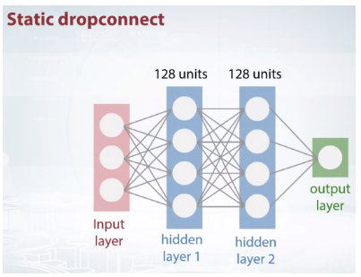

So recall that, usually we have an input layer densely connected to, say 128 units.

We will instead use a first hidden layer with a very

huge number of units, say 4,096 units.

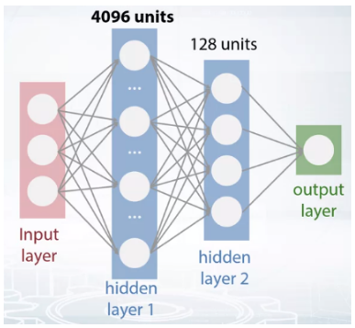

This is a huge network for a usual competition and it will overfeed badly.

But now to regularlize it, we'll at random drop 99% of

Connections between the input layer and the first hidden layer.

We call it static drop connect because originally in drop connect,

we need to drop random connections at every learning iterations while we

fix connectivity pattern for the network for the whole learning process.

So you see the point, we increase the number of hidden units, but

the number of parameters in the first hidden layer remains small.

Notice that anyway the weight matrix of the second layer becomes huge,

but it turns out to be okay in the practice.

This is very powerful regularizations.

And more of the networks with different connectivity patterns makes

much nicer than networks without static drop connect.

All right, last class of models to discuss are linear models.

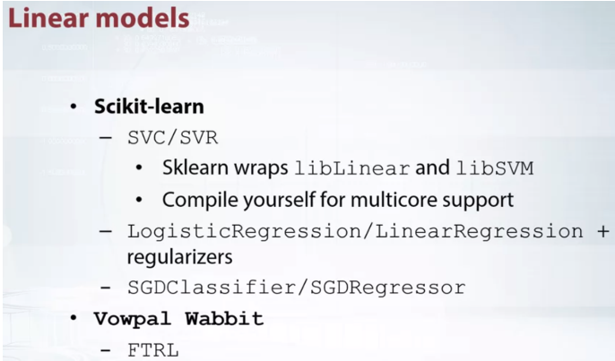

Yet, a carefully tuned live GPM would probably beat support vector machines,

even on a large, sparse data set.

SVM's do not require almost any tuning, which is truly beneficial.

SVM's for classification and regression are implemented in SK learners or

wrappers to algorithms from libraries called libLinear and libSVM.

The latest version of libLinear and libSVM support multicore competitions,

but unfortunately it is not possible to use multicore version in Sklearn,

so we need to compile these libraries manually to use this option.

And I've never had anyone use kernel SVC lately,

so in this video we will talk only about linear SVM.

In Sklearn we can also find logistic and linear regression with various

regularization options and also, as your declassifier and regressor.

We've already mentioned them while discussing metrics.

For the data sets that do not fit in the memory, we can use Vowpal Wabbit.

It implements learning of linear models in online fashion.

It only reads data row by row directly from the hard drive and

never loads the whole data set in the memory.

Thus, allowing to learn on a very huge data sets.

A method of online learning for linear models called flow the regularized leader

or FTRL in short was particularly popular some time ago.

It is implemented in Vowpal Wabbit but

there are also lots of implementations in pure Python.

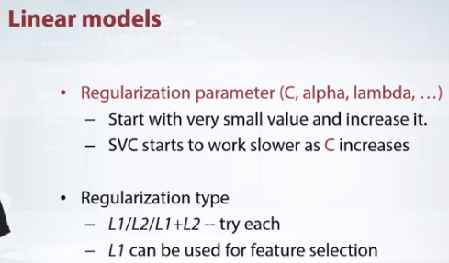

The hyper parameters we usually need to tune linear models are L2 and

L1 regularization of weights.

Once again, regularization is denoted with red color because of the higher

the regularization weight is the more model struggle to learn something.

But know that, the parameter see in SVM is inversely proportional to

Regularization weight, so the dynamics is opposite.

In fact, we do not need to think about the meaning of the parameters in the case of

one parameter, right?

We just try several values and find one that works best.

For SVM, I usually start a very small seed, say 10 to the power of minus 6 and

then I try to increase it, multiply each time by a factor of 10.

I start from small values because the larger the parameter C is,

the longer the training takes.

What type of regularization, L1 or L2 do you choose?

Actually, my answer is try both.

To my mind actually they are quite similar and one benefit that L1 can give us

is weight sparsity, so the sparsity pattern can be used for feature selection.

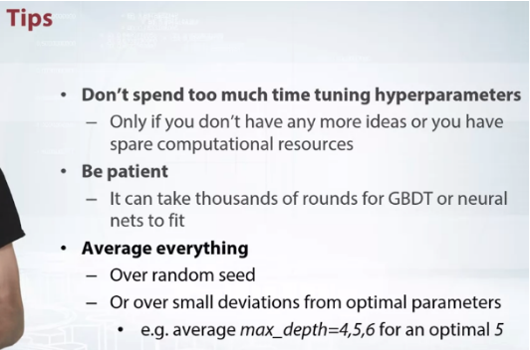

A general advise I want to give here do not spend too much time on

tuning hyperparameters, especially when the competition has only begun.

You cannot win a competition by tuning parameters.

Appropriate features, hacks, leaks, and insights will

give you much more than carefully tuned model built on default features.

I also advice you to be patient.

It was my personal mistake several times.

I hated to spend more then ten minutes on training models and was amazed

how much the models could improve if I would let it train for a longer time.

And finally, average everything.

When submitting, learn five models starting from different random

initializations and average their predictions.

It helps a lot actually and some people average not only random seed,

but also other parameters around an optimal value.

For example, if optimal depth for extra boost is 5,

Wow, it would be better if we could average 3 xg-boosts with depth 4, 5, and 6.

What can we do to deal with overfitting in LightGBM?

Increase `bagging_fraction`

**Un-selected is correct**

Decrease `min_data_in_leaf`

**Un-selected is correct**

Increase `min_data_in_leaf`

**Correct**

Yes, this parameter serves as regularization parameter: the higher `min_data_in_leaf`, more regularized the model.

Increase `bagging_seed`

**Un-selected is correct**

Decrease `num_leaves`

**Correct**

In fact, higher `num_leaves` more complex trees GBM can build.

## Question 2

What of the following parameter changes speed-up *training process* for LightGBM? That is, time needed for one boosting iteration is decreased.

Decreasing bagging_fraction

**Correct**

Yes! This parameter controls fraction of objects, that will be used at every boosting iteration.

Increasing max_bin

**Un-selected is correct**

Decreasing num_leaves

**Correct**

Correct! The number of splits in a tree is very dependent on num_leaves parameter.

Decreasing verbosity

**Un-selected is correct**

3. Question 3

How usually training time of SVM changes if we increase the value of parameter "C"?

Training time increases

**Correct**

Yes! That is why it is better to start with small values of "C"

When training neural networks, it is common to use "weight decay," where after each update, the weights are multiplied by a factor slightly less than 1. This prevents the weights from growing too large, and can be seen as gradient descent on a quadratic regularization term.

# Question 1

## **Which hyperparameters are first to tune in sklearn's RandomForest?**

**Correct answers:**

* n_estimators, max_depth, min_samples_split Yes! These parameters are important. The first one should just be sufficiently large, you do not actually need to tune it.

**Incorrect answers:**

* n_jobs, random_state, verbose. Some of these parameters can even change the result of the training but only because of randomness involved. They are for sure not the parameters to tune.
* bootstrap, oob_score, warm_start. These parameters are not what you want to tune in the model!

# Question 2

## **Suppose you fit LightGBM to your train data and check performance on the validation set. The train set consists of 500 rows and 1000 different features and validation set consist of 50 objects. You run automatic hyperparameter optimization method overnight and in the morning you select the best parameters, produce results for the test set and submit to the leaderboard. We also know that test set comes from the same distribution as train and validation sets.**

**Correct answers:**

* There is a high chance of overfitting to the validation set. That is, there is a high chance that score on the test set will be bad. This is because we've tried too much hyperparameters while the dataset is small and the number of features is large. *Correct!*This is because of [multiple comparisons fallacy](https://en.wikipedia.org/wiki/Multiple_comparisons_problem).

**Incorrect answers:**

* There is a low chance of overfitting to the validation set. That is, there is a high chance that score on the test set will be good. This is because we found good parameters on validation set and test set is similar to the test set. The fact that test and validation sets come from the same distribution does not make them similar in terms of optimal hyperparameters.

# Question 3

## **Suppose you want to find a good set of hyperparameters for a dataset with 1000 points and have resources to do fitting 2000 times. Which method of model selection your should use?**

**Correct answers:**

* k-Fold scheme (i.e. split data into k part, use k-1 parts for training and the last one for quality estimation; repeat for each part). Yes! It is easy to note than we will check 2000 / k sets of hyperparameters -- this number still big enough (for typical k in [3,..,10]), but this scheme is much more robust.

**Incorrect answers:**

* Hold-Out scheme (i.e. divide data into two parts, use first for model fitting and second for estimation of quality). See previous question for detailed explanation.
* Select model by quality on training set (i.e. fit model on whole dataset and measure quality on the same data). This is overfitting. Such way cannot be used to estimating quality of model.
* Leave-one-out validation (i.e. fit model for all points except one and estimate quality for this single point; repeat for every point). Since LOO requires 1000 fittings for single set of hyperparameters, we can estimate only 2 combinations of hyperparameters -- it's way too small.

# Question 4

## **Suppose you train Neural Network with SGD and see that it overfits data. Which of the following actions can help you to regularize model?**

**Correct answers:**

* Insert (or increase rate of) Dropout layers inside NN. Yes, Dropout is a known way to regularize model via dropping some randomly selected features at every step.
* Add (or increase) Weight Decay. Weight Decay is essentially the same thing as L2 Regularization.
* Reduce number of parameters (e.g. remove some layers) Reducing number of parameters make model less flexible and harder to overfit

**Incorrect answers:**

* Change optimization method to Adam. Adam is a better optimizer than SGD, thus overfits training data better and faster.
* Add more layers. No, this will increase complexity of neural net and do not introduce any regularization effect.

**ADDITIONAL LINKS**

Hyper-parameters are parameters that are not directly learnt within estimators. In scikit-learn they are passed as arguments to the constructor of the estimator classes. Typical examples include C, kernel and gamma for Support Vector Classifier, alpha for Lasso, etc.

It is possible and recommended to search the hyper-parameter space for the best [cross validation](https://scikit-learn.org/stable/modules/cross_validation.html#cross-validation) score.

Any parameter provided when constructing an estimator may be optimized in this manner. Specifically, to find the names and current values for all parameters for a given estimator, use:

estimator.get_params()

<https://scikit-learn.org/stable/modules/grid_search.html>

Above link explains the way todo hyper parameter optimization using grid search and other ways in scikit learn.

<http://fastml.com/optimizing-hyperparams-with-hyperopt/>

the above links explains using hyper-opt for parameter optimization.

# **Complete Machine Learning Guide to Parameter Tuning in Gradient Boosting (GBM) in Python**

# [**https://www.analyticsvidhya.com/blog/2016/02/complete-guide-parameter-tuning-gradient-boosting-gbm-python/**](https://www.analyticsvidhya.com/blog/2016/02/complete-guide-parameter-tuning-gradient-boosting-gbm-python/)

# awesome guide showing GBM on real dataset with comparing and improving on leader board score on Kaggle. A must.

**PRACTICAL GUIDE**

Guide to approach problems given by 4 different grandmasters

From number 1

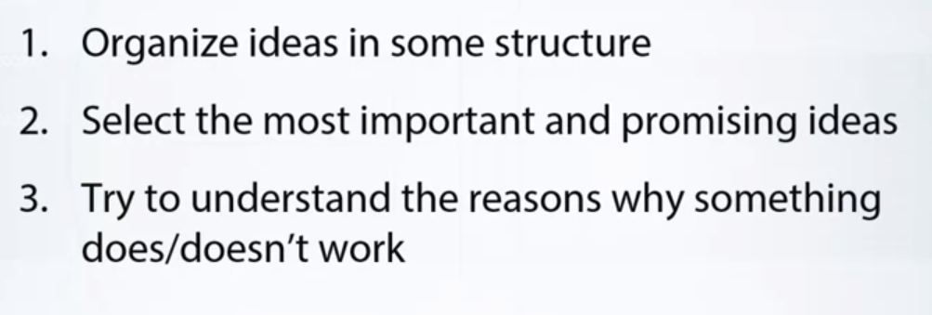

Personally, I like to organize these ideas into some structure. So you may want to sort ideas into priority order.Most important and promising needs to be implemented first.

Or you may want to organize these ideas into topics. Ideas about feature generation, validation, metric optimization. And so on. Now pick up an idea and implement it. Try to derive some insights on the way. Especially, try to understand why something does or doesn't work. For example, you have an idea about trying a deep gradient boosting decision tree model. To your joy, it works.Now, ask yourself why? Is there some hidden data structure we didn't notice before? Maybe you have categorical features with a lot of unique values. If this is the case, you as well can make a conclusion that mean encodings may work great here. So in some sense, the ability to analyze the work and derive conclusions while you're trying out your ideas will get you on the right track to reveal hidden data patterns and leaks.

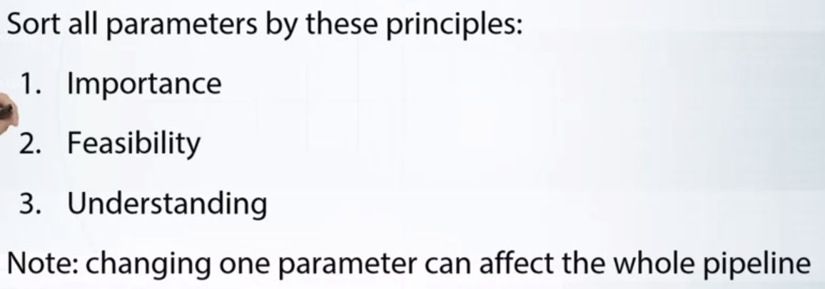

After we checked out most important ideas, you may want to switch to parameter training. I personally like the view, everything is a parameter. From the number of features, through gradient boosting decision through depth. From the number of layers in convolutional neural network, to the coefficient you finally submit is multiplied by. To understand what I should tune and change first, I like to sort all parameters by these principles. First, importance. Arrange parameters from important to not useful at all. Tune in this order. These may depend on data structure, on target, on metric, and so on. Second, feasibility. Rate parameters from, it is easy to tune, to, tuning this can take forever. Third, understanding. Rate parameters from, I know what it's doing, to, I have no idea. Here it is important to understand what each parameter will change in the whole pipeline. For example, if you increase the number of features significantly, you may want to change ratio of columns which is used to find the best split in gradient boosting decision tree. Or, if you change number of layers in convolution neural network, you will need more reports to train it, and so on.

By number 2

Every problem starts with data loading and preprocessing. I usually don't pay much attention to some sub optimal usage of computational resources but this particular case is of crucial importance.

Doing things right at the very beginning will make your life much simpler and will allow you to save a lot of time and computational resources. I usually start with basic data preprocessing like labeling, coding, category recovery, both enjoying additional data. Then, I dump resulting data into HDF5 or MPI format. HDF5 for Panda's dataframes, and MPI for non bit arrays.Running experiment often require a lot of kernel restarts, which leads to reloading all the data. And loading class CSC files may take minutes while loading data from HDF5 or MPI formats is performed in a matter of seconds.

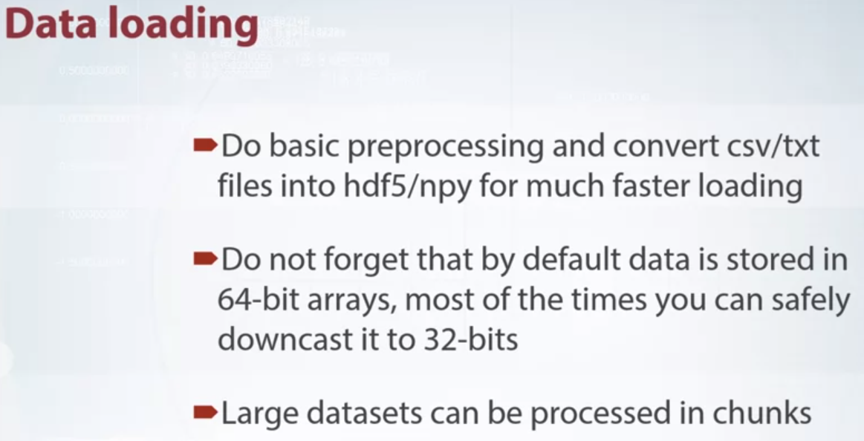

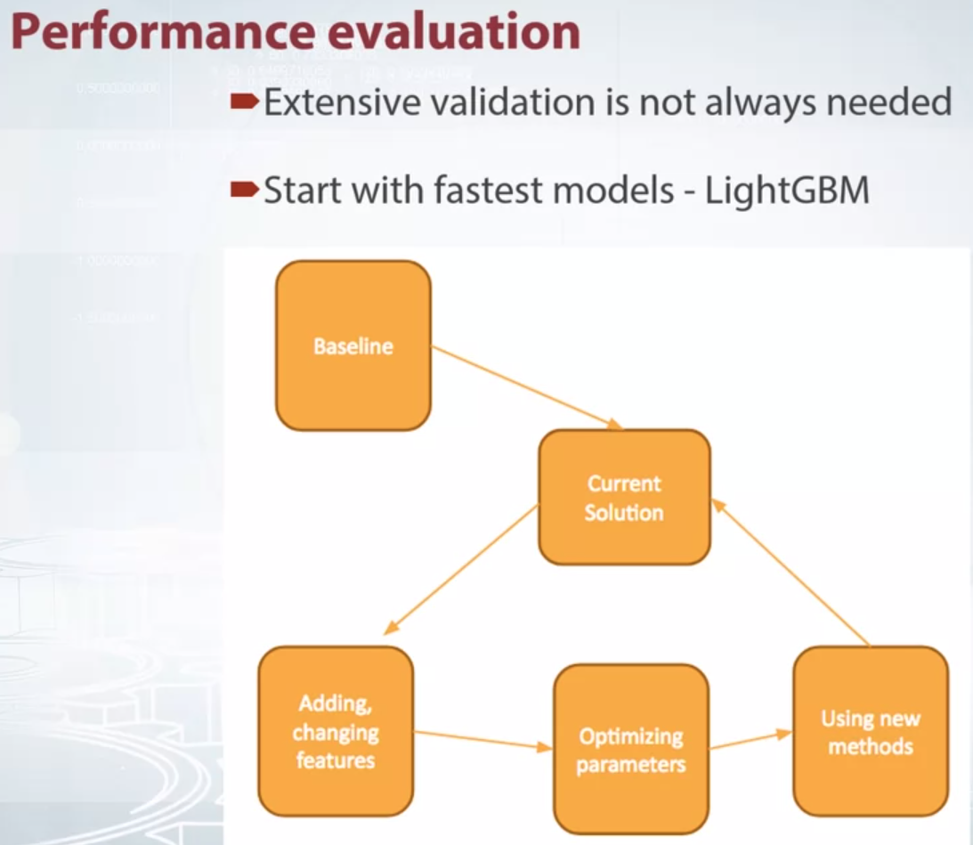

Also keep in mind that Panda's support out of the box data relink by chunks, via chunks ice parameter in recess fee function. So most of the data sets may be processed without a lot of memory. When it comes to performance evaluation, I am not a big fan of extensive validation. Even for medium-sized datasets like 50,000 or 100,000 rows. You can validate your models with a simple train test split instead of full cross validation loop. Switch to full CV only when it is really needed. For example, when you've already hit some limits and can move forward only with some marginal improvements. Same logic applies to initial model choice. I usually start with LightGBM, find some reasonably good parameters, and evaluate performance of my features.

I want to emphasize that I use early stopping, so I don't need to tune number of boosting iterations.

And god forbid start SVMs, random forest, or neural networks, you will waste too much time just waiting for them to fit. I switch to tuning the models, and sampling, and staking, only when I am satisfied with feature engineering.

In some ways, I describe my approach as, fast and dirty, always better. Try focusing on what is really important, the data. Do EDA, try different features. Google domain-specific knowledge. Your code is secondary.

BY NUMBER 3

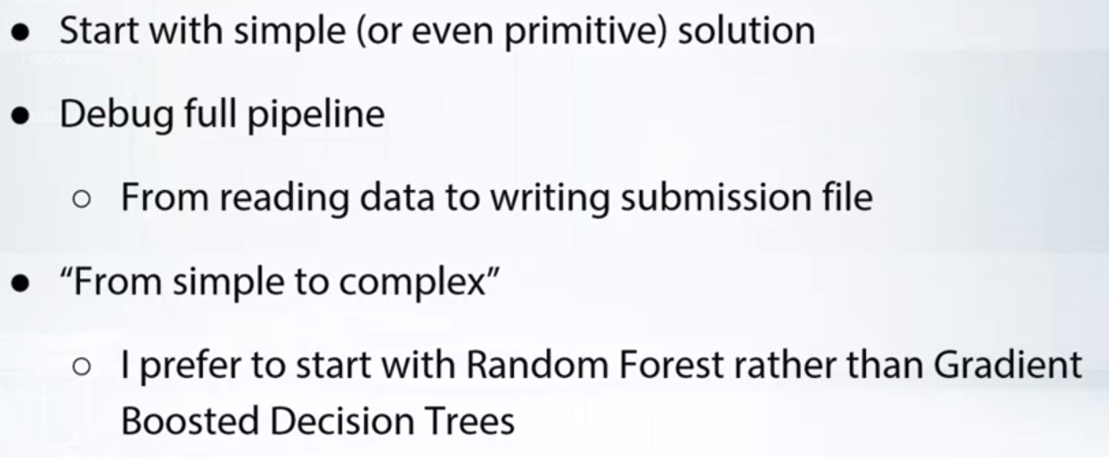

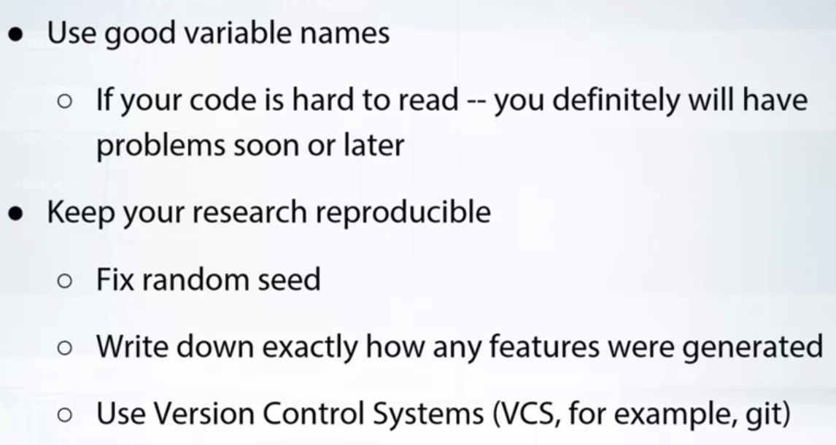

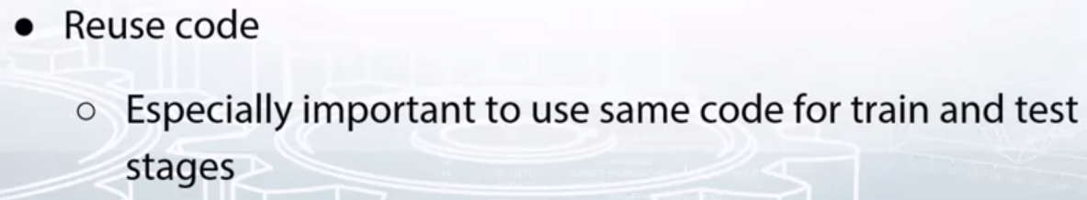

ALSO READ PAPER

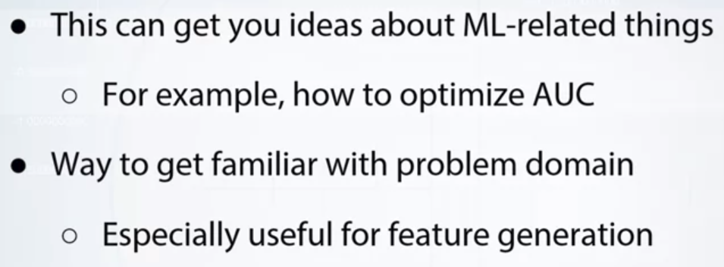

**BY 4TH ONE**

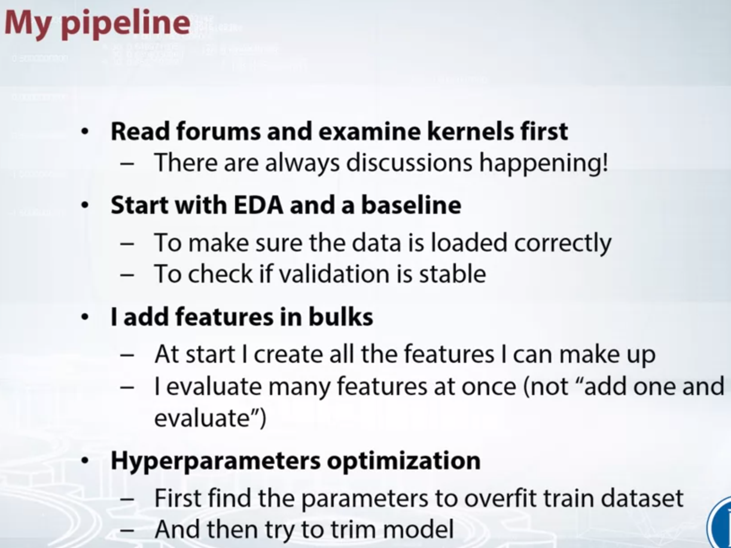

I usually start the competition by monitoring the forums and kernels.

It happens that a competition starts, someone finds a bug in the data. And the competition data is then completely changed, so I never join a competition at its very beginning.

I usually start a competition with a quick EDA and a simple baseline. I tried to check the data for various leakages. For me, the leaks are one of the most interesting parts in the competition. I then usually do several submissions to check if validation score correlates with publicly the board score.

Usually, I try to come up with a list of things to try in a competition, and I more or less try to follow it.

But sometimes I just try to generate as many features as possible, put them in XGboost and study what helps and what does not. When tuning parameters, I first try to make model overfit to the training set and only then I change parameters to constrain the model.

I had situations when I could not reproduce one of my submissions. I accidentally changed something in the code and I could not remember what exactly, so nowadays I'm very careful about my code and script.

Another problem? Long execution history in notebooks leads to lots of defined global variables.And global variables surely lead to bugs. So remember to sometimes restart your notebooks.

It's okay to have ugly code, unless you do not use this to produce a submission.

It would be easier for you to get into this code later if it has a descriptive variable names. I always use git and try to make the code for submissions as transparent as possible. I usually create a separate notebook for every submission so I can always run the previous solution and compare.

And I treat the submission notebooks as script. I restart the kernel and always run them from top to bottom.

_____________________________________________________________________

**MARIOUS ML PIPELINE**

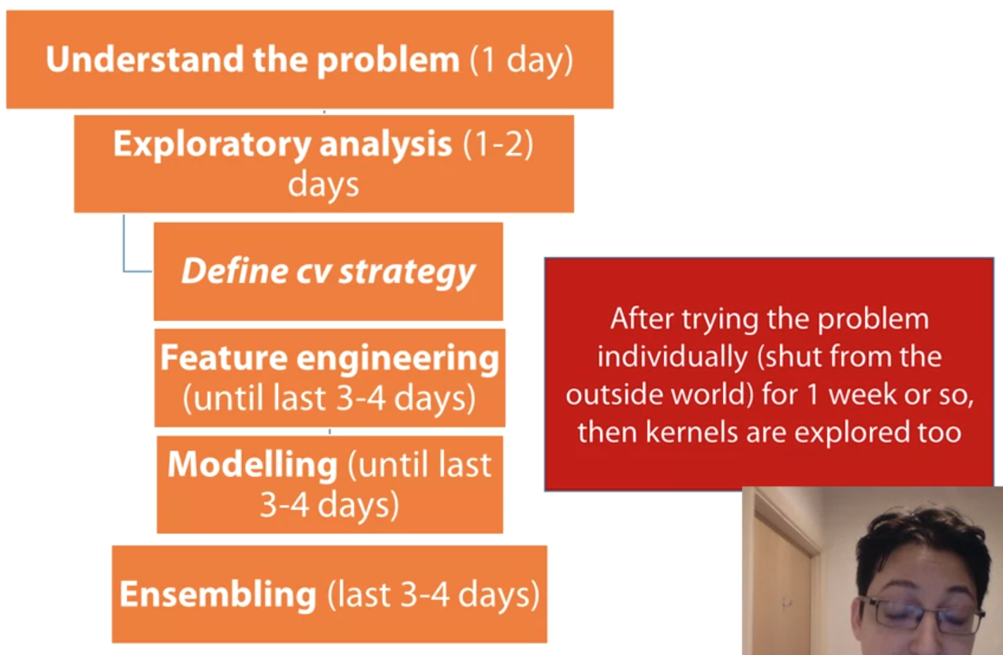

So, different software is suited for different types of problems.Keras and TensorFlow is obviously really good for when solving an image classification or sound classification and text problems that you can pretty much use it in any other problem as well.Then you most probably if you use Python, you need scikit learn and XGBoost, Lighgbm. This is the pinnacle of machine learning right now. And how do I set this up? Normally I create either an anaconda environment or a virtual environment in general, and how a different one for its competition, because it's easy to set this up. So, you just set this up, you download the necessary packages you need, and then you're good to go. This is a good way, a clean way to keep everything tidy and to really know what you used and what you find useful in the particular competitions. It's also a good validation for later on, when we will have to do this again, to find an environment that has worked well for this type of problem and possibly reuse it. Another question I ask at this point is what the metric I'm being tested on. Again, is it a regression program, is it a classification program, it is root mean square error, it is mean absolute error. I ask these questions because I try to find if there's any similar competition with similar type of data that I may have dealt with in the past, because this will make this preparation much much better, because I'll go backwards,find what I had used in the past and capitalize on it. So, reuse it, improve it, or even if I don't have something myself, I can just find other similar competitions or explanations of these type of problem from the web and try to see what people had used in order to integrate it to my approaches. So, this is what it means to understand the problem at this point. It's more about doing the screen search, this screening in order to understand what type of preparation I need to do, and actually do this preparation, in order to be able to solve this problem competitively, in terms of hardware, software and other resources, past resources in dealing with these types of problems.

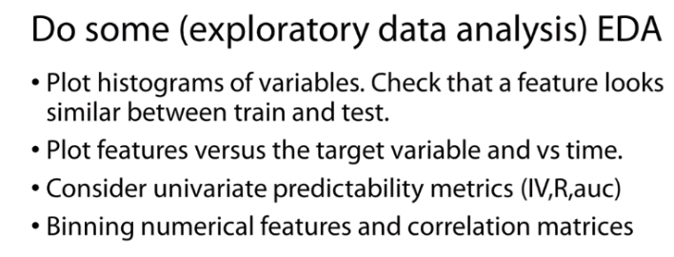

Then I spent the next one or two days to do some exploratory data analysis.

The first thing that I do is I see all my features,

assuming a tabular data set,

in the training and the test data and to see how consistent they are.

I tend to plot distributions and to try to find if there are any discrepancies.

So is this variable in the training data set very

different than the same variable in the test set?

Because if there are discrepancies or differences,

this is something I have to deal with.

Maybe I need to remove these variables or scale them in a specific way.

In any case, big discrepancies can cause problems to the model,

so that's why I spend some time here and do

some plotting in order to detect these differences.

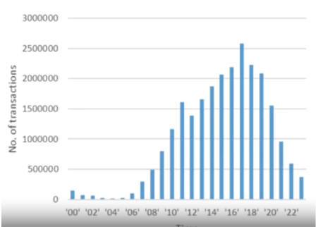

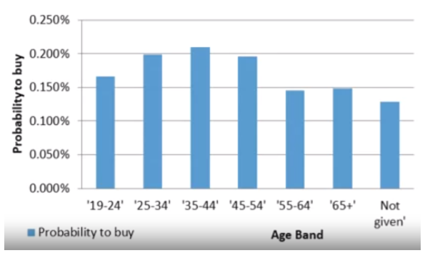

The other thing that I do is I tend to

plot features versus the target variable and possibly versus time,

if time is available.

And again, this tells me to understand the effect of time,

how important is time or date in this data set.

And at the same time it helps me to understand which are like the most predictive inputs,

the most predictive variables.

This is important because it generally gives me intuition about the problem.

How exactly this helps me is not always clear.

Sometimes it may help me define a gross validation strategy or

help me create some really good features but in general,

this kind of knowledge really helps to understand the problem.

I tend to create cross tabs for example with

the categorical variables and the target variable and also creates

unpredictability metrics like information value and you see chi square for example,

in order to see what's useful and whether I can make hypothesis about the data,

whether I understand the data and how they relate with the target variable.

The more understanding I create at this point,

most probably will lead to better features for better models applied on this data.

Also while I do this,

I like to bin numerical features into

bands in order to understand if there nonlinearities.

When I say nonlinearities,

whether the value of a feature is low,

target variable is high,

then as the value increases the target variable decreases as well.

So whether there are strange relationships trends,

patterns, or correlations between features and the target variable,

in order to see how best to handle this later on and get

an intuition about which type of problems or which type of models would work better.

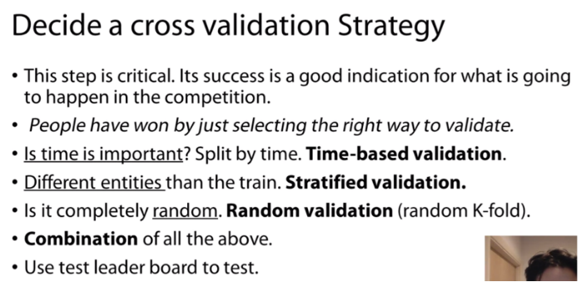

Once I have understood the data,

to some extent, then it's time for me to define a cross validation strategy.

I think this is a really important step

and there have been competitions where people were able to

win just because they were able to find

the best way to validate or to create a good cross validation strategy.

And by cross validation strategy,

I mean to create a validation approach that best resembles what you're being tested on.

If you manage to create this internally then you can create

many different models and create many different features and anything you do,

you can have the confidence that is working or it's not working,

if you've managed to build the cross validation strategy in a consistent way

with what you're being tested on so consistency is the key word here.

The first thing I ask is,

"Is time important in this data?"

So do I have a feature which is called date or time?

If this is important then I need to switch to a time-based validation.

Always have past data predicting future data,

and even the intervals,

they need to be similar with the test data.

So if the test data is three months in the future,

I need to build my training and validation to account for this time interval.

So my validation data always need to be

three months in the future and compared to the training data.

You need to be consistent in order to have

the most consistent results with what you are been tested on.

The other thing that I ask is,

"Are there different entities between the train and the test data?"

Imagine if you have different customers in

the training data and different in the test data.

Ideally, you need to formulate

your cross validation strategy so that in the validation data,

you always have different customers running in

training data otherwise you are not really testing in a fair way.

Your validation method would not be consistent with the test data.

Obviously, if you know a customer and you try to predict it, him or her,

why you have that customer in your training data,

this is a biased prediction when compared to the test data,

that you don't have this information available.

And this is the type of questions you need to ask yourself when you are at this point,

"Am I making a validation which is really consistent with what am I being tested on?"

The other thing that is often the case is

that the training and the test data are completely random.

I'm sorry, I just shortened my data and I took a random part, put it on training,

the other for test so in that case,

is any random type of cross validation could help for example,

just do a random K-fold.

There are cases where you may have to use a combination of all the above so you

have strong temporal elements at the same time you have different entities,

so different customers to predict for past and future and at the same time,

there is a random element too.

You might need to incorporate all of them do make a good strategy.

What I do is I often start with

a random validation and just see how it fares with the test leader board,

and see how consistent the result is with what they have internally,

and see if improvements in my validation lead to improvements to the leader board.

If that doesn't happen,

I make a deeper investigation and try to understand why.

It may be that the time element is very strong and I need to

take it into account or there are different entities between the train and test data.

These kinds of questions in order to formulate a better validation strategy.

Once the validation strategy has been defined,

now I start creating many different features.

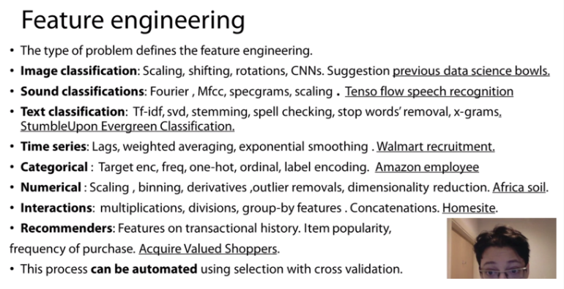

It says give you the different type of

future engineering you can use in different types of problems,

and also suggestions for the competition to look

up which was quite representative of this time.

But you can ignore these for now. Look at it later.

The main point is different problem requires

different feature engineering and I put everything when I say feature engineering.

I put the day data cleaning and preparation as well,

how you handle missing values,

and the features you generate out of this.

The thing is, every problem has its own corpus of

different techniques you use to derive or create new features.

It's not easy to know everything because sometimes it's too much,

I don't remember it myself so what I tend to do

is go back to similar competitions and see what

people are using or what people have used in the past and I incorporate into my code.

If I have dealt with this or a similar problem

in the past then I look at my code to see what I had done in the past,

but still looking for ways to improve this.

I think that's the best way to be able to handle any problem.

The good thing is that a lot of the feature engineering can be automated.

You probably have already seen that but,

as long as your cross validation strategy is consistent with the test data and reliable,

then you can potentially try all sorts of

transformations and see how they work in your validation environment.

If they work well, you can be confident that this type of

feature engineering is useful and use it for further modeling.

If not, you discard and try something else.

Also the combinations of what you can do in terms of

feature engineering can be quite vast in different types of

problems so obviously time is a factor here, and scalability too.

You need to be able to use your resources well in order to be able to search

as much as you can in order to get the best outcome.

This is what I do. Normally if I have more time

to do this feature engineering in a competition,

I tend to do better because I explore more things.

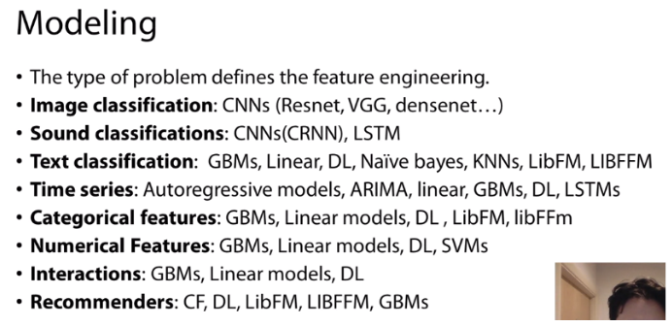

And the modeling is pretty much the same story.

So, it's type problem has its own type of model that works best.

Now, I don't want to go through that list again,

I put it here so that you can use it for reference.

But, again, the way you work this out is you look for literature,

you sense other previous competitions that were

similar and you try to find which type of problem,

which type of model or best for its type of problem.

And it's not surprise that for typical dataset,

when I say typical dataset I mean,

tabular dataset rather boosting machines in the form of XGBoost and GBM turned to

work best for problems like aim as classification sound classification,

deep learning in the form of convolutional neural networks tend to work even better.

So, this is roughly what you need to know.

New techniques are being developed so,

I think your best chance here or what I have used in order to

do well in the past was knowing what's tends to work well with its problem,

and going backwards and trying to find other code or

other implementations and similar problems in order

to integrate it with mine and try to get a better result.

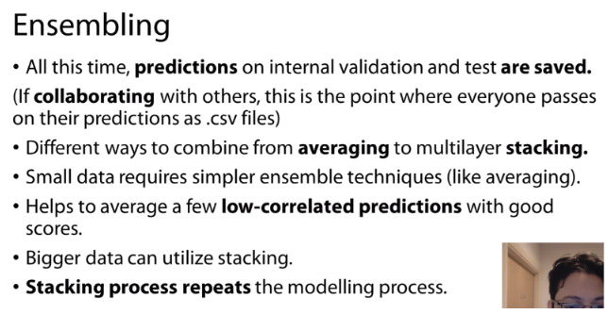

I should mention that each of

the previous models needs to be changed sometimes differently.

So you need to spend time within

this cross-validation strategy in order to find the best parameters,

and then we move onto Ensembling.

Every time you apply

your cross-validation procedure with

a different feature engineering and a different joint model,

it's time, you saved two types of predictions,

you save predictions for the validation data and you save predictions for the test data.

So now that you have saved all these predictions and by the way this is the point

that if you collaborate with others that tend to send you the predictions,

and you'll be surprised that sometime that collaboration is just this.

So people just sending these prediction files for the validation and the test data.

So now you can find the best way to combine

these models in order to get the best results.

And since you already have predictions for the validation data,

you know the target variable for the validation data,

so you can explore different ways to combine them.

The methods could be simple,

could be an average,

or already average, or it can go up to a multilayer stacking in general.

Generally, what you need to know is that from my experience,

smaller data requires simple ensemble techniques like averaging.

And also what tends to show is to look at correlation between predictions.

So find it here that work well,

but they tend to be quite diverse.

So, when you use fusion correlation,

the correlation is not very high.

That means they are likely to bring new information,

and so when you combine you get the most out of it.

But if you have bigger data there are,

you got pretty must try all sorts of things.

What I like to think of is it is that,

when you have really big data,

the stacking process that impedes the modeling process.

By that, I mean that you have

a new set of features this time they are predictions of models,

but you can apply the same process you have used before.

So you can do feature engineering,

you can create new features or you can remove the features/ prediction that

you no longer need and you can use this in

order to improve the results for your validation data.

This process can be quite exhaustive,

but well, again, it can be automated to some extent.

So, the more time you have here,

most probably the better you will do.

But from my experience, 2,

3 days is good in order to get the best out of all the models you have built and depends

obviously on the volume of data or

volume of predictions you have generated up until this point.

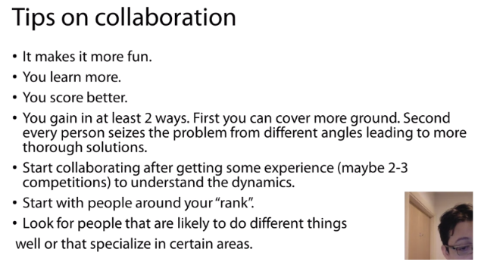

At this point I would like to share a few thoughts about collaboration.

Many people have asked me this and I think this is a good point to share.

These ideas has greatly helped me to do well in competitions.

The first thing is that it makes things more fun.

I mean you are not alone,

you're with other people and that's always more energizing,

it's always more interesting, it's more fun,

you can communicate with the others through times like Skype,

and yeah I think it's more collaborative as the world says, it is better.

You learn more.

I mean you can be really good,

but, you know, you always always learn from others.

No way to know everything yourself.

So it's really good to be able to share points with other people,

see what they do learn from them and become

better and grow as a data scientist, as a model.

From my experience you score far better than trying to solve a problem alone,

and I think these happens for mainly for two ways.

There are more but these are main two.

First you can cover more ground because,

you can say, you can focus on ensembling,

I will focus on feature engineering or you will focus on

joining this type of model and I will focus on another type of model.

So, you can generally cover more ground.

You can divide task and you can search,

you can cover more ground in terms of the possible things you can try in a competition.

The second thing is that every person sees the problem from different angles.

So, that's very likely to generate more diverse predictions.

So something we do is although we kind of

define together by the different strategy when we form teams,

then we would like to work for maybe

one week separately without discussing with one another,

because this helps to create diversity.

Otherwise, if we over discuss this,

we might generate pretty much the same things.

So, in other words,

our solutions might be too correlated to add more value.

So, this is a good way in order to

leverage the different mindset each person has in solving these problems.

So, for one week,

each one works separately and then after some point,

we start combining or work more closely.

I would advise people to start collaborating after getting some experience,

and I say here two or three competitions just because Cargo has some rules.

Sometimes, it is easy to make mistakes.

I think it's better to understand the environment,

the competition environment well before

exploring these options in order to make certain that,

no mistakes are done,

no violation of the rules.

Sometimes new people tend to make these mistakes.

So, it's good to have this experience prior to trying to collaborating.

I advise people to start forming teams with people around their rank

because sometimes it is frustrating when you

join a high rank or a very experienced team I would say.

It's bad to say experience from rank,

because you don't know sometimes how to contribute,

you still don't understand all the competition dynamics and it might stall your progress,

if you join a team and you're not able to contribute.

So, I think it's better to, in most cases,

to try and find people around your rank or around your experience and grow together.

This way is the best form of collaboration I think.

Another tip for collaborating is to try to collaborate

with people that are likely to take

diverse approaches or different approaches than yourself.

You learn more this way and it is more likely that when you combine,

you will get a better score.

So, such for people who are sort of famous

for doing well certain things and in order to get the most out of it,

to learn more from each other and get better results in the leader board.

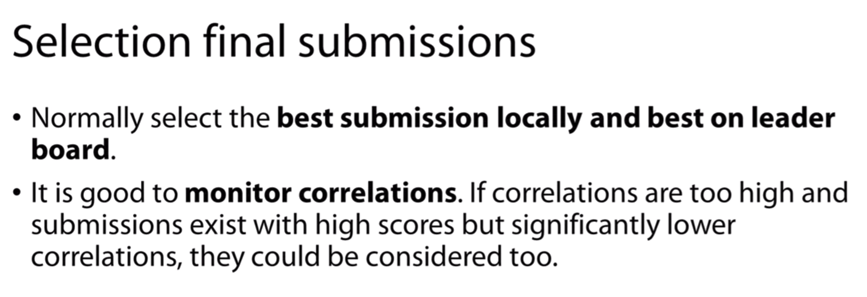

Main idea is by diverse submission even though one is having a low score you have better chances of doing a good position on the leader board.

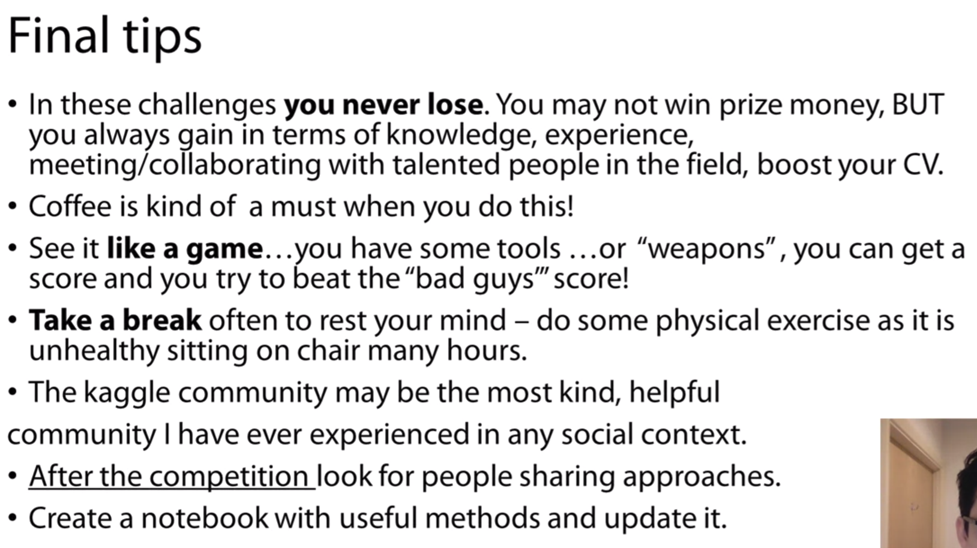

# **Macros[¶](https://mrswzenwnufdumipqzjcjz.coursera-apps.org/notebooks/Reading%20materials/Macros.ipynb#Macros)**

This notebook shows how to use *macros* commands in Jupyter.

What is *macro*? It is just a named code snippet. Similarly to functions, we can use macros to wrap frequently used code. For example, we can define a macro, that will load all the libraries for us.

### **Step 1: Define macro**

To save some code as a macro we need to put that code in a cell and run it.

In [1]:

**import** numpy **as** np

**import** pandas **as** pd

**from** tqdm **import** tqdm_notebook

**import** os

**import** sys

**import** os.path

​

**import** matplotlib.pyplot **as** plt

**import** matplotlib **as** mpl

**from** matplotlib **import** rc

**from** cycler **import** cycler

**%**matplotlib inline

​

mpl.rcParams['axes.prop_cycle'] = cycler('color', ['#ff0000', '#0000ff', '#00ffff','#ffA300', '#00ff00',

'#ff00ff', '#990000', '#009999', '#999900', '#009900', '#009999'])

​

rc('font', size=16)

rc('font',**\*\***{'family':'serif','serif':['Computer Modern']})

rc('text', usetex=**False**)

rc('figure', figsize=(12, 10))

rc('axes', linewidth=.5)

rc('lines', linewidth=1.75)

​

print('The libraries have been loaded!')

The libraries have been loaded!

Now you need to remember the number inside squre brackets of In [<number>]. Now, to save the code, in that cell you need to use macro magic:

%macro __imp <number>

In [2]:

**%**macro **-**q __imp 1

Now try it!

In [3]:

__imp

The libraries have been loaded!

### **Step 2: save macro**

To this end we've only created a macro, but it will be lost, when the kernel is restarted. We need to somehow store it, so than we can load it easily later. In can be done with %store macro.

In [4]:

**%**store __imp

Stored '__imp' (Macro)

Now __imp is saved in a kind of Jupyter's global memory. You can list all the stored variables like that:

In [5]:

**%**store

Stored variables and their in-db values:

__imp -> IPython.macro.Macro("import numpy as np\nimport pa

Now **restart the kernel** and get back to this cell without running the previous ones. To run the stored macro you need to retrieve the macro first with the following line:

In [1]:

**%**store **-**r __imp

And only then call the macro:

In [2]:

__imp

The libraries have been loaded!

### **Step 3: auto restore macro**

So you need to use as many as 2 cells! But, fortunately, Jupyer can load the stored variables (and macros) automatically. To enable it you need to update you .ipython_profile [config](http://ipython.readthedocs.io/en/stable/development/config.html). If you've never heared of it, then it is not yet created, otherwise you should know where it lives.

On Coursera's notebooks we will create it here: ~/.ipython/profile_default/ipython_profile.py and notify the ipython, that we want it to automatically restore stored variables.

c.StoreMagics.autorestore = True

In [4]:

**!**echo "c = get_config()\nc.StoreMagics.autorestore = True" **>** **~/**.ipython**/**profile_default**/**ipython_config.py

**!**cat **~/**.ipython**/**profile_default**/**ipython_config.py

c = get_config()

c.StoreMagics.autorestore = True

That's it! Now **restart your notebook (kernel)** and **define and store macro** again (step 1 and first code cell from step 2). And finally, to test it, **restart the kernel** again. Now you can immediately access __imp macro, so that all the libraries are loaded with a 5 char line of code.

In [1]:

__imp

The libraries have been loaded!

**ADDITIONAL MATERIALS**

[**https://www.dataquest.io/blog/jupyter-notebook-tips-tricks-shortcuts/**](https://www.dataquest.io/blog/jupyter-notebook-tips-tricks-shortcuts/)

**Notebook showing awesome jupyter notebook features. A must read !!!**

**________________________________________**

**ADVANCE FEATURES 2**

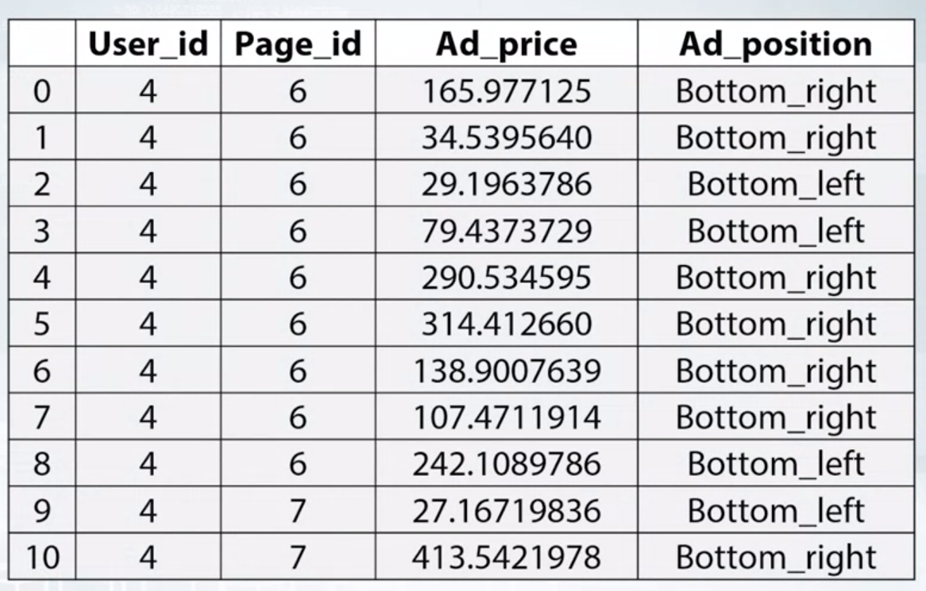

Transformed into

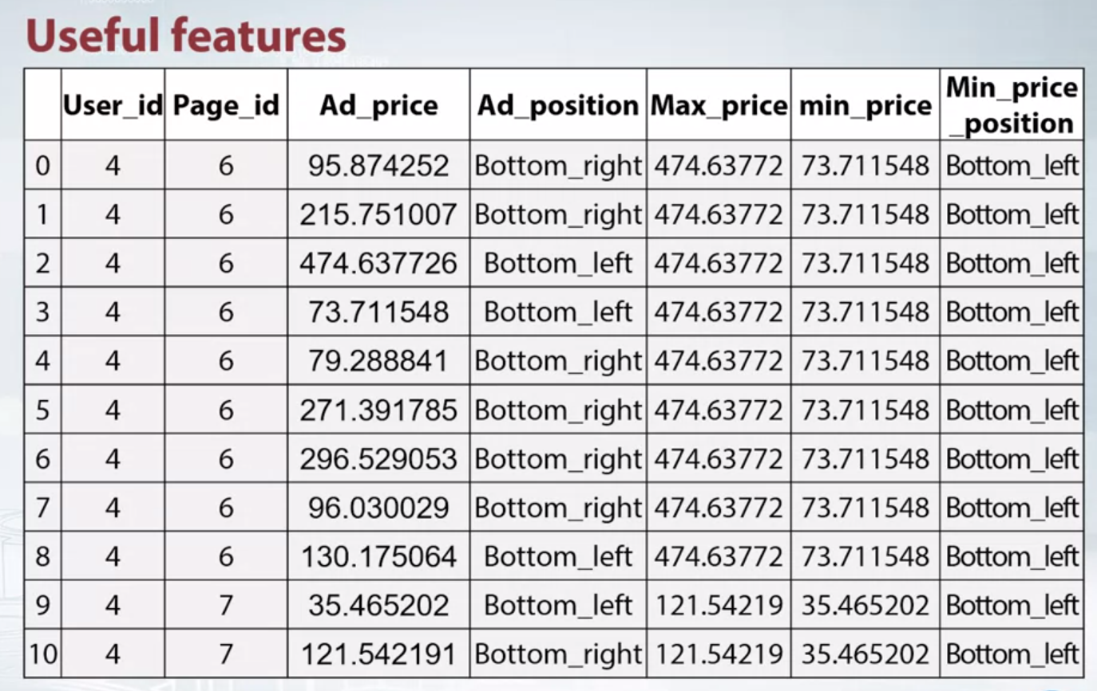

To create this we have

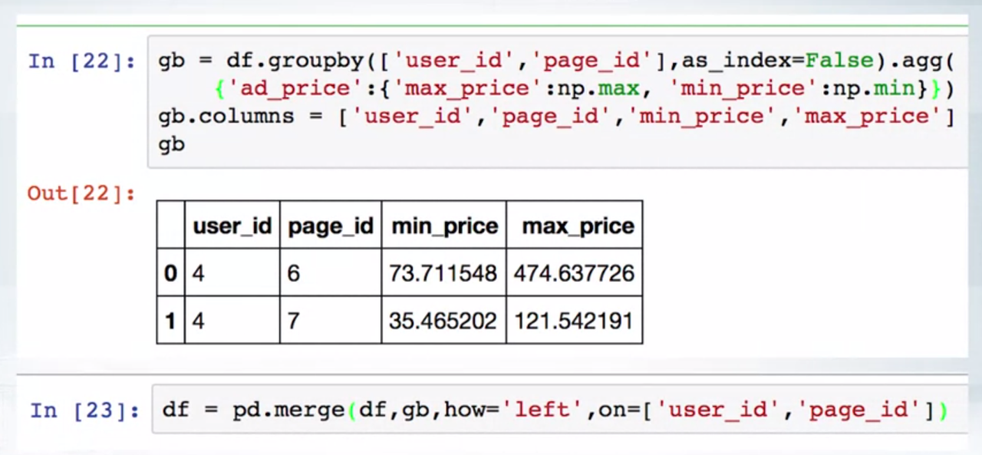

Let's consider a simple example. Here we have a chunk of data for some CTR task. Let's forget about target variable and focus on human features. Namely, User_ID, unique identifier of a user, Page_ID, an identifier of a page user visited, Ad_price, item prices in the ad, and Ad_position, relative position of an ad on the web page. The most straightforward way to solve this problem is to label and call the Ad_position and feed some classifier. It would be a very good classifier that could take into account all the hidden relations between variables. But no matter how good it is, it still treats all the data points independently. And this is where we can apply feature engineering. We can imply that an ad with the lowest price on the page will catch most of the attention. The rest of the ads on the page won't be very attractive. It's pretty easy to calculate the features relevant to such an implication. We can add lowest and highest prices for every user and page per ad. Position of an ad with the lowest price could also be of use in such case. Here's one of the ways to implement statistical features with paid ads. If our data is stored in the data frame df, we call groupby method like this to get maximum and minimum price values. Then store this object in gb variable, and then join it back to the data frame df.

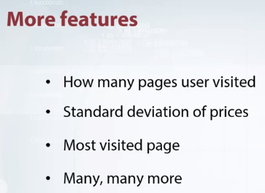

I want to emphasize that you should not stop at this point. It's possible to add other useful features not necessarily calculated within user and page per. It could be how many pages user has visited, how many pages user has visited during the given session, and ID of the most visited page, how many users have visited that page, and many, many more features.The main idea is to introduce new information. By that means, we can drastically increase the quality of the models.

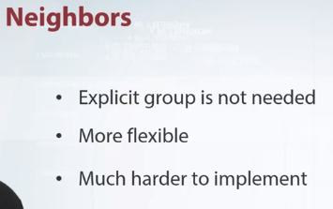

But what if there is no features to use groupby on? Well, in such case, we can replace grouping operations with finding the nearest neighbors. On the one hand, it's much harder to implement and collect useful information. On the other hand, the method is more flexible. We can fine tune things like the size of relevant neighborhood or metric.

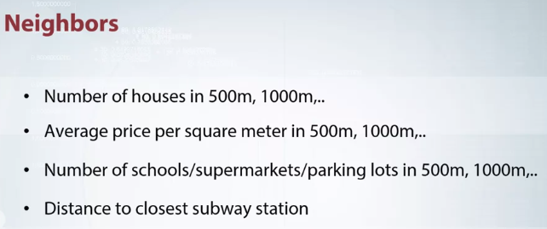

The most common and natural example of neighborhood analysis arises from purposive pricing. Imagine that you need to predict rental prices. You would probably have some characteristics like floor space, number of rooms, presence of a bus stop. But you need something more than that to create a really good model. It could be the number of other houses in different neighborhoods like in 500 meters, 1,000 meters, or 1,500 meters, or average price per square meter in such neighborhoods, or the number of schools, supermarkets, and parking lots in such neighborhoods.The distances to the closest objects of interest like subway stations or gyms could also be of use. I think you've got the idea. In the example, we've used a very simple case, where neighborhoods were calculated in geographical space. But don't be afraid to apply this method to some abstract or even anonymized feature space.

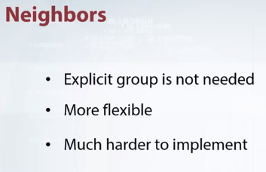

But don't be afraid to apply this method to some abstract or even anonymized feature space. It still could be very useful. My team and I used this method in Spring Leaf competition. Furthermore, we did it in supervised fashion. 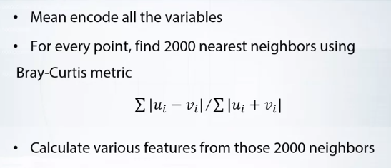

Here is how we have done it. First of all, we applied mean encoding to all variables. By doing so, we created homogeneous feature space so we did not worry about scaling and importance of each particular feature. After that, we calculated 2,000 nearest neighbors with Bray-Curtis metric. 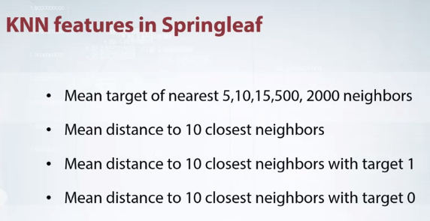

Then we evaluated various features from those neighbors like mean target of nearest 5, 10, 15, 500, 2,000 neighbors, mean distance to 10 closest neighbors, mean distance to 10 closest neighbors with target 1, and mean distance to 10 closest neighbors with target 0, and, it worked great. In conclusion, I hope you embrace the main ideas of both groupby and nearest neighbor methods and you would be able to apply them in practice.



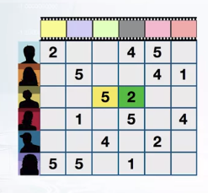

Here's a classic example of recommendations. Suppose we have some information about user, like age, region, interest and items like gender, year length. Also we know ratings that users gave to some items. These ratings can be organized in a user item matrix with row corresponding to users, and columns corresponding to items, as shown in the picture. In a cell with coordinates i, j, the user or agent can be chooser i, give the item j. 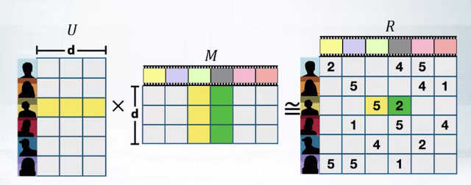

Assume that our user have some features Ui. And jth item have is corresponding feature Mj. And scalar product of these features produce a rating Rij. Now we can apply matrix factorization to learning those features for item and users. Sometimes these features can have an interpretation. Like the first feature in item can be measured of or something similar. But generally you should consider them as some extra features, which we can use to encode user in the same way as we did before with labeling encoder or mean encoding. Specifically our assumption about scale of product is the following. If we present all attributes of user and items as matrixes, the matrix product will be very close to the matrix's ratings. In other words, which way to find matrix's U and M, such as their product gives the matrix R. This way, this approach is called matrix factorization or matrix composition.

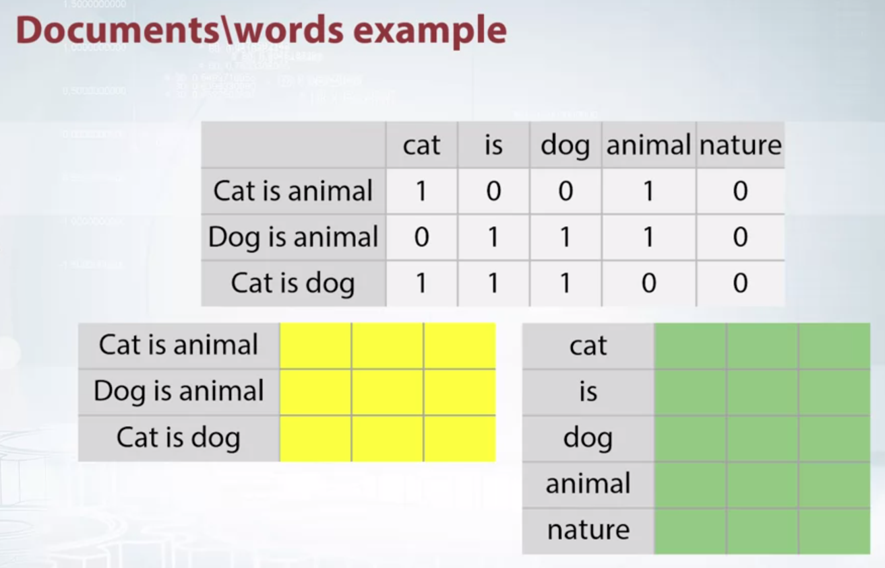

In previous examples, we used both row and column related features. But sometimes we don't let the features correspond to rows. Let's consider another example. Suppose that we are texts, do you remember how we usually classify text? We extract features and each document was described by a large sparse vector. If we do matrix factorization over these parse features, we will get the representation for index displayed in yellow, and terms displayed in green. Although we can somehow use representation for jumps, we are interested only in representations for dogs. Now every document is described by a small, dense vector. These are our features, and we can use them in a way similar to previous example.This case is often called dimension energy reduction. It's quite an efficient way to reduce the size of feature metric, and extract real valued features from categorical ones.

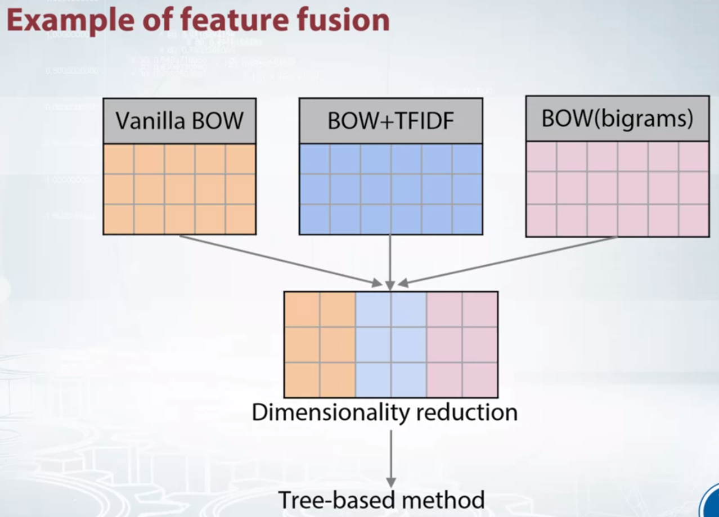

In competitions we often have different options for pre processing. For example, using text data, you can run bag of bi grams and so on. Using matrix optimization technique, you are able to extract features from all of these matrices. Since the resulting matrices will be small, we can easily join them and use togetherness of the features in tree-based models

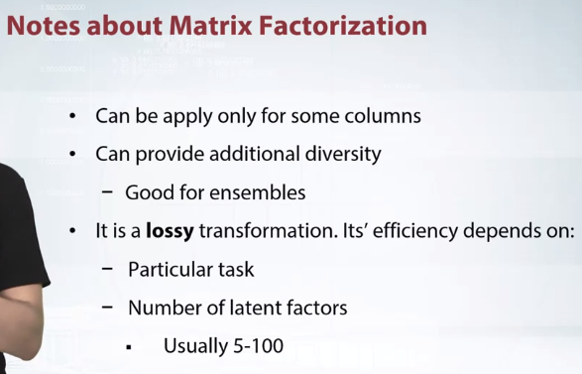

Now I want to make a few comments about matrix factorization. Not just that we are not constrained to reduce whole matrix, you can apply factorization to a subset of a column and leave the other as is. Besides reduction you can use pressure boards for getting another presentation of the same data.

This is especially useful for example since it provides velocity of its models and leads to a better.Of course matrix factorization is a loss of transformation, in other words we will lose some information after the search reduction.

Efficiency of this approach heavily depends on a particular task and choose a number of latent factors. The number should be considered as a hyper parameter and needs to be tuned. It's a good practice to choose a number of factors between 5 and 100.

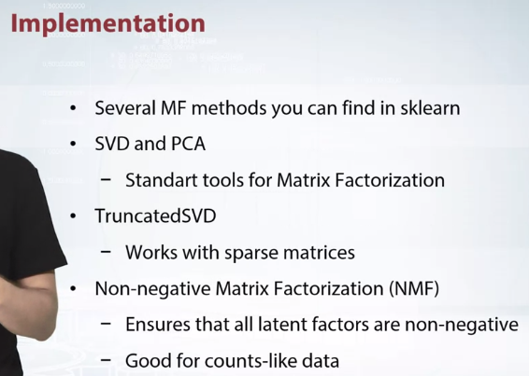

Now, let's switch from general idea to particular implementations. Several matrix factorization methods are implemented in scikit learn as the most famous SVD and PCA. In addition, their use included TruncatedSVD, which can work with sparse matrices. It's very convenient for example, in case of text datasets. Also there exists a so called non-negative matrix factorization, or NMF. It impose an additional restrictions that all hidden factors are non-negative, that is either zero or a positive number. It can be applied only to non-negative matrixes. For example matrix where all represented occurence of each word in the document. 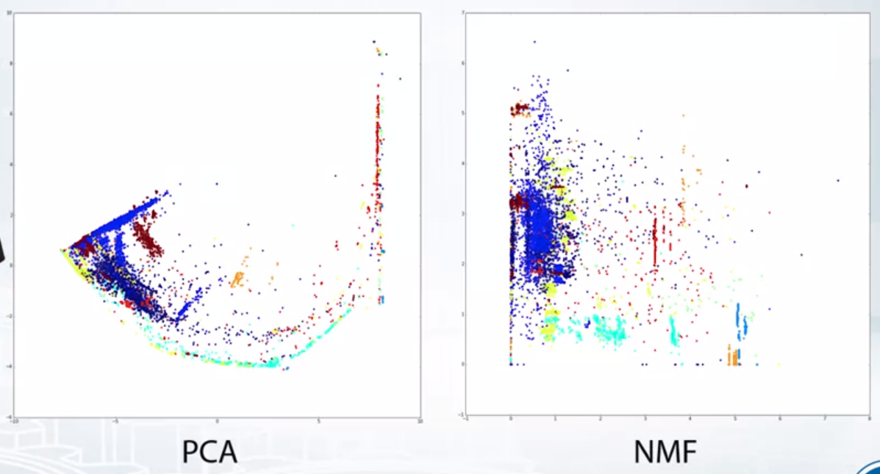NMF has an interesting property, it transforms data in a way that makes data more suitable for decision trees. Take a look at the picture from Microsoft Mobile Classification Challenge. It can be seen that NMF transform data forms lines parallel to the axis. A few more notes on matrix factorizations.

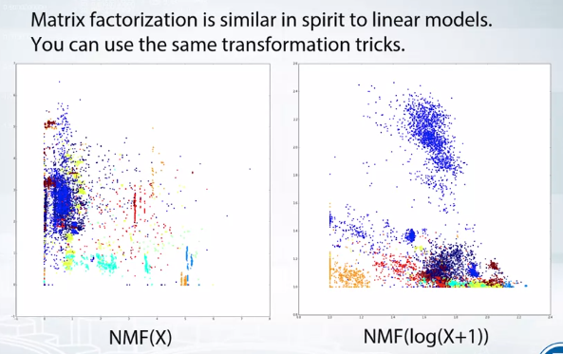

Essentially they are very similar to linear models, so we can use the same transformation tricks as we use for linear models. So in addition to standard NMF, I advise you to apply the factorization to logarithmic transformed data. Here's another plot from the competition. It's clear that these two transformations produce different features, and we don't have to choose the best one. Instead, it's beneficial to use both of them.

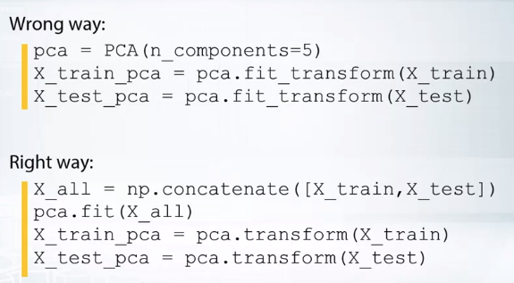

I want to note that matrix factorization is a trainable transformation, and has its own parameters. So we should be careful, and use the same transformation for all parts of your data set.

Reading and transforming each part individually is wrong, because in that case you will get two different transformations. This can lead to an error which will be hard to find.

The correct method is shown above, first we need to the data information on all data and only then apply to each individual piece. To sum up, matrix composition is a very general approach to dimensional reduction and feature extraction. It can be used to transform categorical feature into real ones.

And tricks for linear models are also suitable for matrix factorizations.

**FEATURE INTERACTION**

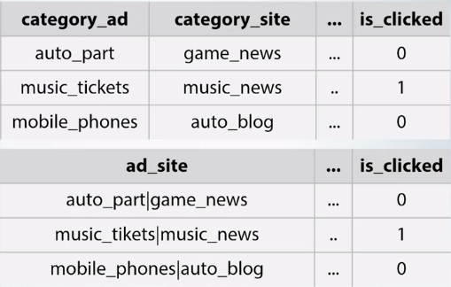

The main topic of this video is Feature Interactions. You will learn how to construct them and use in problem solving. Additionally, we will discuss them for feature extraction from decision trees. Let's start with an example. Suppose that we are building a model to predict the best advertisement banner to display on a website. Among available features, there are two categorical ones that we will concentrate on. The category of the advertising banner itself and the category of the site the banner will be showing on. Certainly, we can use the features as two independent ones, but a really important feature is indeed the combination of them. We can explicitly construct the combination in order to incorporate our knowledge into a model. Let's construct new feature named ad_site that represents the combination. It will be categorical as the old ones, but set of its values will be all possible combinations of two original values. From a technical point of view, there are two ways to construct such interaction.

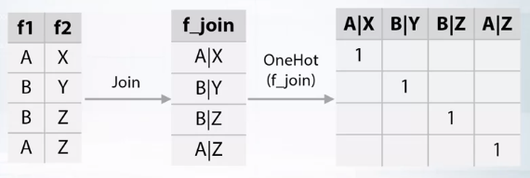

Let's look at a simple example. Consider our first feature, f1, has values A or B. Another feature, f2, has values X or Y or Z, and our data set consist of four data points. The first approach is to concatenate the text values of f1 and f2, and use the result as a new categorical feature f_join. We can then apply the OneHot according to it. The second approach consist of two steps.

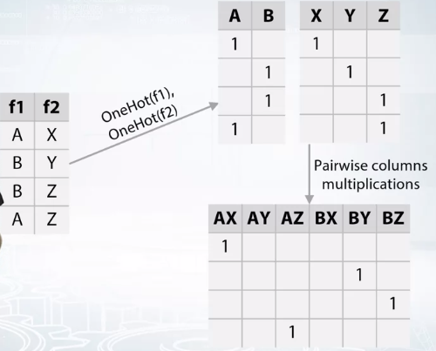

Firstly, apply OneHot and connect to features f1 and f2. Secondly, construct new metrics by multiplying each column from f1 encoded metrics to each column from f2 encoded metrics. It was nothing that both methods results inpractically the same new feature representations. In the above example, we can consider as interactions between categorical features, but similar ideas can be applied to real valued features.

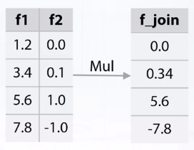

For example, having two real valued features f1 and f2, interactions between them can be obtained by multiplications of f1 and f2. In fact, we are not limited to use only multiply operation.Any function taking two arguments like sum, difference, or division is okay.

The following transformations significantly enlarge feature space and makes learning easier, but keep in mind that it makes over fitting easier too. It should be emphasized that for tree based algorithms such as the random forest or gradient boost decision trees it's difficult to extract such kind of dependencies. That's why these transformation are very efficient for tree based methods.

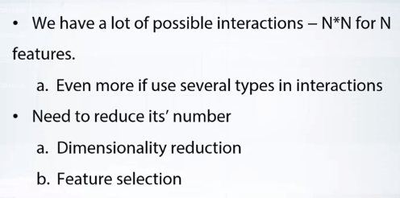

Let's discuss practical details now. Where wise future generation approaches greatly increase the number of the features. If there were any original features, there will be n square.And will be even more features if several types of interaction are used. There are two ways to moderate this, either do feature selection or dimensionality reduction. I prefer doing the selection since not all but only a few interactions often achieve the same quality as all combinations of features. For each type of interaction, I construct all pairwise feature interactions. Feature random forests over them and select several most important features. Because number of resulting features for each type is relatively small.

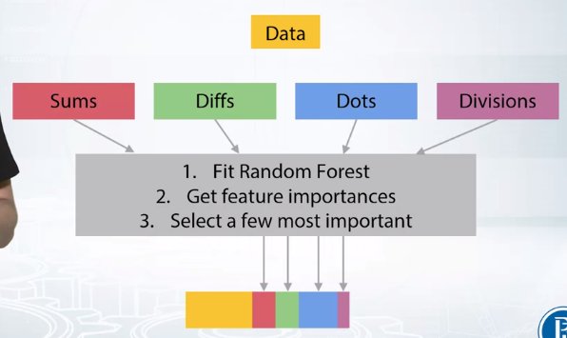

It's possible to join them together along with original features and use as input for any machine learning algorithm usually tree based methods.

It's possible to join them together along with original features and use as input for any machine learning algorithm usually to be by use method. During the video, we have examined the method to construct second order interactions.But you can similarly produce throned order or higher. Due to the fact that number of features grow rapidly with order, it has become difficult to work with them. Therefore high order directions are often constructed semi-manually

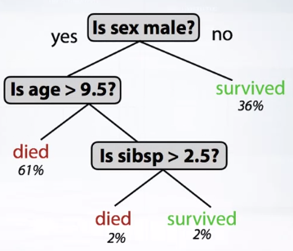

Additionally, I would like to talk about methods to construct categorical features from decision trees. Take a look at the decision tree. Let's map each leaf into a binary feature. The index of the object's leaf can be used as a value for a new categorical feature. If we use not a single tree but an ensemble of them. For example, a random forest, then such operation can be applied to each of entries.

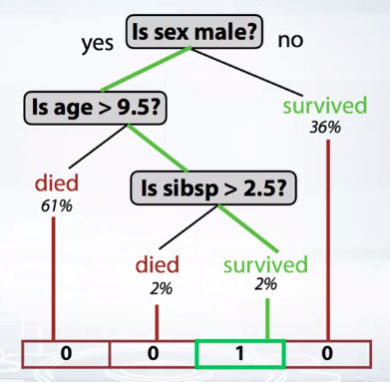

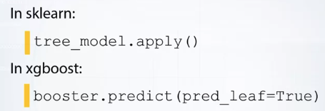

This is a powerful way to extract high order interactions. This technique is quite simple to implement. Tree-based models from sklearn library have an apply method which takes as input feature metrics and returns corresponding indices of leaves. In xgboost, also support via parameters pred_leaf in predict method. I suggest we need to look at library documentations in order to get more information about these methods and APIs.

**tSNE**

Today, we will discuss this new method for visualizing data integrating features. At the end of this video, you will be able to use tSNE in your products. In the previous video, we learned about matrix factorization technique that is very close to linear models.

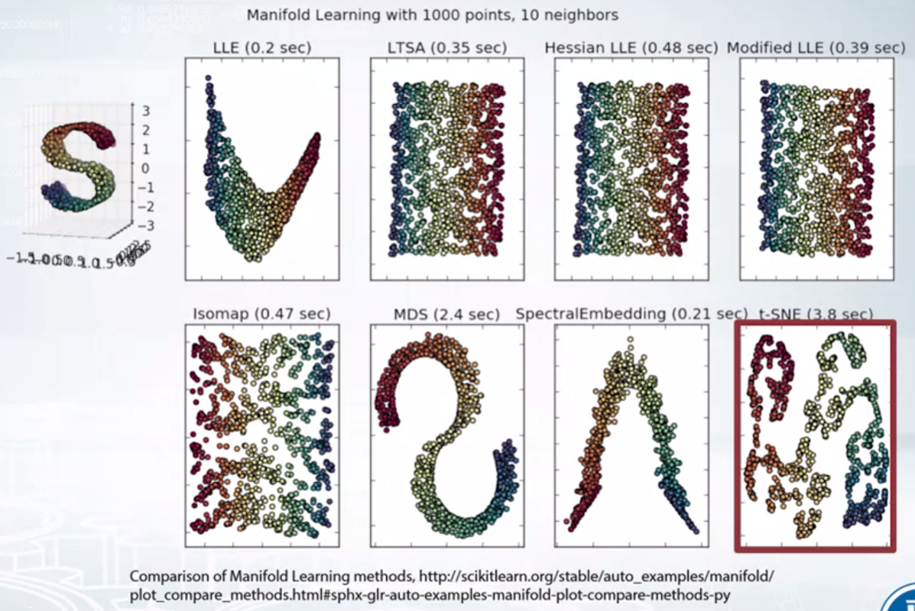

In this video, we will touch the subject of non-linear methods of dimensionality reduction. That says in general are called manifold learning. For example, look at the data in form of letter S on the left side. On the right, we can see the results of running different manifold learning algorithm on the data. This new result is placed at the right bottom corner on the slide. This new algorithm is the main topic of the lecture, as it tells of how this really works won't be explained here. But you will come to look at additional materials for the details. Let's just say that this is a method that tries to project points from high dimensional space into small dimensional space so that the distances between points are approximately preserved. Let's look at the example of the tSNE on the MNIST dataset. 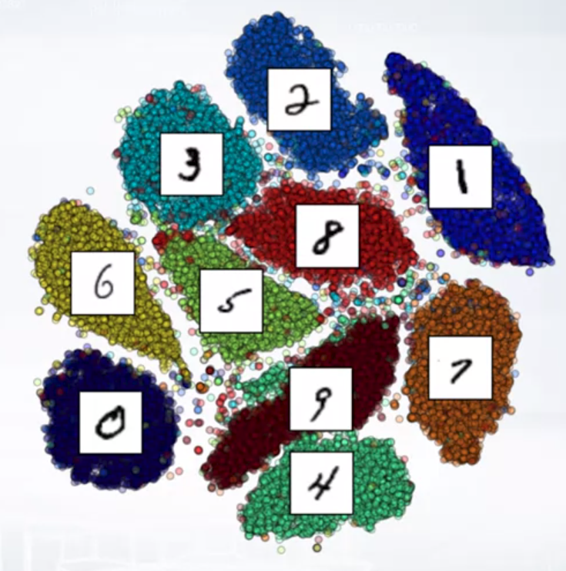

Here are points from 700 dimensional space that are projected into two dimensional space. You can see that such projection forms explicit clusters. colour shows that these clusters are meaningful and corresponds to the target numbers well. Moreover, neighbor clusters corresponds to a visually similar numbers. For example, cluster of three is located next to the cluster of five which intern is adjustment to the cluster of six and eight. If data has explicit structure as in case of MNIST dataset, it's likely to be reflected on tSNE plot. For the reason tSNE is widely used in exploratory data analysis. However, do not assume that tSNE is a magic wand that always helps.For example, a misfortune choice of hyperparameters may lead to poor results. 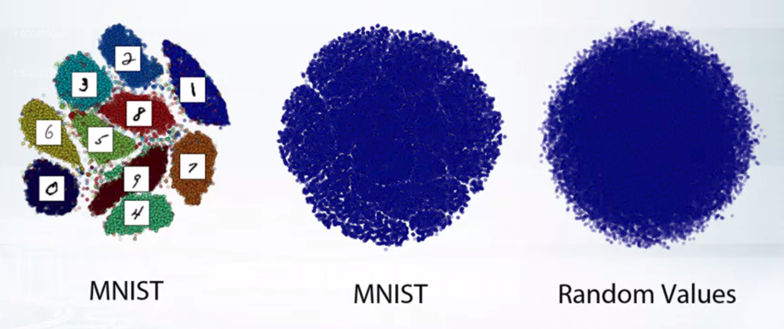

Consider an example, in the center is the least presented a tSNE projection of exactly the same MNIST data as in previous example, only perplexity parameter has been changed. On the left, for comparison, we have plots from previous right. On the right, so it present a tSNE projection of random data. We can see as a choice of hybrid parameters change projection of MNIST data significantly so that we cannot see clusters. Moreover, new projection become more similar to random data rather than to the original. Let's find out what depends on the perplexity hyperparameter value. 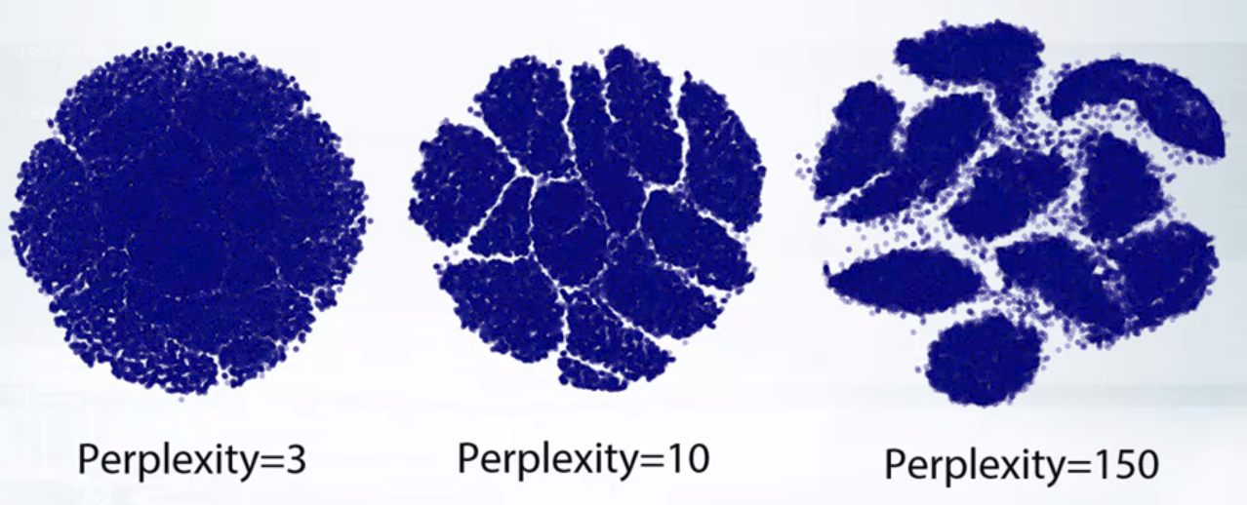

On the left, we have perplexity=3, in the center=10, and on the right= 150. I want to emphasize that these projections are all made for the same data. The illustration shows that these new results strongly depends on its parameters, and the interpretation of the results is not a simple task. In particular, one cannot infer the size of original clusters using the size of projected clusters. Similar proposition is valid for a distance between clusters. 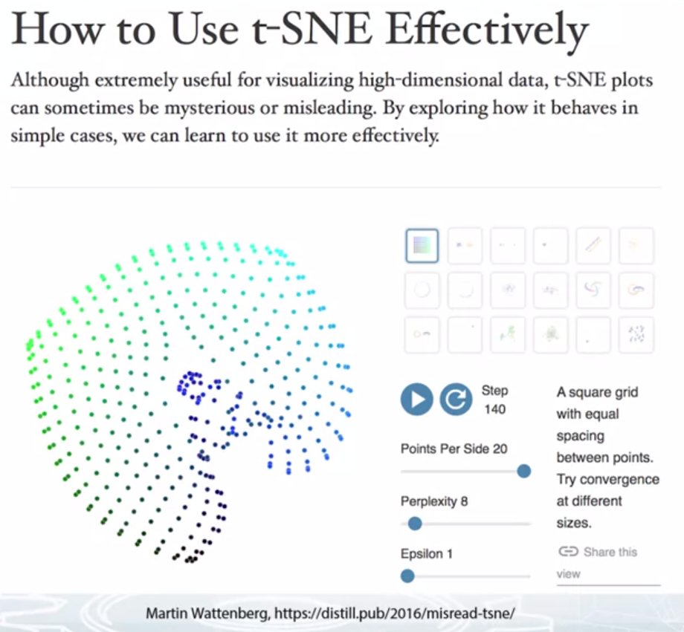

Blog distill.pub contain a post about how to understand and interpret the results of tSNE. Also, it contains a great interactive demo that will help you to get into issues of how tSNE works. I strongly advise you to take a look at it. In addition to exploratory data analysis, tSNE can be considered as a method to obtain new features from data. You should just concatenate the transformers coordinates to the original feature matrix.

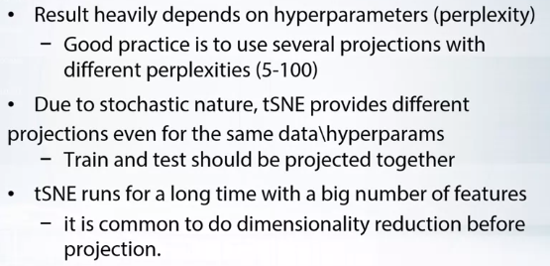

Now if you've heard this about practical details, as it has been shown earlier, the results of tSNE algorithm, it strongly depends on hyperparameters. It is good practice to use several projections with different perplexities. In addition, because of the stochasticity of this method results in different projections even with the same data and hyperparameters. This means the train and test sets should be projected together rather than separately. Also, tSNE will run for a long time if you have a lot of features. If the number of features is greater than 500, you should use one of dimensionality reduction approaches and reduce the number of features, for example, to 100.

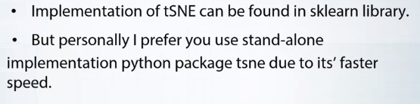

Implementation of tSNE can be found in the sklearn library. But personally, I prefer to use another implementation from a separate Python package called tSNE, since it provide a way more efficient implementation.

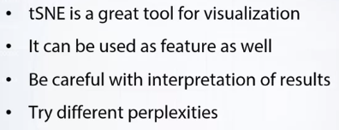

**QUIZ**

# Question 1

## Imagine that we apply X = PCA(n_components=5).fit_transform(data) and data has shape (5000, 53). What is the shape of X?

Correct answers:

* (5000, 5). Yes, it should be (n_samples, n_components).

Incorrect answers:

* (5, 53). No, we cannot transform 5000 samples into 5.
* (5, 5000). No, we cannot transform 5000 samples into 5.
* (53, 5). No, we cannot transform 5000 samples into 53.

# Question 2

## To which data NMF is NOT applicable?

Correct answers:

* Standardized matrix. "Standardized" means that every feature column has zero mean and unit variance. This implies that we have negative values and cannot apply NMF.

Incorrect answers:

* Bag-of-words matrix. Since BoW matrix is non-negative matrix, we *can* apply NMF to it.
* One-Hot encoded feature. Since this matrix contains only 0's and 1's -- it is non-negative and we can apply NMF.

# Question 3

## Suppose we have 2 categorical features: f1 with A possible values and f2 with B possible values. How many values will their interaction have?

Correct answers:

* Less or equal to A * B. True. Sometimes some value (e.g. *a*) from A cannot be used with some value (eg *b*) from B. In this case, we have no change to see *ab* combination. If all value from A can be used with all values from B -- we will get A*B new possible values.

Incorrect answers:

* Exactly A + B. No, it's too small.
* Exactly A * B. Not exactly, sometimes some value (e.g. *a*) from A cannot be used with some value (eg *b*) from B. In this case, we have no change to see *ab* combination.
* max(A, B). No, it's way too small.

# Question 4

## Imagine we have 2 categorical features represented as integers: f1 with all values in range [0, 1000] and f2 with values in range [0, 100]. What is the correct way to build their interaction?

Correct answers:

* f1.astype(str) + "_" + f2.astype(str). Yes, this is the right answer

Incorrect answers:

* f1 + f2. There are some problems. For example, if f1+f2=100: it is an interaction of 0 and 100, 100 and 0, or 90 and 10?
* f1.astype(str) + f2.astype(str). There is some problems. For example, "123": it is an d interaction of "1" and "23" or "12" and "3"?
* (f1 + f2).astype(str). It is essentially the same way as just f1+f2.

# Question 5

## What is a correct way to get t-SNE projection of train and test data?

Correct answers:

* Apply t-SNE to concatenation of train and test and split projection back. This this the rigth way since train and test will projected in the same way.

Incorrect answers:

* Apply t-SNE to the train and after that to the test. This this case we will have 2 different projections.
* Apply t-SNE to the test first and after to train. This this case we will have 2 different projections.
* Doesn't matter, all variants will produce the same result. No, since tSNE results in randomized projection

# Question 6

## Is it possible to do t-SNE projection into 20-dimensional space?

Correct answers:

* Yes, why not. You can do tSNE projection into arbitrary space.

Incorrect answers:

* No, only 2-dim or 3-dim projections are possible. Wrong! Despite tSNE is quite often used for visualization purposes, you don't limit to use only 2- or 3-dimensional projections.

ADDITIONAL LINK

<https://github.com/kartik-nighania/Multicore-TSNE> TSNE WITH PYTORCH ON MULTICORE - VERY FAST

<https://distill.pub/2016/misread-tsne/>

AWESOME BLOG WITH VISUALIZATION ON TSNE - MUST WATCH !!

popular method for exploring high-dimensional data is something called t-SNE, introduced by van der Maaten and Hinton in 2008 [1]. The technique has become widespread in the field of machine learning, since it has an almost magical ability to create compelling two-dimensonal “maps” from data with hundreds or even thousands of dimensions. Although impressive, these images can be tempting to misread. The purpose of this note is to prevent some common misreading. We’ll walk through a series of simple examples to illustrate what t-SNE diagrams can and cannot show. The t-SNE technique really is useful—but only if you know how to interpret it.

Before diving in: if you haven’t encountered t-SNE before, here’s what you need to know about the math behind it. The goal is to take a set of points in a high-dimensional space and find a faithful representation of those points in a lower-dimensional space, typically the 2D plane. The algorithm is non-linear and adapts to the underlying data, performing different transformations on different regions. Those differences can be a major source of confusion.

A second feature of t-SNE is a tuneable parameter, “perplexity,” which says (loosely) how to balance attention between local and global aspects of your data. The parameter is, in a sense, a guess about the number of close neighbors each point has. The perplexity value has a complex effect on the resulting pictures. The original paper says, *“The performance of SNE is fairly robust to changes in the perplexity, and typical values are between 5 and 50.”* But the story is more nuanced than that. Getting the most from t-SNE may mean analyzing multiple plots with different perplexities.

That’s not the end of the complications. The t-SNE algorithm doesn’t always produce similar output on successive runs, for example, and there are additional hyperparameters related to the optimization process.

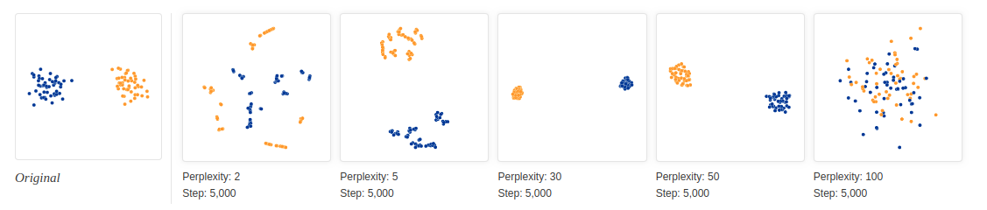

With perplexity values in the range (5 - 50) suggested by van der Maaten & Hinton, the diagrams do show these clusters, although with very different shapes. Outside that range, things get a little weird. With perplexity 2, local variations dominate. The image for perplexity 100, with merged clusters, illustrates a pitfall: for the algorithm to operate properly, the perplexity really should be smaller than the number of points. Implementations can give unexpected behavior otherwise.

Each of the plots above was made with 5,000 iterations with a learning rate (often called “epsilon”) of 10, and had reached a point of stability by step 5,000. How much of a difference do those values make? In our experience, the most important thing is to iterate until reaching a stable configuration.

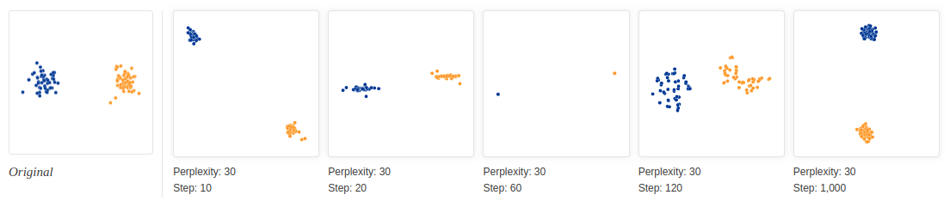

The images above show five different runs at perplexity 30. The first four were stopped before stability. After 10, 20, 60, and 120 steps you can see layouts with seeming 1-dimensional and even pointlike images of the clusters. If you see a t-SNE plot with strange “pinched” shapes, chances are the process was stopped too early. Unfortunately, there’s no fixed number of steps that yields a stable result. Different data sets can require different numbers of iterations to converge.

Another natural question is whether different runs with the same hyperparameters produce the same results. In this simple two-cluster example, and most of the others we discuss, multiple runs give the same global shape. Certain data sets, however, yield markedly different diagrams on different runs;

## 2. Cluster sizes in a t-SNE plot mean nothing

So far, so good. But what if the two clusters have different standard deviations, and so different sizes? (By size we mean bounding box measurements, not number of points.) Below are t-SNE plots for a mixture of Gaussians in plane, where one is 10 times as dispersed as the other.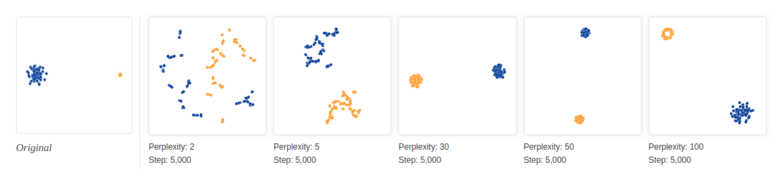

Surprisingly, the two clusters look about same size in the t-SNE plots. What’s going on? The t-SNE algorithm adapts its notion of “distance” to regional density variations in the data set. As a result, it naturally expands dense clusters, and contracts sparse ones, evening out cluster sizes. To be clear, this is a different effect than the run-of-the-mill fact that any dimensionality reduction technique will distort distances. (After all, in this example all data was two-dimensional to begin with.) Rather, density equalization happens by design and is a predictable feature of t-SNE.

The bottom line, however, is that you cannot see relative sizes of clusters in a t-SNE plot.

## 3. Distances between clusters might not mean anything

What about distances *between* clusters? The next diagrams show three Gaussians of 50 points each, one pair being 5 times as far apart as another pair.

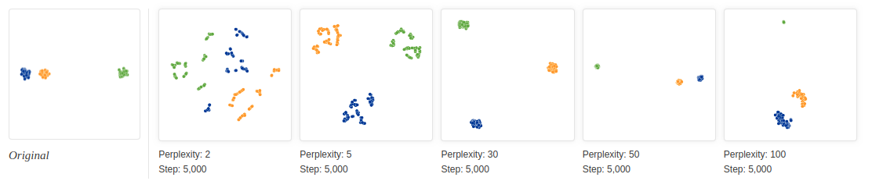

At perplexity 50, the diagram gives a good sense of the global geometry. For lower perplexity values the clusters look equidistant. When the perplexity is 100, we see the global geometry fine, but one of the cluster appears, falsely, much smaller than the others. Since perplexity 50 gave us a good picture in this example, can we always set perplexity to 50 if we want to see global geometry?

Sadly, no. If we add more points to each cluster, the perplexity has to increase to compensate. Here are the t-SNE diagrams for three Gaussian clusters with 200 points each, instead of 50. Now none of the trial perplexity values gives a good result.

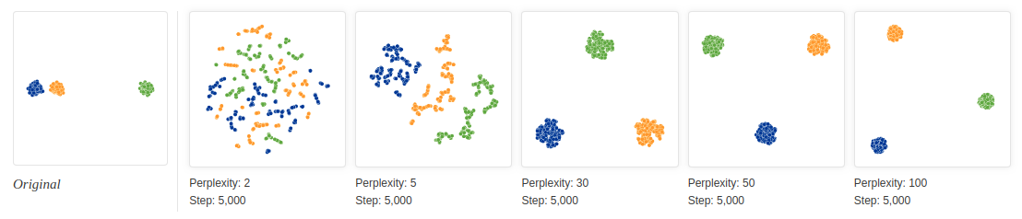

It’s bad news that seeing global geometry requires fine-tuning perplexity. Real-world data would probably have multiple clusters with different numbers of elements. There may not be one perplexity value that will capture distances across all clusters—and sadly perplexity is a global parameter. Fixing this problem might be an interesting area for future research.

The basic message is that distances between well-separated clusters in a t-SNE plot may mean nothing.

## 4. Random noise doesn’t always look random.

A classic pitfall is thinking you see patterns in what is really just random data. Recognizing noise when you see it is a critical skill, but it takes time to build up the right intuitions. A tricky thing about t-SNE is that it throws a lot of existing intuition out the window. The next diagrams show genuinely random data, 500 points drawn from a unit Gaussian distribution in 100 dimensions. The left image is a projection onto the first two coordinates.

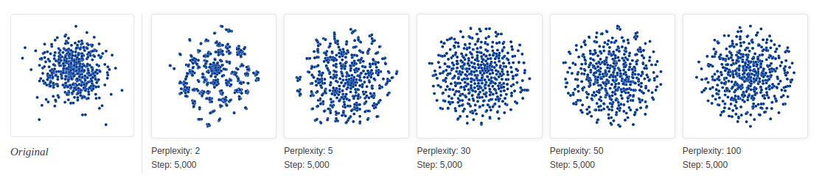

The plot with perplexity 2 seems to show dramatic clusters. If you were tuning perplexity to bring out structure in the data, you might think you’d hit the jackpot.

Of course, since we know the cloud of points was generated randomly, it has no statistically interesting clusters: those “clumps” aren’t meaningful. If you look back at previous examples, low perplexity values often lead to this kind of distribution. Recognizing these clumps as random noise is an important part of reading t-SNE plots.

There’s something else interesting, though, which may be a win for t-SNE. At first the perplexity 30 plot doesn’t look like a Gaussian distribution at all: there’s only a slight density difference across different regions of the cloud, and the points seem suspiciously evenly distributed. In fact, these features are saying useful things about high-dimensional normal distributions, which are very close to uniform distributions on a sphere: evenly distributed, with roughly equal spaces between points. Seen in this light, the t-SNE plot is more accurate than any linear projection could be.

## 5. You can see some shapes, sometimes

It’s rare for data to be distributed in a perfectly symmetric way. Let’s take a look at an axis-aligned Gaussian distribution in 50 dimensions, where the standard deviation in coordinate i is 1/i. That is, we’re looking at a long-ish ellipsoidal cloud of points.

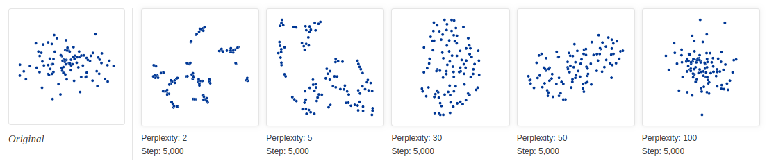

For high enough perplexity values, the elongated shapes are easy to read. On the other hand, at low perplexity, local effects and meaningless “clumping” take center stage. More extreme shapes also come through, but again only at the right perplexity. For example, here are two clusters of 75 points each in 2D, arranged in parallel lines with a bit of noise.

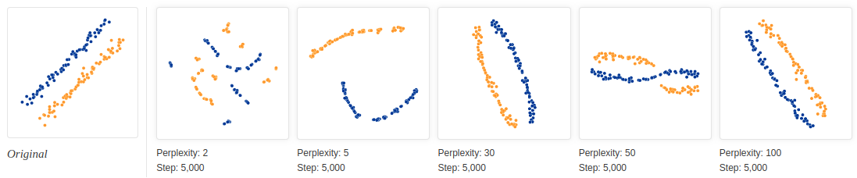

For a certain range of perplexity the long clusters look close to correct, which is reassuring.

Even in the best cases, though, there’s a subtle distortion: the lines are slightly curved outwards in the t-SNE diagram. The reason is that, as usual, t-SNE tends to expand denser regions of data. Since the middles of the clusters have less empty space around them (as in Gaussian dist. More points int the middle than at the end of the bell curve) than the ends, the algorithm magnifies them.

## 6. For topology, you may need more than one plot

Sometimes you can read topological information off a t-SNE plot, but that typically requires views at multiple perplexities. One of the simplest topological properties is containment. The plots below show two groups of 75 points in 50 dimensional space. Both are sampled from symmetric Gaussian distributions centered at the origin, but one is 50 times more tightly dispersed than the other. The “small” distribution is in effect contained in the large one.

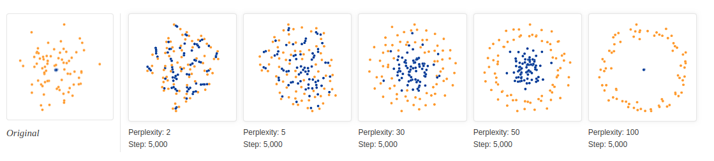

The perplexity 30 view shows the basic topology correctly, but again t-SNE greatly exaggerates the size of the smaller group of points. At perplexity 50, there’s a new phenomenon: the outer group becomes a circle, as the plot tries to depict the fact that all its points are about the same distance from the inner group. If you looked at this image alone, it would be easy to misread these outer points as a one-dimensional structure.

## Conclusion

There’s a reason that t-SNE has become so popular: it’s incredibly flexible, and can often find structure where other dimensionality-reduction algorithms cannot. Unfortunately, that very flexibility makes it tricky to interpret. Out of sight from the user, the algorithm makes all sorts of adjustments that tidy up its visualizations. Don’t let the hidden “magic” scare you away from the whole technique, though. The good news is that by studying how t-SNE behaves in simple cases, it’s possible to develop an intuition for what’s going on.

______________________________________________

<https://scikit-learn.org/stable/auto_examples/ensemble/plot_feature_transformation.html>

# **Feature transformations with ensembles of trees**

Transform your features into a higher dimensional, sparse space. Then train a linear model on these features.

First fit an ensemble of trees (totally random trees, a random forest, or gradient boosted trees) on the training set. Then each leaf of each tree in the ensemble is assigned a fixed arbitrary feature index in a new feature space. These leaf indices are then encoded in a one-hot fashion.

Each sample goes through the decisions of each tree of the ensemble and ends up in one leaf per tree. The sample is encoded by setting feature values for these leaves to 1 and the other feature values to 0.

The resulting transformer has then learned a supervised, sparse, high-dimensional categorical embedding of the data.

Exactly what we have learned in the video of using leaf nodes of tree to create new features is done over here.

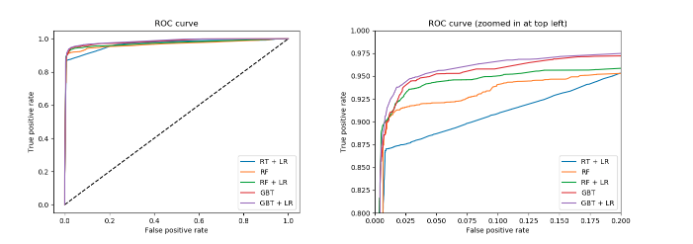

*# Author: Tim Head <betatim@gmail.com>*

*#*

*# License: BSD 3 clause*

**import** **numpy** **as** **np**

np.random.seed(10)

**import** **matplotlib.pyplot** **as** **plt**

**from** **sklearn.datasets** **import** [make_classification](https://scikit-learn.org/stable/modules/generated/sklearn.datasets.make_classification.html#sklearn.datasets.make_classification)

**from** **sklearn.linear_model** **import** [LogisticRegression](https://scikit-learn.org/stable/modules/generated/sklearn.linear_model.LogisticRegression.html#sklearn.linear_model.LogisticRegression)

**from** **sklearn.ensemble** **import** ([RandomTreesEmbedding](https://scikit-learn.org/stable/modules/generated/sklearn.ensemble.RandomTreesEmbedding.html#sklearn.ensemble.RandomTreesEmbedding), [RandomForestClassifier](https://scikit-learn.org/stable/modules/generated/sklearn.ensemble.RandomForestClassifier.html#sklearn.ensemble.RandomForestClassifier),

[GradientBoostingClassifier](https://scikit-learn.org/stable/modules/generated/sklearn.ensemble.GradientBoostingClassifier.html#sklearn.ensemble.GradientBoostingClassifier))

**from** **sklearn.preprocessing** **import** [OneHotEncoder](https://scikit-learn.org/stable/modules/generated/sklearn.preprocessing.OneHotEncoder.html#sklearn.preprocessing.OneHotEncoder)

**from** **sklearn.model_selection** **import** [train_test_split](https://scikit-learn.org/stable/modules/generated/sklearn.model_selection.train_test_split.html#sklearn.model_selection.train_test_split)

**from** **sklearn.metrics** **import** [roc_curve](https://scikit-learn.org/stable/modules/generated/sklearn.metrics.roc_curve.html#sklearn.metrics.roc_curve)

**from** **sklearn.pipeline** **import** [make_pipeline](https://scikit-learn.org/stable/modules/generated/sklearn.pipeline.make_pipeline.html#sklearn.pipeline.make_pipeline)

n_estimator = 10

X, y = [make_classification](https://scikit-learn.org/stable/modules/generated/sklearn.datasets.make_classification.html#sklearn.datasets.make_classification)(n_samples=80000)

X_train, X_test, y_train, y_test = [train_test_split](https://scikit-learn.org/stable/modules/generated/sklearn.model_selection.train_test_split.html#sklearn.model_selection.train_test_split)(X, y, test_size=0.5)

*# It is important to train the ensemble of trees on a different subset*

*# of the training data than the linear regression model to avoid*

*# overfitting, in particular if the total number of leaves is*

*# similar to the number of training samples*

X_train, X_train_lr, y_train, y_train_lr = [train_test_split](https://scikit-learn.org/stable/modules/generated/sklearn.model_selection.train_test_split.html#sklearn.model_selection.train_test_split)(

X_train, y_train, test_size=0.5)

*# Unsupervised transformation based on totally random trees*

rt = [RandomTreesEmbedding](https://scikit-learn.org/stable/modules/generated/sklearn.ensemble.RandomTreesEmbedding.html#sklearn.ensemble.RandomTreesEmbedding)(max_depth=3, n_estimators=n_estimator,

random_state=0)

rt_lm = [LogisticRegression](https://scikit-learn.org/stable/modules/generated/sklearn.linear_model.LogisticRegression.html#sklearn.linear_model.LogisticRegression)(solver='lbfgs', max_iter=1000)

pipeline = [make_pipeline](https://scikit-learn.org/stable/modules/generated/sklearn.pipeline.make_pipeline.html#sklearn.pipeline.make_pipeline)(rt, rt_lm)

pipeline.fit(X_train, y_train)

y_pred_rt = pipeline.predict_proba(X_test)[:, 1]

fpr_rt_lm, tpr_rt_lm, _ = [roc_curve](https://scikit-learn.org/stable/modules/generated/sklearn.metrics.roc_curve.html#sklearn.metrics.roc_curve)(y_test, y_pred_rt)

*# Supervised transformation based on random forests*

rf = [RandomForestClassifier](https://scikit-learn.org/stable/modules/generated/sklearn.ensemble.RandomForestClassifier.html#sklearn.ensemble.RandomForestClassifier)(max_depth=3, n_estimators=n_estimator)

rf_enc = [OneHotEncoder](https://scikit-learn.org/stable/modules/generated/sklearn.preprocessing.OneHotEncoder.html#sklearn.preprocessing.OneHotEncoder)(categories='auto')

rf_lm = [LogisticRegression](https://scikit-learn.org/stable/modules/generated/sklearn.linear_model.LogisticRegression.html#sklearn.linear_model.LogisticRegression)(solver='lbfgs', max_iter=1000)

rf.fit(X_train, y_train)

rf_enc.fit(rf.apply(X_train))

rf_lm.fit(rf_enc.transform(rf.apply(X_train_lr)), y_train_lr)

y_pred_rf_lm = rf_lm.predict_proba(rf_enc.transform(rf.apply(X_test)))[:, 1]

fpr_rf_lm, tpr_rf_lm, _ = [roc_curve](https://scikit-learn.org/stable/modules/generated/sklearn.metrics.roc_curve.html#sklearn.metrics.roc_curve)(y_test, y_pred_rf_lm)

*# Supervised transformation based on gradient boosted trees*

grd = [GradientBoostingClassifier](https://scikit-learn.org/stable/modules/generated/sklearn.ensemble.GradientBoostingClassifier.html#sklearn.ensemble.GradientBoostingClassifier)(n_estimators=n_estimator)

grd_enc = [OneHotEncoder](https://scikit-learn.org/stable/modules/generated/sklearn.preprocessing.OneHotEncoder.html#sklearn.preprocessing.OneHotEncoder)(categories='auto')

grd_lm = [LogisticRegression](https://scikit-learn.org/stable/modules/generated/sklearn.linear_model.LogisticRegression.html#sklearn.linear_model.LogisticRegression)(solver='lbfgs', max_iter=1000)

grd.fit(X_train, y_train)

grd_enc.fit(grd.apply(X_train)[:, :, 0])

grd_lm.fit(grd_enc.transform(grd.apply(X_train_lr)[:, :, 0]), y_train_lr)

y_pred_grd_lm = grd_lm.predict_proba(

grd_enc.transform(grd.apply(X_test)[:, :, 0]))[:, 1]

fpr_grd_lm, tpr_grd_lm, _ = [roc_curve](https://scikit-learn.org/stable/modules/generated/sklearn.metrics.roc_curve.html#sklearn.metrics.roc_curve)(y_test, y_pred_grd_lm)

*# The gradient boosted model by itself*

y_pred_grd = grd.predict_proba(X_test)[:, 1]

fpr_grd, tpr_grd, _ = [roc_curve](https://scikit-learn.org/stable/modules/generated/sklearn.metrics.roc_curve.html#sklearn.metrics.roc_curve)(y_test, y_pred_grd)

*# The random forest model by itself*

y_pred_rf = rf.predict_proba(X_test)[:, 1]

fpr_rf, tpr_rf, _ = [roc_curve](https://scikit-learn.org/stable/modules/generated/sklearn.metrics.roc_curve.html#sklearn.metrics.roc_curve)(y_test, y_pred_rf)

[plt.figure](https://matplotlib.org/api/_as_gen/matplotlib.pyplot.figure.html#matplotlib.pyplot.figure)(1)

[plt.plot](https://matplotlib.org/api/_as_gen/matplotlib.pyplot.plot.html#matplotlib.pyplot.plot)([0, 1], [0, 1], 'k--')

[plt.plot](https://matplotlib.org/api/_as_gen/matplotlib.pyplot.plot.html#matplotlib.pyplot.plot)(fpr_rt_lm, tpr_rt_lm, label='RT + LR')

[plt.plot](https://matplotlib.org/api/_as_gen/matplotlib.pyplot.plot.html#matplotlib.pyplot.plot)(fpr_rf, tpr_rf, label='RF')

[plt.plot](https://matplotlib.org/api/_as_gen/matplotlib.pyplot.plot.html#matplotlib.pyplot.plot)(fpr_rf_lm, tpr_rf_lm, label='RF + LR')

[plt.plot](https://matplotlib.org/api/_as_gen/matplotlib.pyplot.plot.html#matplotlib.pyplot.plot)(fpr_grd, tpr_grd, label='GBT')

[plt.plot](https://matplotlib.org/api/_as_gen/matplotlib.pyplot.plot.html#matplotlib.pyplot.plot)(fpr_grd_lm, tpr_grd_lm, label='GBT + LR')

[plt.xlabel](https://matplotlib.org/api/_as_gen/matplotlib.pyplot.xlabel.html#matplotlib.pyplot.xlabel)('False positive rate')

[plt.ylabel](https://matplotlib.org/api/_as_gen/matplotlib.pyplot.ylabel.html#matplotlib.pyplot.ylabel)('True positive rate')

[plt.title](https://matplotlib.org/api/_as_gen/matplotlib.pyplot.title.html#matplotlib.pyplot.title)('ROC curve')

[plt.legend](https://matplotlib.org/api/_as_gen/matplotlib.pyplot.legend.html#matplotlib.pyplot.legend)(loc='best')

[plt.show](https://matplotlib.org/api/_as_gen/matplotlib.pyplot.show.html#matplotlib.pyplot.show)()

[plt.figure](https://matplotlib.org/api/_as_gen/matplotlib.pyplot.figure.html#matplotlib.pyplot.figure)(2)

[plt.xlim](https://matplotlib.org/api/_as_gen/matplotlib.pyplot.xlim.html#matplotlib.pyplot.xlim)(0, 0.2)

[plt.ylim](https://matplotlib.org/api/_as_gen/matplotlib.pyplot.ylim.html#matplotlib.pyplot.ylim)(0.8, 1)

[plt.plot](https://matplotlib.org/api/_as_gen/matplotlib.pyplot.plot.html#matplotlib.pyplot.plot)([0, 1], [0, 1], 'k--')

[plt.plot](https://matplotlib.org/api/_as_gen/matplotlib.pyplot.plot.html#matplotlib.pyplot.plot)(fpr_rt_lm, tpr_rt_lm, label='RT + LR')

[plt.plot](https://matplotlib.org/api/_as_gen/matplotlib.pyplot.plot.html#matplotlib.pyplot.plot)(fpr_rf, tpr_rf, label='RF')

[plt.plot](https://matplotlib.org/api/_as_gen/matplotlib.pyplot.plot.html#matplotlib.pyplot.plot)(fpr_rf_lm, tpr_rf_lm, label='RF + LR')

[plt.plot](https://matplotlib.org/api/_as_gen/matplotlib.pyplot.plot.html#matplotlib.pyplot.plot)(fpr_grd, tpr_grd, label='GBT')

[plt.plot](https://matplotlib.org/api/_as_gen/matplotlib.pyplot.plot.html#matplotlib.pyplot.plot)(fpr_grd_lm, tpr_grd_lm, label='GBT + LR')

[plt.xlabel](https://matplotlib.org/api/_as_gen/matplotlib.pyplot.xlabel.html#matplotlib.pyplot.xlabel)('False positive rate')

[plt.ylabel](https://matplotlib.org/api/_as_gen/matplotlib.pyplot.ylabel.html#matplotlib.pyplot.ylabel)('True positive rate')

[plt.title](https://matplotlib.org/api/_as_gen/matplotlib.pyplot.title.html#matplotlib.pyplot.title)('ROC curve (zoomed in at top left)')

[plt.legend](https://matplotlib.org/api/_as_gen/matplotlib.pyplot.legend.html#matplotlib.pyplot.legend)(loc='best')

[plt.show](https://matplotlib.org/api/_as_gen/matplotlib.pyplot.show.html#matplotlib.pyplot.show)()

__________________________________________________________

CODE FOR KNN NOTEBOOK

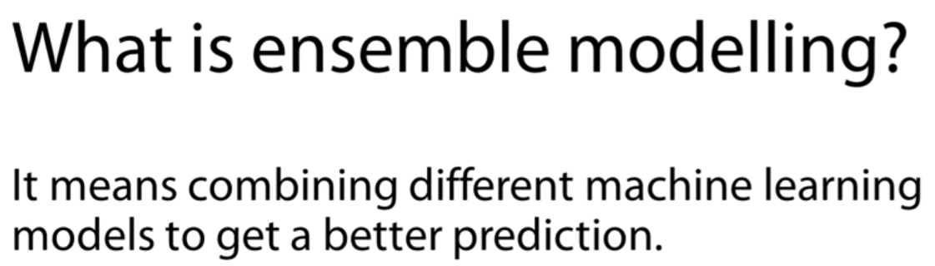

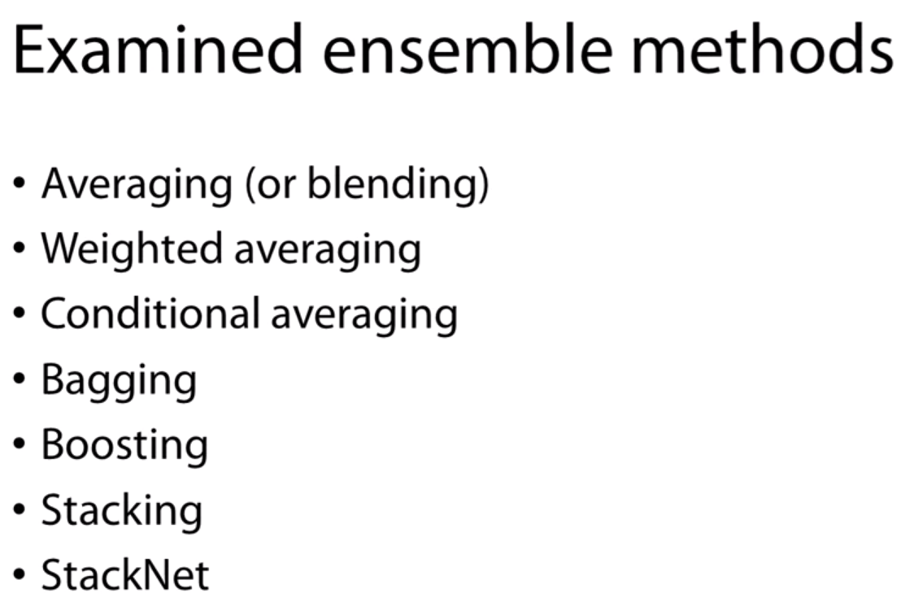

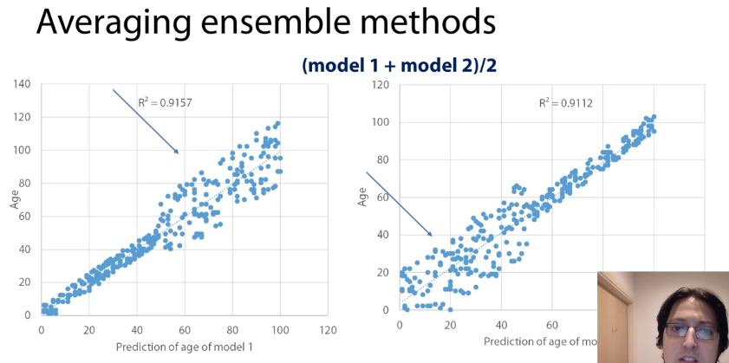

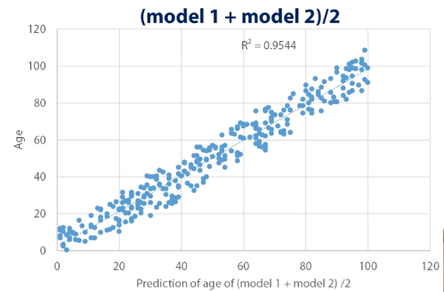

So we have two models that have a similar predictive power, but they look quite different. It's quite obvious that they do better in different parts of the distribution of age. So what will happen if we were to try to combine this two with a simple averaging method, in other words, just say (model 1 + model two) / 2, so a simple averaging method. The end result will look as in the new graph. So, our square has moved to 0.95, which is a considerable improvement versus the 0.91 we had before, and as you can see, on average, the points tend to be closer with the reality. So the average error is smaller. However, as you can see, the model doesn't do better as an individual models for the areas where the models were doing really well, nevertheless, it does better on average.

In weighted avg. we take lets say 0.7 of one model value and 0.3 of other models prediction value and sum it up.

Conditional avg takes like if the parameter x is greator than 40 lets say. Then predict using model 2 else predict using model 1.

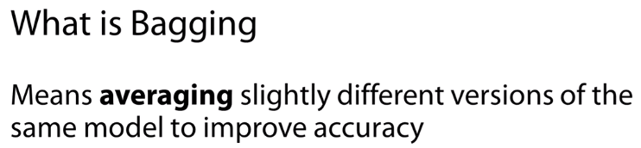

bagging refers to averaging slightly different versions of the same model as a means to improve the predictive power. A common and quite successful application of bagging is the Random Forest.Where you would run many different versions of decision trees in order to get a better prediction.

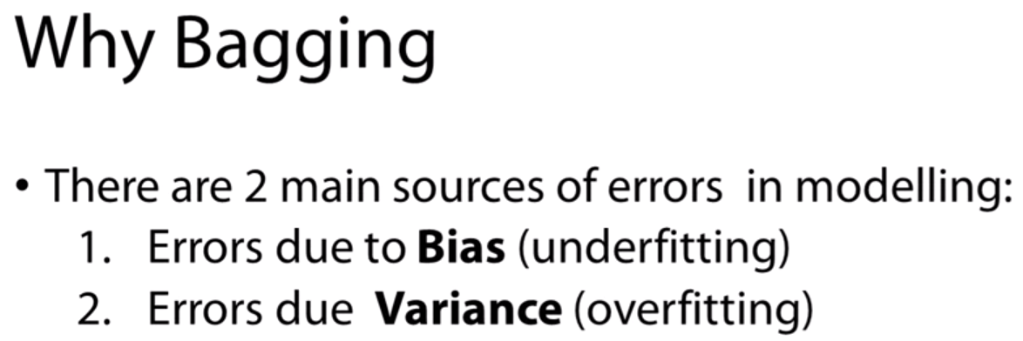

These 2 errors are not in bagging but what bagging solves in general.

If we were to visualize the relationship between prediction error and model complexity, it would look like that. When we begin the training of the model, we can see that the training error make the error in that training data gets reduced and the same happens in the test data because the predictions are easily generalizable. They are simple. However, after a point, any improvements in the training error are not realized into test data. This is the point where the model starts over exhausting information, creates predictions that are not generalizable. This is where bagging actually comes into play and offers it's utmost value. By making slightly different or let say randomized models, we ensure that the predictions do not read very high variance. They're generally more generalizable. We don't over exhaust the information in the training data. At the same time, we saw before that when you average slightly different models, we are generally able to get better predictions and we can assume that in 10 models, we are still able to find quite significant information about the training data. Therefore, this is why bagging tends to work quite well and personally, I always use bagging. When I say, "I fit a model," I have actually not fit a model I have fit a bagging version of this model so probably that different models.

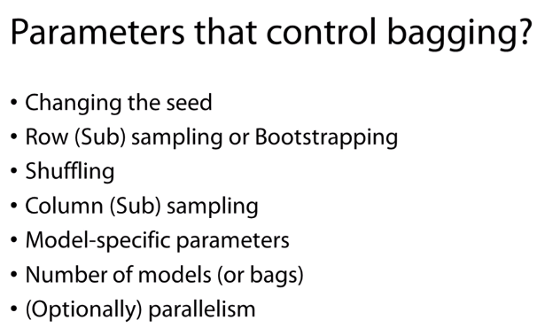

Which parameters are associated with bagging? The first is the seed. We can understand that many algorithms have some randomized procedures so by changing the seed you ensure that they are made slightly differently. At the same time, you can run a model with less rows or you could use bootstrapping.Bootstrapping is different from row sub-sampling in the sense that you create an artificial dataset so you might let's say data row the training data three or four times. You create a random dataset from the training data. A different form of randomness can be imputed with shuffling. There are some algorithms, which are sensitive to the order of the data. By changing the order you ensure that the models become quite different. Another way is to dating a random sample of columns so bid models on different features or different variables of the data. Then you have model-specific parameters. For example, in a linear model, you will try to build 10 different let's say logistic regression with slightly different regularization parameters. Obviously, you could also control the number of models you include in your ensemble or in this case we call them bags. Normally, we put a value more than 10 here but, in principle, the more bags you put, it doesn't hurt you. It makes results better but after some point, performance start plateauing. So there is a cost benefit with time but, in principle, more bags is generally better and optionally, you can also apply parallelism. Bagging models are independent to each other, which means you can build many of them at the same time and make full use of your computation power

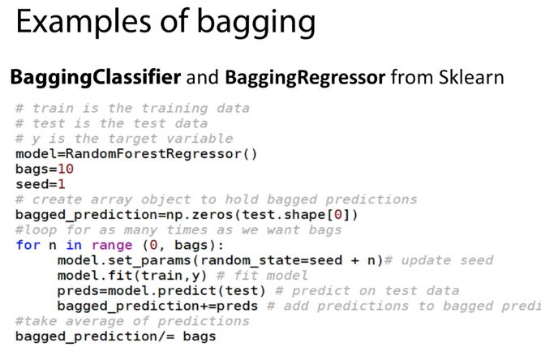

ust to let you know that a bagging estimators that scikit-learn has in Python are actually quite cool. Therefore, I recommend them. This is a typical 15 lines of code that I use quite often. They seem really simple but they're actually quite efficient.Assuming you have a training at the test dataset and to target variable, what you do is you specify some bagging parameters. What is the model I'm going to use at random forest? How many bags I'm going to run? 10. What will be my seed? One. Then you create an object, an empty object that will save the predictions and then you run a loop for as many bags as you have specified. In this loop, you repeat the same. You change the seed, you feed the model, you make predictions in the test data and you save these predictions and then, you just take an average of these predictions.

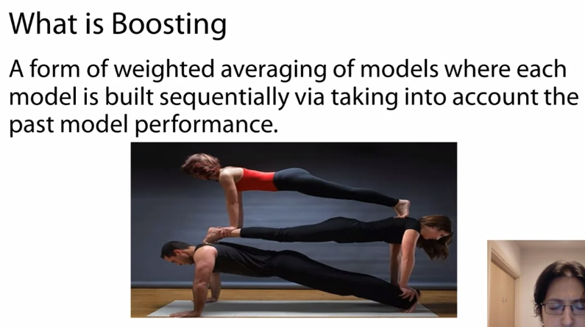

Like gradient boosting decision trees (GBDT). Each tree added decreases the gradient error of the whole system. And so on and so forth.

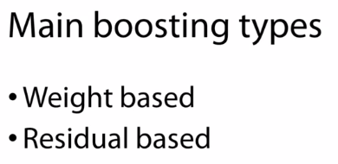

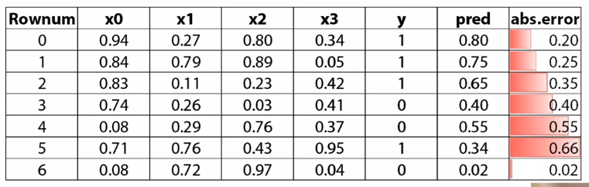

Let's call them x0, x1, x2, and x3, and we want to use these features to predict a target variable, y. What we are going to do in weight boosting is, we are going to fit a model, and we will generate predictions. Let's call them pred.These predictions have a certain margin of error. We can calculate these absolute error, and when I say absolute error, is absolute of y minus our prediction. You can see there are predictions which are very, very far off, like row number five, but there are others like number six, which the model has actually done quite well. 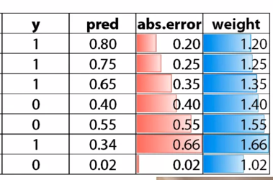

So what we do based on this is we generate, let's say, a new column or a new vector, where we create a weight column, and we say that this weight is 1 plus the absolute error. There are different ways to calculate this weight. Now, I'm just giving you this as an example. You can infer that there are different ways to do this, but the overall principle is very similar. So what you're going to do next is, you're going to fit a new model using the same features and the same target variable, but you're going to also add this weight. What weight says to the model is, I want you to put more significance into a certain role. You can almost interpret weight has the number of times that a certain row appears in my data. So let's say weight was 2, this means that this row appears twice, and therefore, has bigger contribution to the total error. You can keep repeating this process. You can, again, calculate a new error based on this error. You calculate new weights, and this is how you sequentially add models to the ensemble that take into account how well each model has done in certain cases, maximizing the focus from where the previous models have done more wrong.

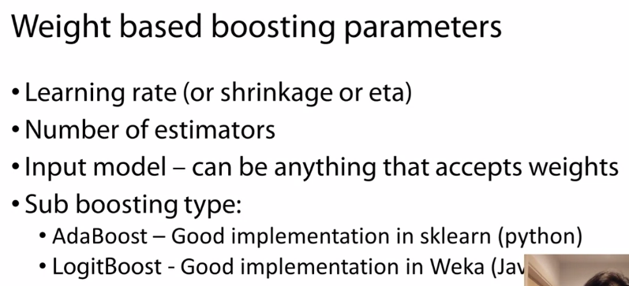

There are certain parameters associated with this type of boosting. One is the learning rate. We can also call it shrinkage or eta. It has different names. Now, if you recall, I explained boosting as a form of weighted averaging. And this is true, because normally what this learning rate. So what we say is, every new model we built, we shouldn't trust it 100%. We should trust it a little bit. This ensures that we don't have one model generally having too much contribution, and completely making something that is not very generalizable. So this ensures that we don't over-trust one model, we trust many models a little bit. It is very good to control over fitting. The second parameter we look at is the number of estimators. This is quite important. And normally, there is an inverse relationship, an opposite relationship, with the learning rate. So the more estimators we add to these type of ensemble, the smaller learning rate we need to put. This is sometimes quite difficult to find the right values, and we do it with the help of cross-validation. So normally, we start with a fixed number of estimators, let's say, 100, and then, we try to find the optimal learning rate for this 100 estimators. Let's say, based on cross-validation performance, we find this to be 0.1. What we can do then is, let's say, we can double the number of estimators, make it 200, and divide the learning rate by 2, so we can put 0.05, and then we take performance. It may be that the relationship is not as linear as I explained, and the best learning rate may be 0.04 or 0.06 after duplicating the estimators, but this is roughly the logic. This is how we work in order to increase estimators, and try to see more estimators give us better performance without losing so much time, every time, trying to find the best learning rate.Another thing we look at is the type of input model. And generally, we can perform boosting with any type of estimator. The only condition is that it needs to accept weight in it's modeling process.So I weigh to say how much we should rely in each role of our data set. And then, we have various boosting types. As I said, I roughly explained to you how we can use the weight as a means to focus on different rows, different cases the model has done wrong, but there are different ways to express this. For example, there are certain boosting algorithm that do not care about the margin of error, they only care if you did the classification correct or not. So there are different variations.One I really like is the AdaBoost, and there is a very good implementation in sklearn, where you can choose any input algorithm. I think it's really good. And another one I really like is, normally,it's only good for logistic regression, and there is a very good implementation in Weka for Java if you want to try. Now, let's move onto the other type of boosting, which has been the most successful.



I believe that in any predictive modeling competition that was not image classification or predicting videos. This has been the most dominant type of algorithm that actually has one most in these challenges so this type of boosting has been extremely successful, but what is it? 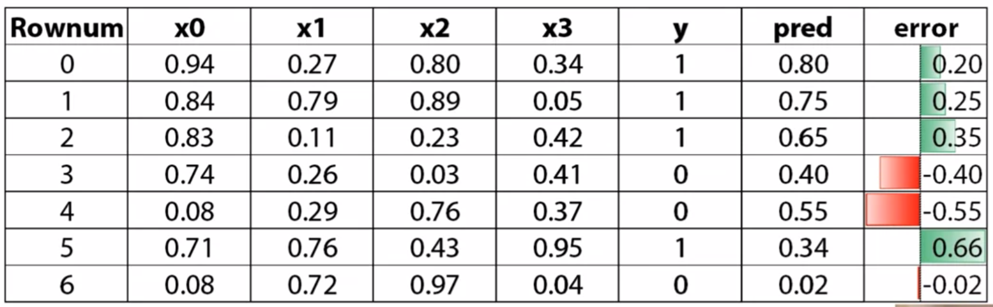I'll try to give you again a similar example in order to understand the concept. Let's say we have again the same dataset, same features, again when trying to predict a y variable, we fit a model, we make predictions. What we do next, is we'll calculate the error of these predictions but this time,not in absolute terms because we're interested about the direction of the error. 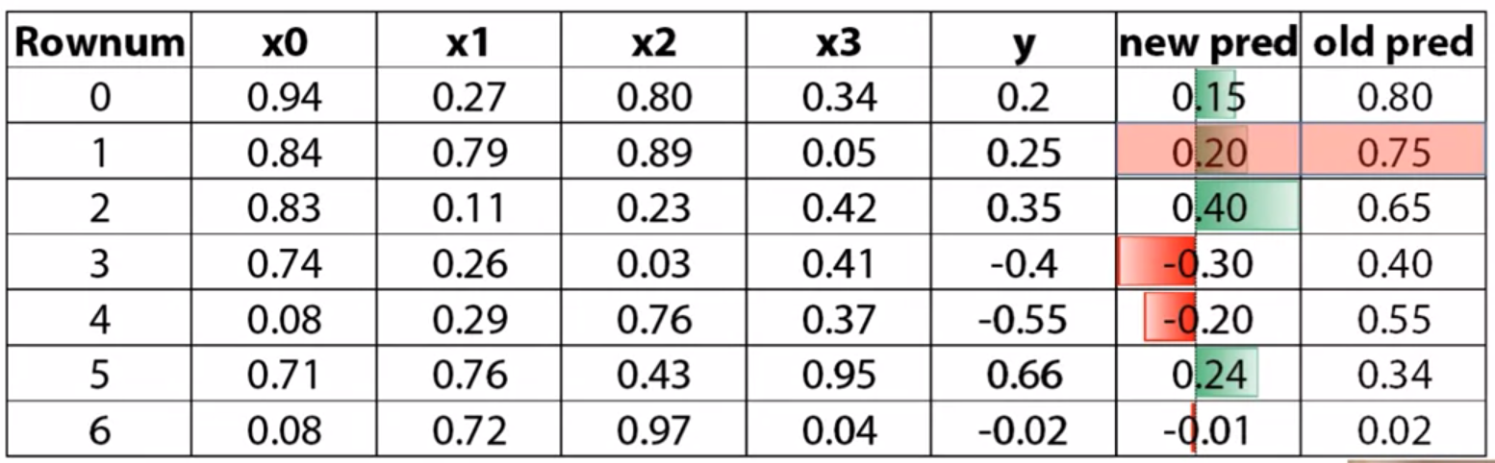

What we do next is we take this error and we make it adding new y variable so the error now becomes the new target variable and we use the same features in order to predict this error. It's an interesting concept and if we wanted, let's say to make predictions for Rownum equals one, what we would do is we will take our initial prediction and then we'll add the new prediction, which is based on the error of the first prediction. So initially, we have 0.75 and then we predicted 0.2. In order to make a final prediction, we would say one plus the other equals 0.95. If you recall, the target for this row, it was one. Using two models, we were able to get closer to the actual answer. This form of boosting works really, really well to minimize the error.

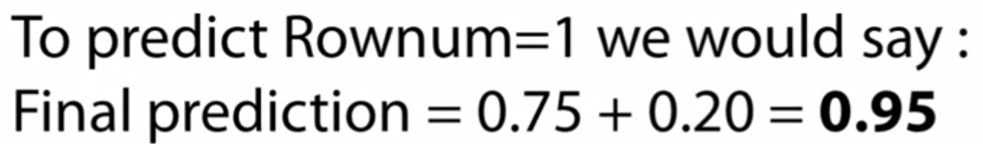

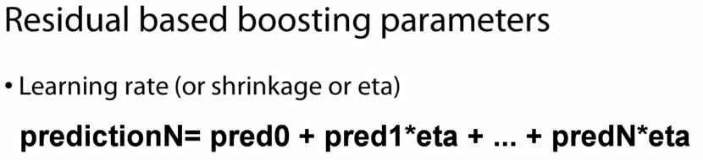



There are certain parameters again which are associated with this type of boosting. The first is again the learning rate and it works pretty much as I explained it before. What you need to take into account is how this is applied.Let's say we have a learning rate of 0.1. In the previous example, where the prediction was 0.2 for the second model, what you will say is I want to move my prediction towards that direction only 10 percent. If you remember the prediction was 0.2, 10 percent of this is 0.02. This is how much we would move towards the prediction of the error. This is a good way to control over fitting.Again, we ensure we don't over rely in one model.

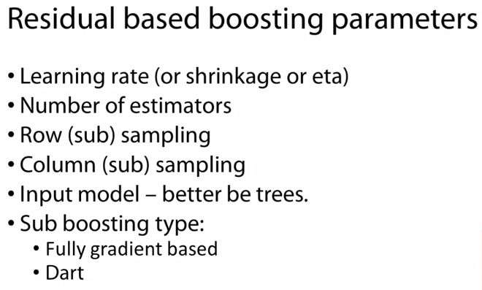

Again, how many estimators you put is quite important. Normally, more is better but you need to offset this with the right learning rate. You need to make certain that every model has the right contribution. If you intent to put many, then you need to make sure that your models have very, very small contribution. Again, you decide these parameters based on cross-validation and the logic is very similar as explained before.Other things that work really well is taking a subset of rows or a subset of columns when you build its model. Actually, there is no reason why we wouldn't use this with the previous algorithm. The way its based, it is more common with this type of boosting, and internally works quite well. For input model, I have seen that this method works really well with this increase but theoretically,you can put anything you want. Again, there are various boosting types. I think the two most common or more successful right now in a predictive modeling context is the gradient based,which is actually what I explained with you how the prediction and you don't move 100 percent with that direction if you apply the learning rate. The other very interesting one, which I've actually find it very efficient especially in classification problems is the dart. Dart, it imposes a drop out mechanism in order to control the contribution of the trees. This is a concept derived from deep learning where you say, "Every time I make a new prediction in my sample, every time I add a new estimate or I'm not relying on all previous estimators but only on a subset of them." Just to give you an example, let's say we have a drop out rate of 20 percent. So far, we have built 10 trees, we want to or 10 models and then we try to see, we try to build a new, an 11th one. What we'll do is we will randomly exclude two trees when we generate a prediction for that 11th tree or that 11th model. By randomly excluding some models, by introducing this kind of randomness, it works as a form of regularization. Therefore, it helps a lot to make a model that generalizes quite well enough for same data. This concept tends to work quite well because this type of boosting algorithm has been so successful.

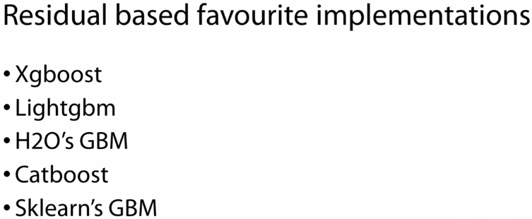

There have been many implementations to try to improve on different parts of these algorithms. One really successful application especially in the comparative predictive modeling world is the Xgboost. It is very scalable and it supports many loss functions. At the same time, is available in all major programming languages for data science. Another good implementation is Lightgbm. As the name connotes, it is lightning fast. Also, it is supported by many programming languages and supports many loss functions. Another interesting case is the Gradient Boosting Machine from H2O. What's really interesting about this implementation is that it can handle categorical variables out of the box and it also comes with a real set of parameters where you can control the modeling process quite thoroughly. Another interesting case, which is also fairly new is the Catboost. What's really good about this is that it comes with the strong initial set of parameters. Therefore, you don't need to spend so much time tuning. As I mentioned before, this can be quite a time consuming process. It can also handle categorical variables out of the box. Ultimately, I really like the Gradient Boosting Machine implementation of Scikit-learn.What I really like about this is that you can put any scikit-learn estimator as a base.

**STACKING**

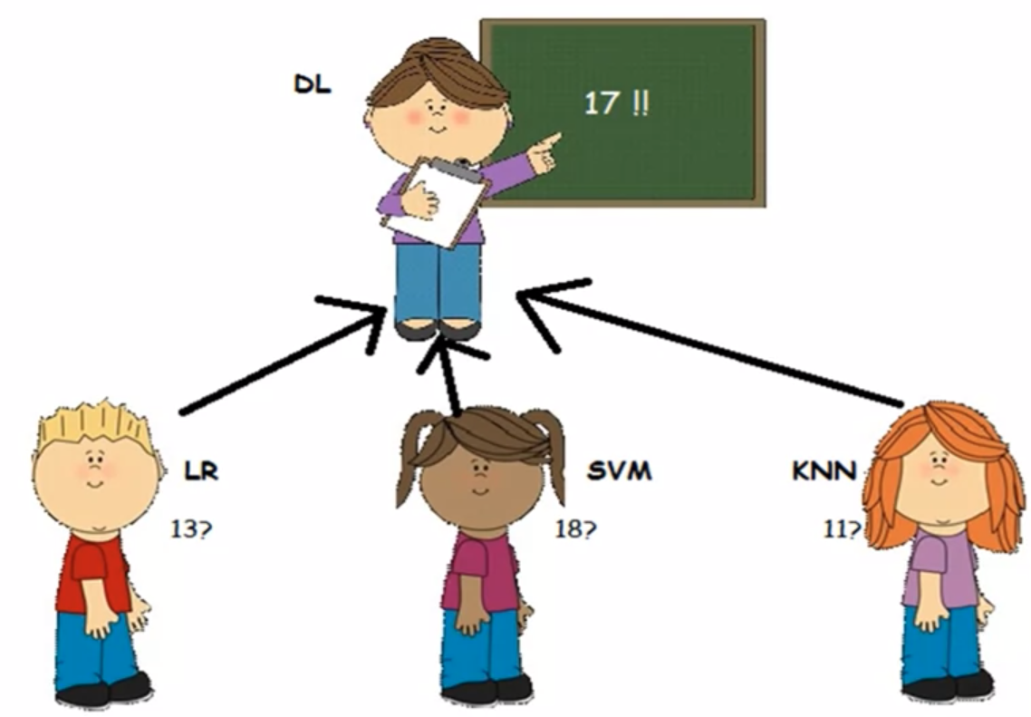

So let's see how these could work in a real life scenario. Let's assume we have three kids, let's name them LR, SVM, KNN, and they argue about a physics question. So each one believes the answer to a physics question is different. First one says 13, second 18, third 11, they don't know how to solve this disagreement. They do the honorable thing, they say let's take an average, which in this case is 14.So you can almost see the kids, there's different models here, they take input data. In this case, it's the question about physics. They process it based on historical information and and they are able to output an estimate, a prediction. Have they done it optimally, though?

Another way to say this is to say there was a teacher, Miss DL, who had seen this discussion, and she decided to step up. While she didn't hear the question, she does know the students quite well,she knows the strength and weaknesses of each one. She knows how well they have done historically in physics questions. And from the range of values they have provided, she is able to give an estimate. Let's say that in this concept, she knows that SVM is really good in physics, and her father works in the department of Physics of Excellence. And therefore she should have a bigger contribution to this ensemble than every other kid, therefore the answer is 17. And this is how a meta model works, it doesn't need to know the input data. It just knows how the models have done historically, in order to find the best way to combine them. And this can work quite well in practice.

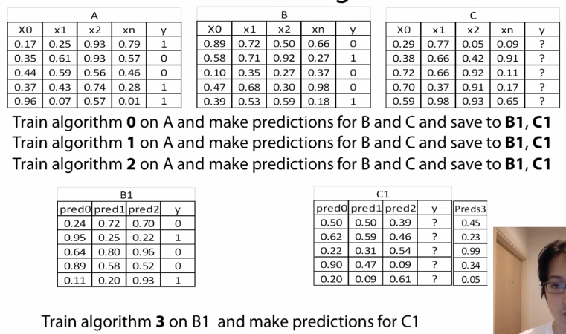

In this case, A will serve the role of the training data set, B will be the validation data set, and C will be the test data sets where we want to make the final predictions. They all have similar architectural, four features, and one target variable we try to predict. So in this case, we can choose an algorithm to train a model based on data set 1, and then we make predictions for B and C at the same time. Now we take these predictions, and we put them into a new data set. So we create a data set to store the predictions for the validation data in B1. And a data set called C1 to save predictions for the test data, called C1. Then we're going to repeat the process, now we're going to choose another algorithm. Again, we will fit it on A data set. We will make predictions on B and C at the same time, and we will save these predictions into the newly-formed data sets. And we essentially append them, we stack them next to each other, this is where stacking takes its name. And we can continue this even more, do it with a third algorithm. Again the same, fit on A, predict on B and C, same predictions.

What we do then is we take the target variable for the B data set, or the validation dataset, which we already knew. And we are going to fit a new model on B1 with the target of the validation data,and then we will make predictions from C1. And this is how we combine different models with stacking, to hopefully make better predictions for the test or the unobserved data.

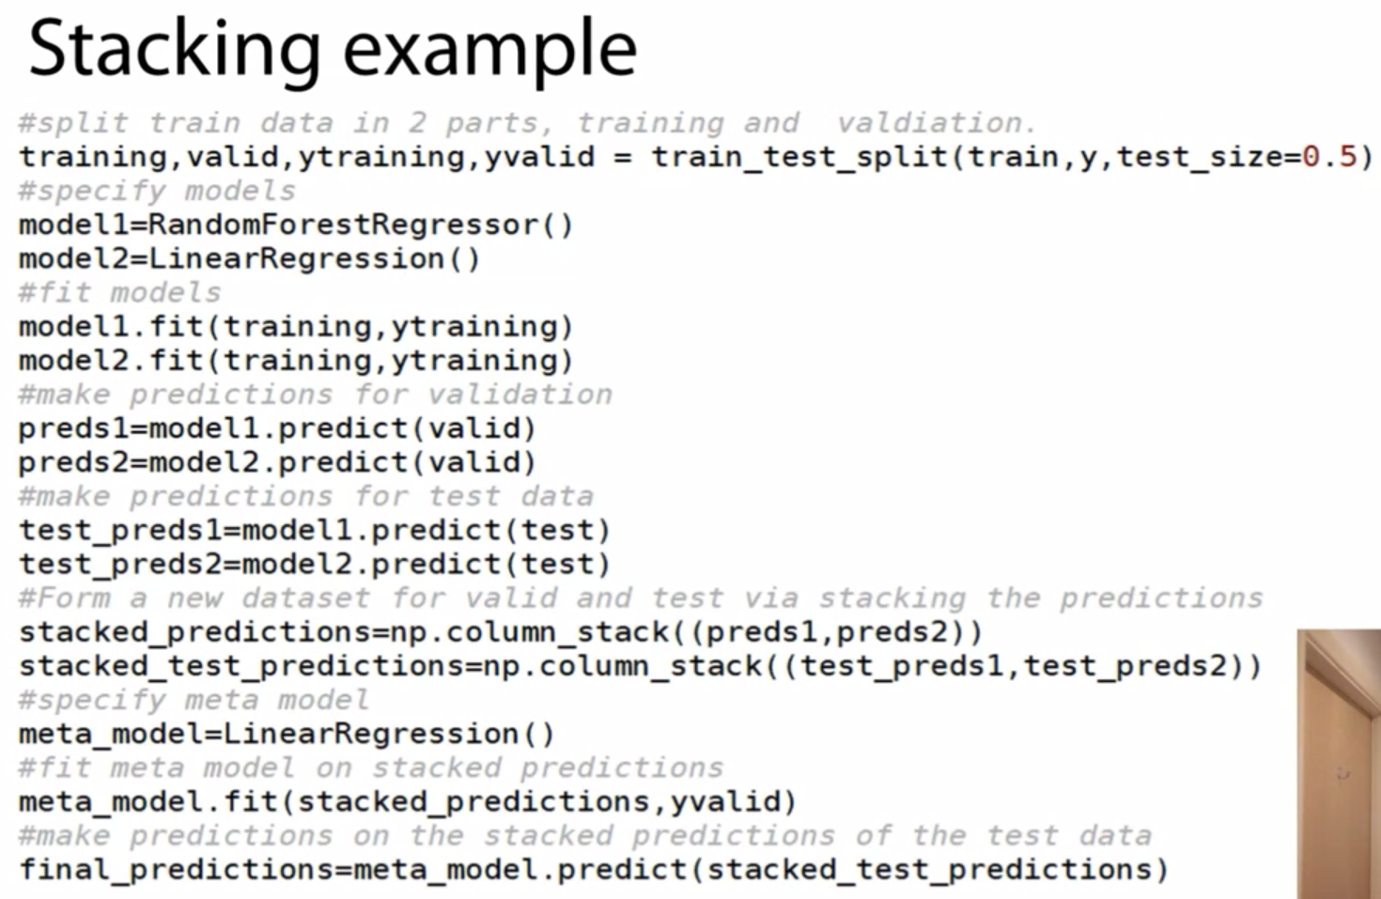

Let us go through an example, a simple example in Python, in order to understand better, as in in code, how it would work. It is quite simple, so even people not very experienced with Python hopefully can understand this.

The main logic is that we will use two base learners on some input data, a random forest and a linear regression. And then, we will try to combine the results, starting with a meta learner, again, it will be linear regression.

Let's assume we again have a train data set, and a target variable for this data set, and a test data set

Maybe the code seems a bit intimidating, but we will go step by step. What we do initially is we take the train data set and we split it in two parts. So we create a training and a valid data set out of this, and we also split the target variable. So we create ytraining and yvalid, and we split this by 50%. We could have chosen something else, let's say 50%. Then we specify our base learners, so model1 is the random forest in this case, and model2 is a linear regression. What we do then is we fit the both models using the training data and the training target. And we make predictions for the validation data for both models, and at the same time we'll make predictions for the test data.Again, for both models, we save these as preds1, preds2, and for the test data, test_preds1 and test_preds2. Then we are going to collect the predictions, we are going to stack the predictions and create two new data sets. One for validation, where we call it stacked_predictions, which consists of preds1 and preds2. And then for the data set for for the test predictions, called stacked_test_predictions, where we stack test_preds1 and test_preds2.

Then we specify a meta learner, let's call it meta_model, which is a linear regression. And we fit this model on the predictions made on the validation data and the target for the validation data, which was our holdout data set all this time. And then we can generate predictions for the test data by applying this model on the stacked_test_predictions. This is how it works.

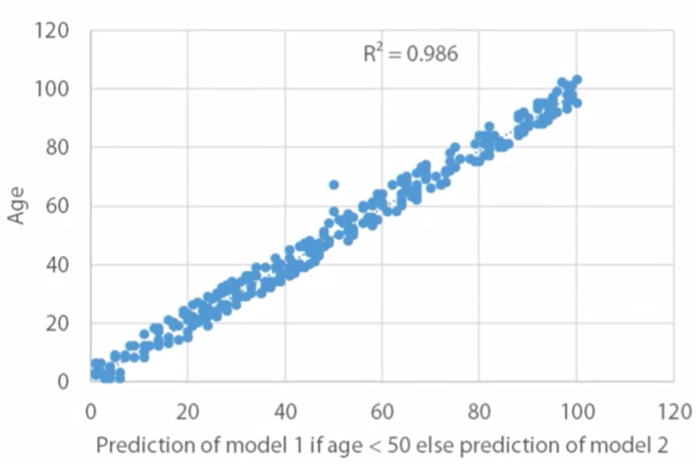



Combined model 1 and 2

Now, I think this is a good time to revisit an old example we used in the first session, about simple averaging. If you remember, we had a prediction that was doing quite well to predict age when the age was less than 50, and another prediction that was doing quite well when age was more than 50. And we did something tricky, we said if it is less than 50, we'll use the first one, if age is more than 50, we will use the other one. The reason this is tricky is because normally we use the targetinformation to make this decision. Where in an ideal world, this is what you try to predict, you don't know it. We have done it in order to show what is the theoretical best we could get, or yeah, the best. So taking the same predictions and applying stacking, this is what the end result would actually look like.

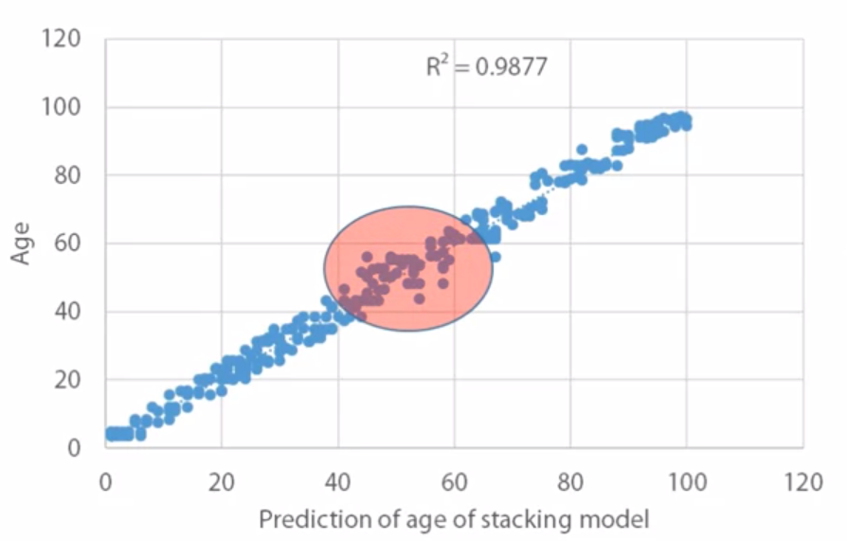

Doing this by stacking.

As you can see, it has done pretty similarly. The only area that there is some error is around the threshold of 50. And that makes sense, because the model doesn't see the target variable, is not able to identify this cut of 50 exactly. So it tries to do it only based on the input models, and there is some overlap around this area. But you can see that stacking is able to identify this, and use it in order to make better predictions.

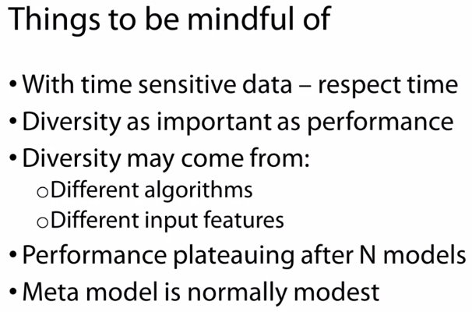

here are certain things you need to be mindful of when using stacking. One is when you have time-sensitive data, as in let's say, time series, you need to formulate your stacking so that you respect time.

What I mean is, when you create your train and validation data, you need to make certain that your train is in the past and your validation is in the future, and ideally your test data is also in the future. So you need to respect this time element in order to make certain your model generalizes well. The other thing you need to look at is, obviously, single model performance is important. But the other thing that is also very important is model diversity, how different a model is to each other. What is the new information each model brings into the table? Now, because stacking, and depending on the algorithms you will use for stacking, can go quite deep into exploring relationships.

It will find when a model is good, and when a model is actually bad or fairly weak. So you don't need to worry too much to make all the models really strong, stacking can actually extract the juice from each prediction. Therefore, what you really need to focus is, am I making a model that brings some information, even though it is generally weak? And this is true, there have been many situations where I've made, I've had some quite weak models in my ensemble, I mean, compared to the top performance. And nevertheless, they were actually adding lots of value in stacking. They were bringing in new information that the meta model could leverage. Normally, you introduce diversity from two forms, one is by choosing a different algorithm. Which makes sense, certain algorithms capitalize on different relationships within the data. For example, a linear model will focus on a linear relationship, a non-linear model can capture better a non-linear relationships. So predictions may come a bit different. The other thing is you can even run the same model, but you try to run it on different transformation of input data, either less features or completely different transformation. For example, in one data set you may treat categorical features as one whole encoding. In another, you may just use label in coding, and the result will probably produce a model that is very different.

Generally, there is no limit to how many models you can stack. But you can expect that there is a plateauing after certain models have been added. So initially, you will see some significant uplift in whatever metric you are testing on every time you run the model. But after some point, the incremental uplift will be fairly small. Generally, there's no way to know this before, exactly what is the number of models where we will start plateauing. But generally, this is a affected by how many features you have in your data, how much diversity you managed to introduce into your models, quite often how many rows of data you have. So it is tough to know this beforehand, butgenerally this is something to be mindful of. But there is a point where adding more models actually does not add that much value.

And because the meta model, the meta model will only use predictions of other models. We can assume that the other models have done, let's say, a deep work or a deep job to scrutinize the data. And therefore the meta model doesn't need to be so deep. Normally, you have predictions with are correlated with the target. And the only thing it needs to do is just to find a way to combine them, and that is normally not so complicated. Therefore, it is quite often that the meta model is generally simpler. So if I was to express this in a random forest context, it will have lower depth than what was the best one you found in your base models.

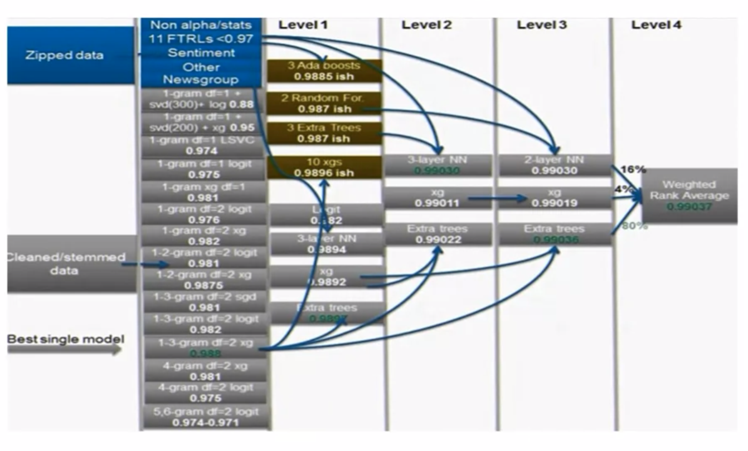

Why would we want to ever try something so complicated? I'm giving you an example of a competition my team used, four layer of stacking, in order to win. And we used two different sources of input data. We generated multiple models. Normally, exit boost and logistic regressions, and then we fed those into a four-layer architecture in order to get the top score. And although we could have escaped without using that fourth layer, we still need it up to level three in order to win. So you can understand the usefulness of deploying deep stacking.

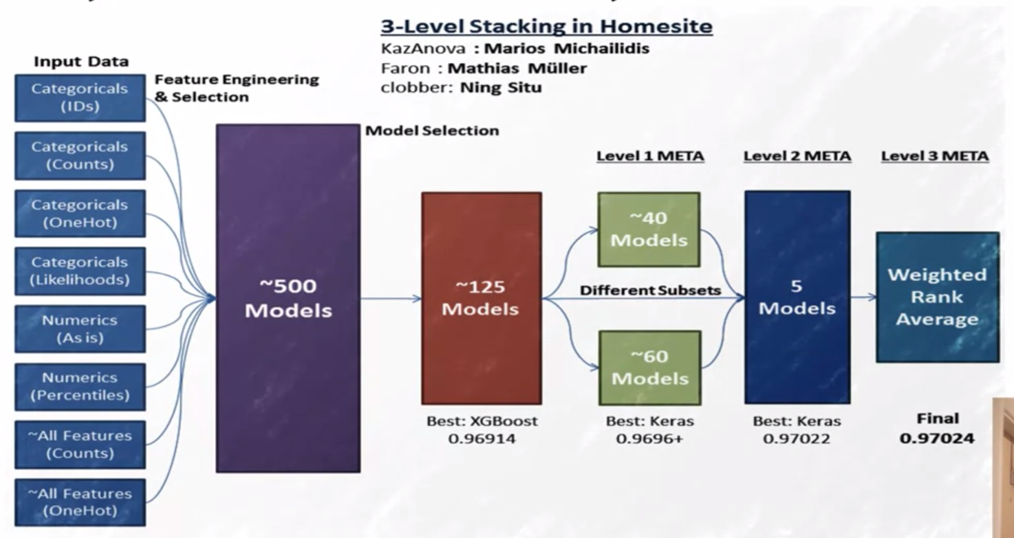

Another example is the Homesite competition organized by Homesite insurance where again, we created many different views of the data. So we had different transformations. We generated many models. We fed those models into a three-level architecture. I think we didn't need the third layer again. Probably, we could have escaped with only two levels but again, deep stacking was necessary in order to win. So there is your answer, deep stacking on multiple levels really helps you to win competitions. In the spirit of fairness and openness, there has been some criticism about large ensembles that maybe they don't have commercial value, they are confidentially expensive. I have to add three things on that.The first is, what is considered expensive today may not be expensive tomorrow and we have seen that, for example, with the deep learning, where with the advent of GPUs, they have become 100 times faster and now they have become again very, very popular. The other thing is, you don't need to always build very, very deep ensembles but still, small ensembles would still really help.So knowing how to do them can add value to businesses, again based on different assumptions about how fast they want the decisions, how much is the uplift you can see from stacking, which may vary, sometimes it's more, sometime is less. And generally, how much computing power they have. We can make a case that even stacking on multiple layers can be very useful. And the last point is that these are predictive modeling competitions so it is a bit like the Olympics. It is nice to be able to see the theoretical best you can get because this is how innovation takes over. This is how we move forward.

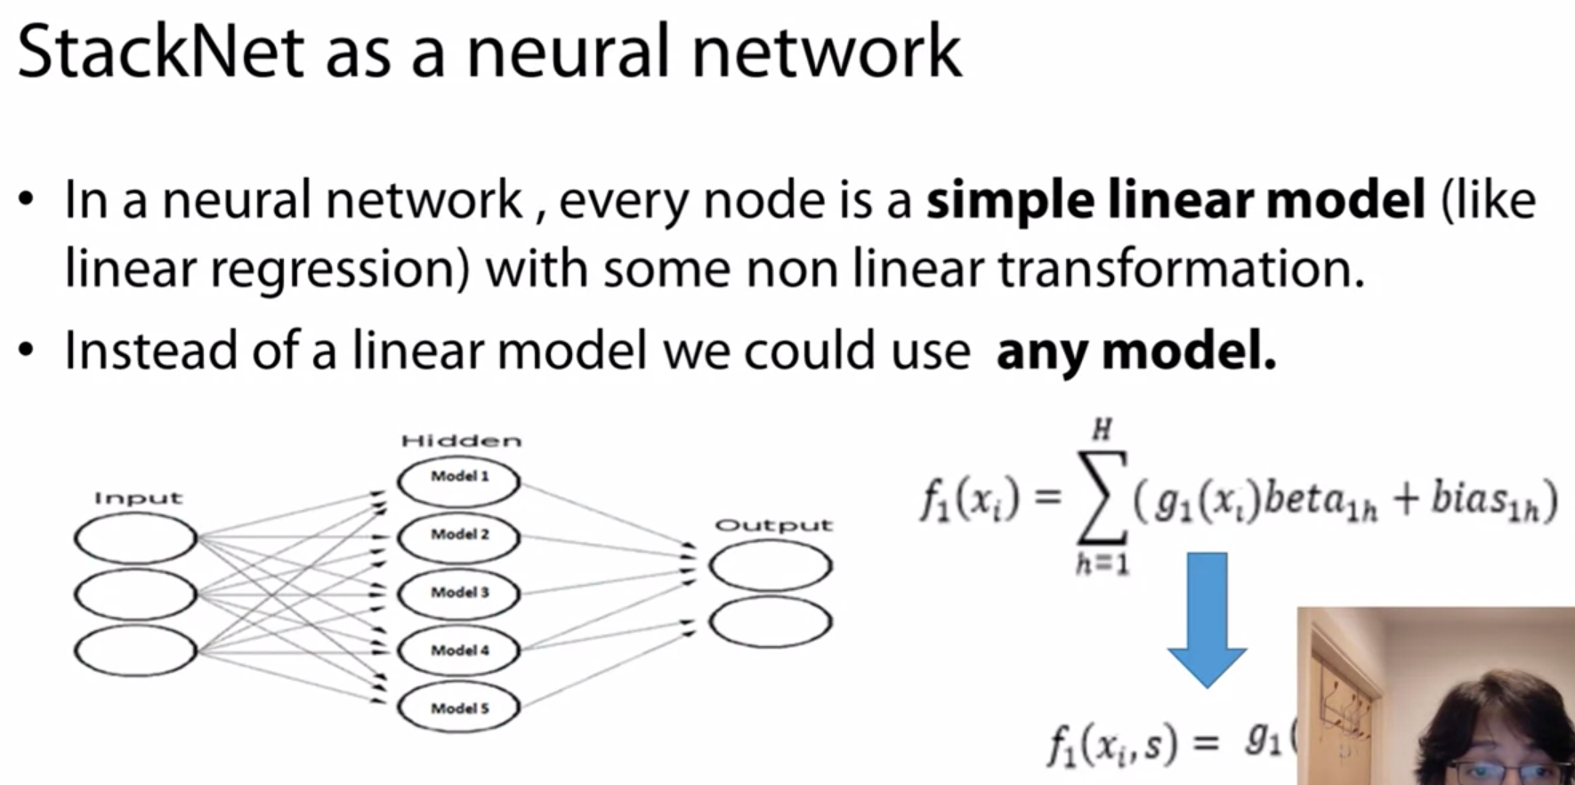

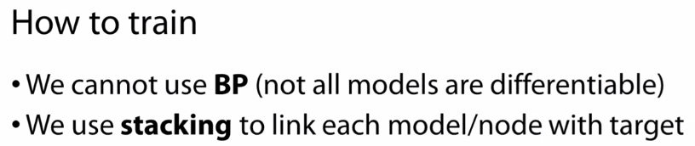

The concept of StackNet is actually not that much different. The only thing we want to do is, we don't want to be limited to that linear regression or to that perception. We want to be able to use any machine learning algorithm. Putting that aside, the architecture should be exactly the same, could be fairly similar. So how to train this? In a typical neural network, we use bipropagation. Here in this context, this is not feasible. I mean in the context of trying to make this network work with any input model because not all are differentiable. So this is why we can use stacking. Stacking here is a way to link the output, the prediction, the output of the node, with target variable. This is how the link also is made from the input features with a node.

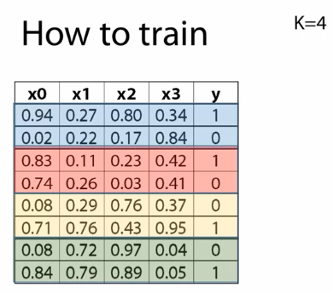

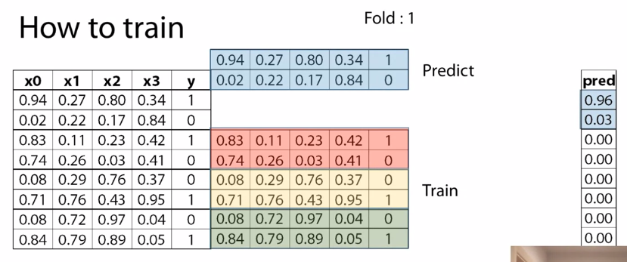

As we saw in the previous python code of training and testing and finally creating our stacked model. That went through partitioning our data. Now if the stack layers will be too many we cannot partition our data so much

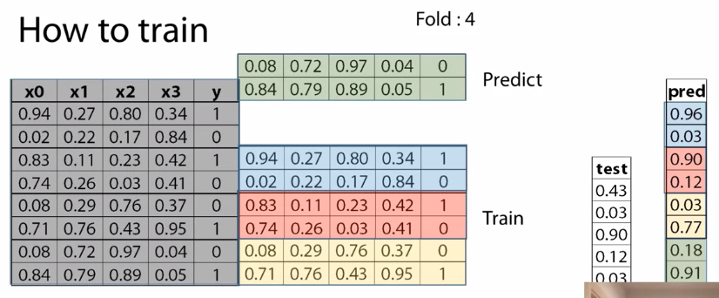

However, if you remember the way that stacking works is you have some train data. And then, you need to divide it into two halves. So, you use the first part called, training, in order to make predictions to the other part called, valid. If we, assuming that adding more layers gives us some uplift, if we wanted to do this again, we would have re-split the valid data into two parts. Let's call it, mini train, and mini valid. And you can see the problem here. I mean, assuming if we have really big data, then this may not really be an issue. But in certain situations where we don't have that much data. Ideally, we would like to do this without having to constantly re-split our data. And therefore minimizing the training data set. So, this is why we use a K-Fold paradigm. Let's assume we have a training data set with four features x0, x1, x2, x3, and the y variable, or target. If we are use k-fold where k = 4, this is a hyper-parameter which is what to put here. We would make four different parts out of these datasets. Here I have put different colors, colors to each one of these parts. What we would do then in order to commence the training, is we will create an empty vector that has the same size as rows, as in the training data,but for now is empty. And then, for each one of the folds, we would start, we will take a subset of the training data. In this case, we will start with red, yellow, and green. We will train a model, and then we will take the blue part, and will make predictions. And we will take these predictions, and we will put them in the corresponding location in the prediction array which was empty. Now, we are going to repeat the same process always using this rotation. So, we are now going to use the blue, the yellow, and the green part, and we will keep to create a model, and we will keep the red part for prediction. Again, we will take these predictions and put it into the corresponding part in the prediction array. And we will repeat again with the yellow, and the green. Something that I need to mention is that the K-Fold doesn't need to be sequential as a date. So, it would have been shuffled. I did it as this way in order to illustrate it better. But once we have finished and we havegenerated a whole prediction for the whole training data, then we can use the whole training data,in order to fit one last model and make now predictions for the test data. Another way we could have done this is for each one of the four models we were making predictions for the validation data. At the same time, we could have been making predictions for the whole test data. And after four models, we will just take an average at the end. We'll just divide the test predictions by four.But a different way to do it, I have found this way I just explained better with neural networks, and the method where you use the whole training data to generate predictions for test better with tree-based methods. So, once we finish the predictions with the test, you can start again with another model this time. So you will generate an empty prediction, you will stack it next to your previous one. And you will repeat the same process. You will essentially repeat this until you'refinished with all models for the same layer. And then, this will become your new training data set and you will generally begin all over again if you have a new layer. This is generally the concept.

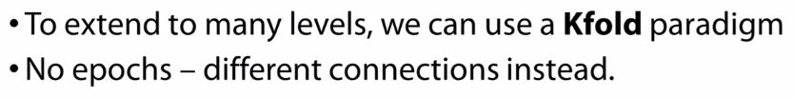

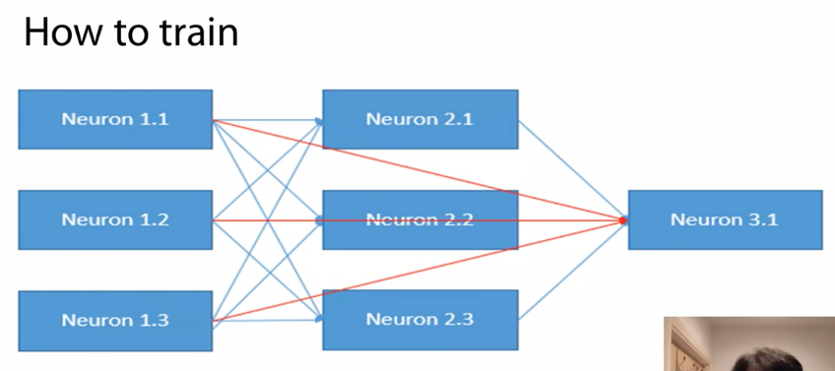

Though we could say this, in order to extend on many layers, we use this K-Fold paradigm.However, normally, neural networks we have this notion of epochs. We have iterations which help us to re-calibrate the weights between the nodes. Here we don't have this option, the way stacking is. However, we can introduce this ability of revisiting the initial data through connections. So, a typical way to connect the nodes is the one we have already explored where you have it input nodes, each node is directly related with the nodes of the previous layer. Another way to do this is to say, a node is not only affected, connected with the nodes of the directly previous layer, but from all previous nodes from any previous layer. So, in order to illustrate this better, if you remember the example with the headmaster where he was using predictions from the teachers,he could have been using also predictions from the students at the same time. This actually can work quite well. And you can also refit the initial data. Not just the predictions, you can actually put your initial x data set, and append it to your predictions. This can work really well if you haven't made many models. So that way, you get the chance to revisit that initial training data,and try to capture more informations. And because we already have metal-models present, the model tries to focus on where we can explore any new information. So in this kind of situation it works quite well. Also, this is very similar to target encoding or many encoding you've seen before where you use some part of the data, let's say, a code on a categorical column, given some cross-validation, you generate some estimates for the target variable. And then, you insert this into your training data. Okay, you don't stack it, as in you don't create a new column, but essentially you replace one column with hold out predictions of your target variable which is essentially very similar. You have created the logic for the target variable, and you are essentially inserting it into your training data idea.

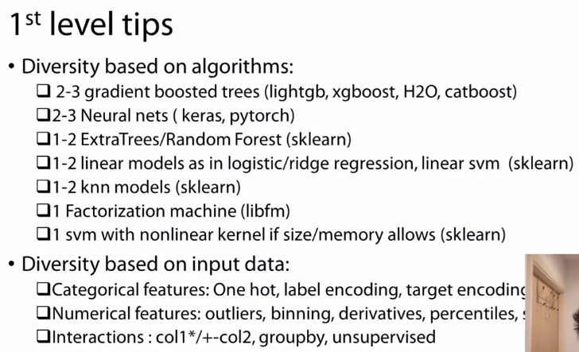

Now, I'll give you a few tips that are going to help you to make a good ensemble, or at least it help you to start with. And I mentioned before when I talked about stacking, what's quite important is to introduce diversity, and one way to do this is based on the algorithms you use. So an architecture that I have found quite useful is to always make two or three gradient boosted trees.And what I'm about to do here is I haven't either tried different implementations, or I try to make one with bigger depth, one with middle depth, and one with low depth, and then I try to tune the parameters around it in order to make them have as similar performance as possible. Again, hoping that the end result will be some models which are fairly diverse to each other. Another thing that I like is, I'm using neural nets either from Keras or PyTorch. And again, what I try to do is, I try to make one which is fairly deep that take three hidden layers, and one which is middle,like two hidden layers, and one that has, let's say, only one hidden layer. Again, I try to diversify, I try to make them slightly different, in order to try and get new information. Then I use a few ExtraTrees or Random Forest, most of the time they work quite well, they normally add. I also add a few linear models or ridge regression. I also like linear support vector machine from scikit-learn.KNN models tend to want quite nice value in many problems, which is surprising because if you look at them individually, they rarely have have good performance by compared to an exit boostthat they generally tend to add quite some value in a metamodeling context. I personally like factorization machines, I find them quite useful, especially libFM that factorizes all pairwise interactions. And if your data permits, so if your data is not so big, I also find useful support vector machines with some sort of non-linear kernel, like RBF. They don't work quite well, especially in regression. The other way you can introduce diversity is with the transformations you make in your own input data, whereas, you can actually run exactly the same models just by having slightly different input data, is enough to generate diversity. So, what we look at for categorical features are train one hot encoding, label encoding as in replacing the categorical values with an index. I can use likelihood encoding or target encoding, or I can replace categories with frequency or counts. For numerical features, I try to take care of outliers or not. I bin the variables from X to Z,from Z to all, and so on. I use derivatives which is a way to smoothen your variables or I could use percentiles or scaling, these are different ways I use to change my numerical features in different models. And then I also explore interactions, like column one, multiple column two, or column one plus column two. I can go up to three or four levels so explore all possible interactions. Another way to explore interactions is with groupby statements where you say, given all categories of a categorical feature, compute the average of another variable, for example. In certain situations, this works quite well. The other thing that I would do is, I would try and supervise techniques like k-means, or SVM, or PCA, or numerical features. Again, it tends to add value quite often

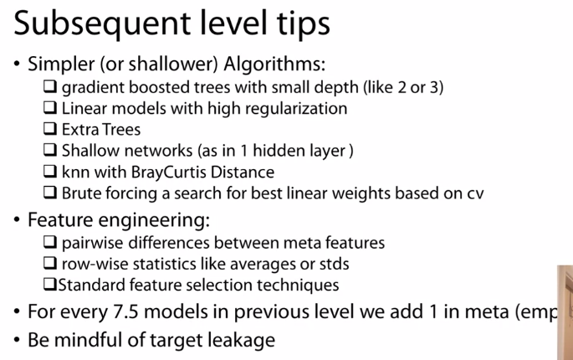

Now, on every other layer, what you the need to keep in mind is that you need to make your algorithms smaller or shallower, more constrained. What does this mean? In gradient boosting trees, means you need to put very small depth, like two or three. Linear models, you need to put high regularization. Extra Trees, just don't make them too big, they tend to work quite well. Shallow neural networks, again, I normally put one layer maximum two layers here, with not that many hidden neurons. We can try KNN with BrayCurtis distance or sometimes it's actually better to brute force the best linear weights we could use. Actually, in a cross-validation try to find the best linear weights, again, symmetric. We can also deploy different feature engineering in this subsequent level. One thing we could do is, we could create pairwise differences between the model's predictions, and this can help because they tend to be quite correlated. So when you create the differences, you essentially force the model to focus on what each new model brings.And you can also create row-wise statistics like averages or standard deviations of all the models.This is almost like an ensemble, you create some ensemble features yourself. You can also deploy standard feature selection techniques, so any techniques you would use to find which features are important. You could use it here to find which models are important and exclude them. A rule which empirically, let's say as a rule of thumb, I've found to work quite well. I mean, not with 100 percent confidence but as a general idea, is that for every seven point five models in one layer, we add one model in the subsequent layer. So if we have seven models, we'll have one metamodel. If we have 15 models, then we will have two metamodels and so on. What we need to be very mindful is that, even though we use this hold-out mechanism, we still might introduce leakage.How we can control this is by selecting the right K, when I mentioned K in the cross-validation. So when we select a very high value there, this means that each model would use more training data when it makes predictions and therefore it might not generalize very well. At the same time, it will exhaust all information about the training data. So again, there is this bias variance threshold where you try to find. So, there is no easy way to spot a mistake here. Normally, you have a test data set, and if you see in your cross-validation that you have a next improvement, that in your test data you don't see it, then you need to go back and try to reduce the number of K-Folds. And hopefully, this will generalize better, at least that's a way that has worked in practice. I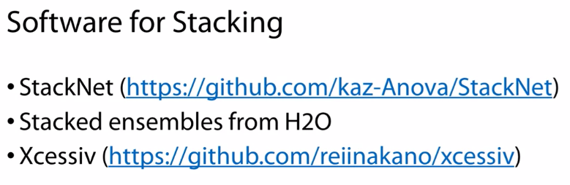

'll list a few software which you can use for stacking, one is StackNet which is the product of my research. You can give it a shot if you want. Another thing which you can try, is Stacked ensembles from H2O.There is also a new software called, Xcessic and Python where you can also create quite diverse, and large ensembles.

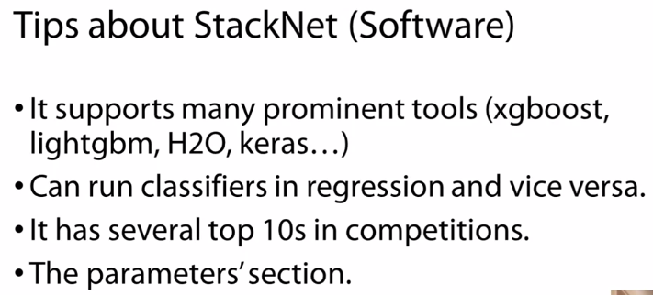

A few more things to know about StackNet if you want to use it, is that it now supports many of the common machine learning tools we use, like xgboost, lightgbm, H2O.So, you can pretty much have available all the great tools in order to build a strong ensemble. An interesting addition which we didn't have much chance to discuss but nevertheless, it is quite interesting, is that you can run classifiers in a regression problem, and vice versa. This means that instead of predicting AIDS, I could be predicting, will this person live more than 50 years old or not. And this tends to work quite well because it makes the model focus in certain areas, and meta-model will be able to utilize this information to make better predictions for AIDS. So, this tends to works quite well. I've found it useful quite many often. So, this is something you should explore. Generally, the software has already many top 10 solutions, and not just by me. So, it has been tested. And in the examples section, I think there is a really interesting example with a very popular kind of competition which was hosted by Amazon. And this example uses StackNet, and you can see how you can get with top 10. But in principle, this is a very nice competition. It doesn't have very big data, nor very small. You can try lots of transformations especially with the categorical data. And it is very good place to start. 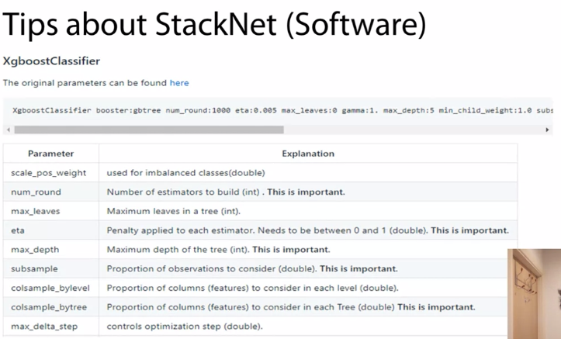

The other thing I wanted to say is that StackNet has also an educational flavor. I made it as such, I have this focus in mind. So, if you go to the parameter section where it leaves all the different tools, you can find sections where they tell you which parameters are the most important. This is based on my experience. For example, in xgboost, num_round is important, eta is important. You can take, then, this information and use it even outside StackNet. For example, if you want to use this, they're from Python. Because the parameters are generally the same. So, if you don't know where to start, how to look here, see which these parameters are important. And focus on them in order to try and get a good resolution.

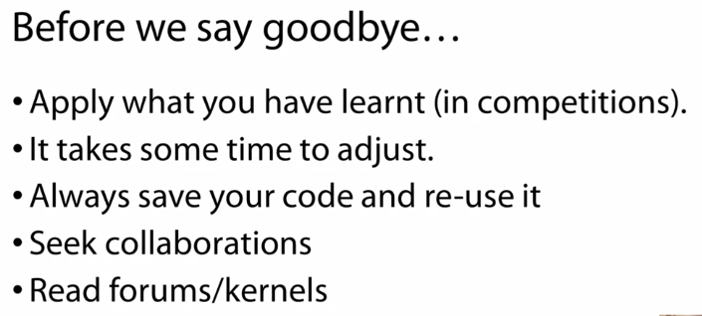

Before we close this session, there are a few things I'd like to tell you. Go out there, apply what you've learned. There is no such thing as learning only theoretically. The best thing to learn is to bleed on the battlefield. Choose a competition. You may start with some which are named as tutorials. And then, you can go on into the real competitions. This is how you've learned.You need to get more practical experience, obviously. Don't be demoralized if you see there's still a gap with the top people, because it does take some time to adjust. You need to learn the dynamics. You need to understand how you need to work, where to optimize your work, how maximize the intensity. So, it takes a bit of time. But you'll get there. My main point is don't get disappointed, you'll definitely get there. Something that has always helped me is to save my code.Let's say at the end of it it's a silence. That is good. Because I can then take home this code in the next competition, and try and improve it. So, this helps to gradually build a much stronger pipeline, and at the same time, it saves time. Something that has helped me personally is to seek collaborations. These generally, I think, there are two elements into it. One is, you definitely improve your result, because every person seizes the problem from different angles, is able to extract different information. Therefore, when you join forces the score is better, but it's also more fun. And since you're doing it, you might as well enjoy it. And the other thing I need to highlight is generally, you need to be connected with forums, and codes, and kernels, because there might be tips, there might be some cutting-edge solutions that come out, and they can significantly sift a leader-board.

**TIPS**

There are a number of ways to validate second level models (meta-models). In this reading material you will find a description for the most popular ones. If not specified, we assume that the data does not have a time component. We also assume we already validated and fixed hyperparameters for the first level models (models).

*a) Simple holdout scheme*

1. Split train data into three parts: partA and partB and partC.
2. Fit N diverse models on partA, predict for partB, partC, test_data getting *meta-features* partB_meta, partC_meta and test_meta respectively.
3. Fit a metamodel to a partB_meta while validating its hyperparameters on partC_meta.
4. When the metamodel is validated, fit it to [partB_meta, partC_meta] and predict for test_meta.

*b) Meta holdout scheme with OOF meta-features*

1. Split train data into K folds. Iterate though each fold: retrain N diverse models on all folds except current fold, predict for the current fold. After this step for each object in train_data we will have N *meta-features* (also known as *out-of-fold predictions, OOF*). Let's call them train_meta.
2. Fit models to whole train data and predict for test data. Let's call these features test_meta.
3. Split train_meta into two parts: train_metaA and train_metaB. Fit a meta-model to train_metaA while validating its hyperparameters on train_metaB.
4. When the meta-model is validated, fit it to train_meta and predict for test_meta.

*c) Meta KFold scheme with OOF meta-features*

1. Obtain *OOF predictions* train_metaand test metafeatures test_meta using b.1 and b.2.
2. Use KFold scheme on train_meta to validate hyperparameters for meta-model. A common practice to fix seed for this KFold to be the same as seed for KFold used to get *OOF predictions*.
3. When the meta-model is validated, fit it to train_meta and predict for test_meta.

*d) Holdout scheme with OOF meta-features*

1. Split train data into two parts: partA and partB.
2. Split partA into K folds. Iterate though each fold: retrain N diverse models on all folds except current fold, predict for the current fold. After this step for each object in partA we will have N *meta-features* (also known as *out-of-fold predictions, OOF*). Let's call them partA_meta.
3. Fit models to whole partA and predict for partB and test_data, getting partB_meta and test_meta respectively.
4. Fit a meta-model to a partA_meta, using partB_meta to validate its hyperparameters.
5. When the meta-model is validated basically do 2. and 3. without dividing train_data into parts and then train a meta-model. That is, first get *out-of-fold predictions* train_metafor the train_data using models. Then train models on train_data, predict for test_data, getting test_meta. Train meta-model on the train_meta and predict for test_meta.

e) KFold scheme with OOF meta-features

1. To validate the model we basically do d.1 -- d.4 but we divide train data into parts partA and partB M times using KFold strategy with M folds.
2. When the meta-model is validated do d.5.

## Validation in presence of time component

*f) KFold scheme in time series*

In time-series task we usually have a fixed period of time we are asked to predict. Like day, week, month or arbitrary period with duration of T.

1. Split the train data into chunks of duration T. Select first M chunks.
2. Fit N diverse models on those M chunks and predict for the chunk M+1. Then fit those models on first M+1 chunks and predict for chunk M+2 and so on, until you hit the end. After that use all train data to fit models and get predictions for test. Now we will have *meta-features* for the chunks starting from number M+1 as well as *meta-features* for the test.
3. Now we can use *meta-features* from first K chunks [M+1,M+2,..,M+K] to fit level 2 models and validate them on chunk M+K+1. Essentially we are back to step 1. with the lesser amount of chunks and *meta-features* instead of features.

*g) KFold scheme in time series with limited amount of data*

We may often encounter a situation, where scheme f) is not applicable, especially with limited amount of data. For example, when we have only years 2014, 2015, 2016 in train and we need to predict for a whole year 2017 in test. In such cases scheme c)could be of help, but with one constraint: KFold split should be done with the respect to the time component. For example, in case of data with several years we would treat each year as a fold.

**QUIZ**

What is the purpose of ensembling?

To make your solution look mighty

To compensate errors of one model by other models

**Correct**

Correct! If models make mistakes on different test samples, ensemble will have higher overall quality

To learn about overfitting by trial-and-error

Question 2

Does ensembling always lead to a better quality?

Yes, always

No, almost never

No, but quite often

**Correct**

Correct! This is why almost every winning solution uses ensembling

Question 3

Which of the following machine learning techniques can potentially be the best?

Linear regression

Bagging of decision trees with max_depth=100

Gradient boosting of k-NN models

Stacking of diversified models

**Correct**

Yes, potentially stacking is the most powerful technique

Question 4

Which class of models can be used as a base model in gradient boosting?

Decision Tree

**Correct**

Of course, for example, GBDT boosts over decision trees.

Linear model

**Correct**

Of course, for example, Xgboost contains implementation of boosting over logistic regressions.

Neural Net

**Correct**

Of course, it is possible, but not widely used. For example, you can use AdaBoost to do this.

# Question 1

## Suppose we are given a train set and test set, that came from the same distribution. We want to use stacking and choose between two validation schemes described in the reading material.

## Select the true statements about validation schemes.

Correct answers:

* Scheme e) gives the validation score with the least variance, if compared to schemes a) -- d).
* Scheme d) is less efficient from computational perspective than scheme a). That is, if a dataset is very large, scheme a) is usually preferred over scheme d).

Incorrect answers:

* Scheme d) is more efficient from computational perspective than scheme a). That is, if a dataset is very large, scheme d) is usually preferred over scheme a).

# Question 2

## Definition: we will call a validation scheme fair if the set, that we use to validate meta-models comes from the same distribution as the meta-test set. In other cases we will call validation scheme leaky. In other words in a fair validation scheme the set that we use to validate meta-models was not used in any way during training first level models.

## Select fair validation schemes. The definition for the schemes can be found in the reading material.

Correct answers:

a) Simple holdout scheme

d) Holdout scheme with OOF meta-features

e) KFold scheme with OOF meta-features

Incorrect answers:

b) Meta holdout scheme with OOF meta-features

c) Meta KFold scheme with OOF meta-features

# Question 3

Which of the following ensembling methods can potentially learn "conditional averaging" (video 1)?

Correct answers:

* Boosting on trees
* Stacking

Incorrect answers:

* Weighted average
* Bagging

# Question 4

## The benefits of the weighted average compared to more advanced ensembling techniques is that

Correct answers:

* It is less prone to overfitting. Yes! A very small number of parameters rarely lead to overfitting.
* It is faster to implement and to run. Yes! It is much easier to implement than stacking.

Incorrect answers:

* It usually gives better quality. Well, in usually stacking can do better.

# Question 5

## In general case, which set of base models is probably the best for stacking?

Correct answers:

* [SVM, GBDT, Neural Network, kNN]. This set contains models from 4 different classes, so it is the most diverse set and it should be in general case be the best for stacking

Incorrect answers:

* [Random Forest, Extra Trees Classifier, GBDT, RGF]. All this are tree-based model, this set is not diverse enough
* [kNN, SVM, Logistic Regression, Neural Net]. SVM and Logistic Regression are linear models, so this set contains only 3 different classes of models (linear, kNN, NN)
* [Logistic Regression, SVM, Random Forest, Extra Trees Classifier, GBDT]. This set contain only models from 2 families (linear and tree-based) so it is not the best choice

# Question 6

## Suppose we are given a classification task. In a simple two model linear mix we usually use weights α for the first model and β for the second one. The coefficients are usually chosen such that α+β=1, because convex combination of probability vectors is a probability vector.Still, sometimes it is beneficial to tune α and beta independently, e.g. mix with α=0.1 and β=0.8 works best.

## However, for some metrics it never makes sense to tune α and β independently. That is, searching for independent α and β will never give you better results than searching for weights, constrained to be β=1−α. Select such metrics.

Correct answers: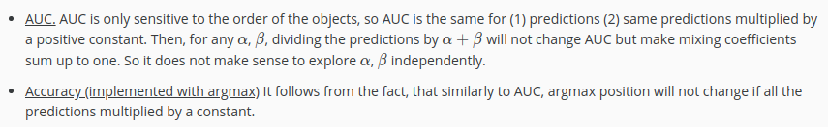

Incorrect answers:

* Hinge loss
* LogLoss

**ADDITIONAL MATERIALS**

<https://mlwave.com/kaggle-ensembling-guide/>

Kaggle ensemble guide. Showing different ways and how it helped then for their competition with results and ways.

**CODE KNN**

**Examples**

**>>>**

**>>> np.bincount(np.arange(5))**

**array([1, 1, 1, 1, 1])**

**>>> np.bincount(np.array([0, 1, 1, 3, 2, 1, 7]))**

**array([1, 3, 1, 1, 0, 0, 0, 1])**

**>>>**

**>>> x = np.array([0, 1, 1, 3, 2, 1, 7, 23])**

**>>> np.bincount(x).size == np.amax(x)+1**

**True**

**The input array needs to be of integer dtype, otherwise a TypeError is raised:**

**>>>**

**>>> np.bincount(np.arange(5, dtype=float))**

**Traceback (most recent call last):**

**File "<stdin>", line 1, in <module>**

**TypeError: array cannot be safely cast to required type**

**A possible use of bincount is to perform sums over variable-size chunks of an array, using the weights keyword.**

**>>>**

**>>> w = np.array([0.3, 0.5, 0.2, 0.7, 1., -0.6]) *# weights***

**>>> x = np.array([0, 1, 1, 2, 2, 2])**

**>>> np.bincount(x, weights=w)**

**array([ 0.3, 0.7, 1.1])**

**minlength : int, optional**

**A minimum number of bins for the output array.**

**THE WEIGHT PARAMETER WITH BINCOUNT and minlength IS AWESOME**

**CATBOOST**

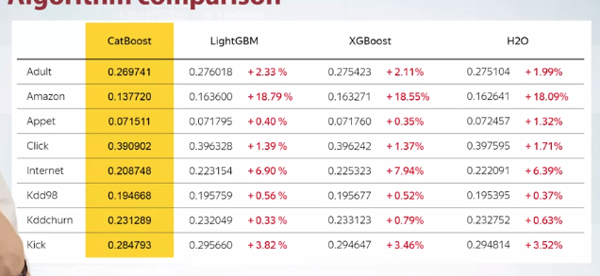

CATBOOST is killing IT THAN lightGBM XGBoost and H2O

Problems with gradient boosting

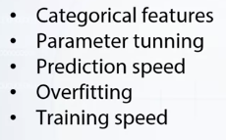

The first problem is that the existing with gradient boosting libraries have not optimal support or no support for categorical features, a very natural type of data that arises in many tasks. To handle them, you need to do advanced processing.

The second problem is that, if you train your model with default parameters, you usually get a very bad result.To get the good model, you need to do hyperparameter tuning.

The next problem arises in time critical applications and it is the prediction speed. If prediction speed is important, then some people don't use gradient boosting and use simple models.

The next problem is overfitting. Gradient boosting is prone to overfitting, which affects the resulting quality of the model.

And the last on this list is the training speed. It is especially important for large data sets when you need to wait for hours or even days for the training to finish. It is important to make training as fast as possible.

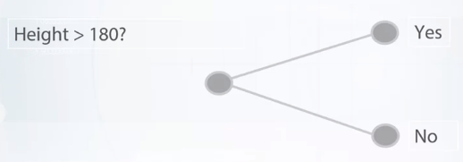

Let's start with a discussion of categorical features. Because the sophisticated categorical feature support is a major advantage of the library. Gradient boosting is a machine learning technique that works great for heterogeneous data, or data from different sources. When working with heterogeneous data, we usually have numerical data and categorical data. An example, if numerical data is height, it is a number. And thus, its values can be compared with each other. Numerical data can be easily used in decision trees.

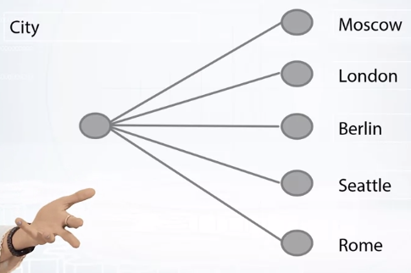

The most commonly used practice for dealing with categorical features and gradient boosting is replacing them with some numerical features during the processing stage. Let me introduce the techniques that are used in CatBoost to deal with categorical features.

The most widely used technique which is usually applied to low categorical features is One-hot encoding. The original feature is removed, and a new binary variable is added for each category. By gradient boosting one hot encoding can be done during the pre possessing phase or during training. However, it can be implemented more efficiently in terms of training time, which we've done in the library. By default, CatBoost uses one-hot encoding for features with small number of different values. This can be controlled with **one_hot_max_size** parameter.Another way that we've implemented is **using number of appearances of category in the data set as a new feature**. This is a simple but powerful technique.

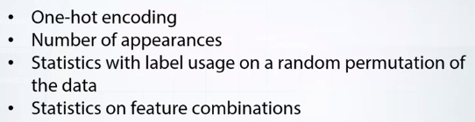

One more way to deal with categorical features is to compute some statistic using the label values of the object. And that is the most powerful technique in terms of resulting quality.

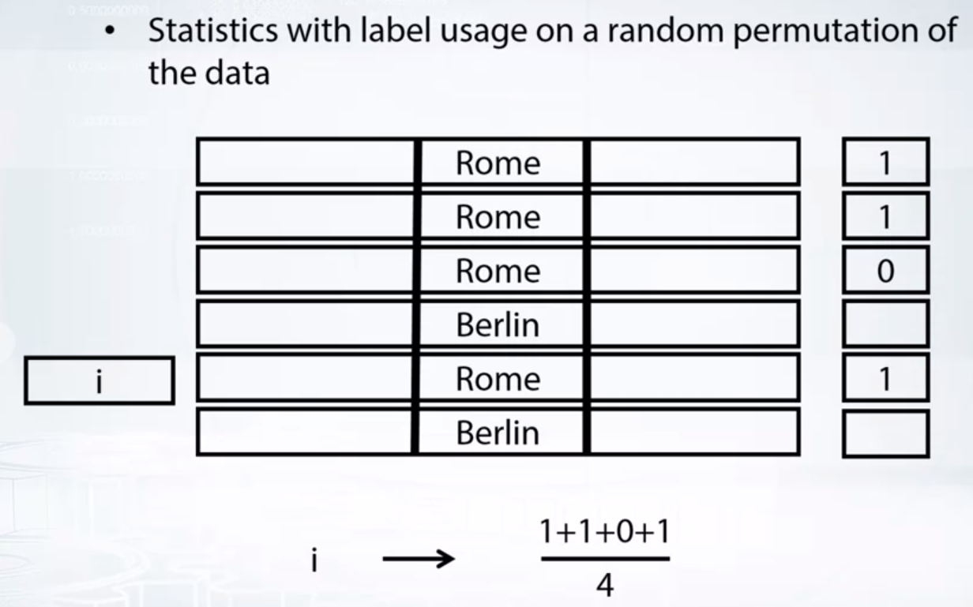

The simplest way is to substitute the category with value on the whole train data set. This procedure leads to.For example, if there is a single object from the category in the whole training data set, then the new numerical feature value will be equal to the label value of this example. A straightforward way to overcome this problem is to partition the data set into two parts, and use one part to only calculate the statistics, and the second part to perform training. This reduces over fitting, but it also reduces the amount of data used to train the model and to calculate the statistics.

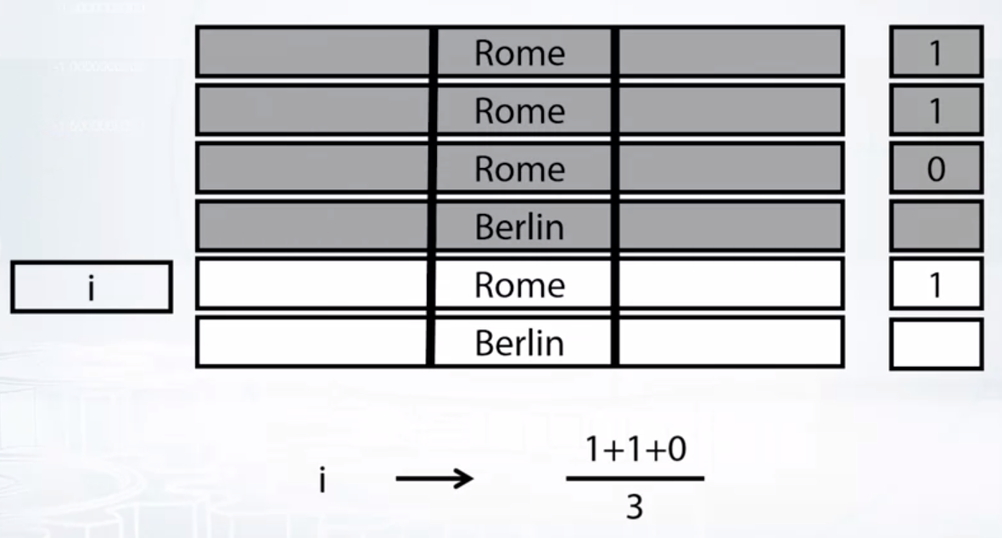

CatBoost uses a more efficient strategy, which reduces overfitting and allows to use the whole data set for training. Namely, we perform a random permutation of the data set and for each object we can get label value and more objects with the same category value placed before the given object in the permutation. It also helps to use other statistics, not only error target.

One more trick is to use several permutations. However, a straightforward statistics computed forseveral permutations will lead to overfitting. To use several permutations, CatBoost train's several models simultaneously, each of which is trained on a separate permutation and uses this model for tree structure selection. Note that any combination of several categorical features could be considered as a new one. For example, assume that the task is music foundation and we have two categorical features, user ID and musical genre. Some user prefer say rock music. When we convert user ID and musical genre to numerical features, we lose this information. And a combination of two features solve this problems and gives a new powerful feature. However, the number of combinations grows exponentially with the number of categorical features in the data set, and it is not possible to consider all of them in the algorithm. When constructing a new split for the current tree, CatBoost considers combinations in a greedy way. Thus, it considers only some good combinations. CatBoost also generates combinations of numerical and categorical features.

CatBoost uses a more efficient strategy, which reduces overfitting and allows to use the whole data set for training. Namely, we perform a random permutation of the data set and for each object we can get error lable] value and more objects with the same category value placed before the given object in the permutation. It also helps to use other statistics, not only error target.

One more trick is to use several permutations. However, a straightforward statistics computed forseveral permutations will lead to overfitting. To use several permutations, CatBoost train's several models simultaneously, each of which is trained on a separate permutation and uses this model for tree structure selection. Note that any combination of several categorical features could be considered as a new one. For example, assume that the task is music foundation and we have two categorical features, user ID and musical genre. Some user prefer say rock music. When we convert user ID and musical genre to numerical features, we lose this information. And a combination of two features solve this problems and gives a new powerful feature. However, the number of combinations grows exponentially with the number of categorical features in the data set, and it is not possible to consider all of them in the algorithm. When constructing a new split for the current tree, CatBoost considers combinations in a greedy way. Thus, it considers only some good combinations. CatBoost also generates combinations of numerical and categorical features.

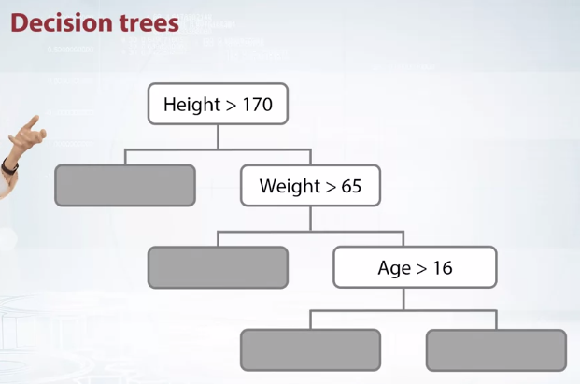

Let's now discuss the next major difference between CatBoost and other libraries. It is the kind trees CatBoost is using as base predictors, although libraries use different kind of trees.Builds trees node by node, eating them in a greedy fashion. This way, you can get a deep [INAUDIBLE] binary tree. Also builds but it builds them layer by layer and then prunes them. XGBoost also does the same builds them layer by layer and then prunes them. So they cannot get very deep.

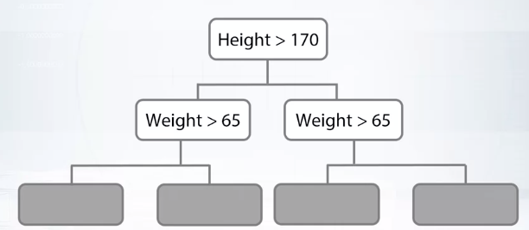

CatBoost uses symmetric trees. The trees where all nodes on the same layer contain the same split. These trees are more simple predictors which make the algorithm more stable to overfitting. They also make the algorithm more stable to hyperparameter changes,which means that training with default parameters will give a good model, and you can reduce the time spent on tuning hyperparameters. This type of trees also ask for a very fast model predictions. CatBoost model prediction is 30 to 60 times faster than those of and extra boost in both single and multithread mode.

**Thus categorical data supports and usage of symmetric trees are two first major features of CatBoost.**

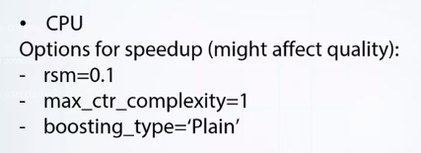

CatBoost has efficient CPU training implementation. We did a lot of speed-ups after their release. Currently, training on large datasets with many numerical features,will be around four times faster than extra boost, and will have similar speed as light GBM. On small dataset, CatBoost will be around two times faster than extra boost and two times slower than light GBM. This comparison was done with dataset epson. There might be cases on which this number will change for example if there are less than 10 features than the bottleneck of the algorithm is different. It is also important to note that CatBoost doesn't have sparse data support yet. So, for sparse data, it will train relatively slow

Now let's talk about some ways to control training speech.

The first parameter I want to talk about is called RSM, random subspace melt.

This parameter controls the part of the features that are used to select the next split. By default, this parameter is set to one but if you have many features, then changing this parameter to a smaller value, will probably not affect the quality. It will slow down the convergence. So, you need to run more iterations of gradient boosting. So, setting this parameters 2.1 might speed up iteration time up to 10 times, and the resulting number of iterations will increase much less by about 20 to 30 percent, so the resulting training time will be smaller. We optimize the algorithm to give the best possible quality which comes with a cost of additional computations. For example, ordered boosting, or usage of several random permutations, or feature combinations, it all requires additional time. But there is a set of options to control that. To disable ordered boosting, you can start booting type two plain. To disable categorical feature combinations, you can set max are complexity to one, or two if you don't want large combinations. An important feature of CatBoost is the GPU support.

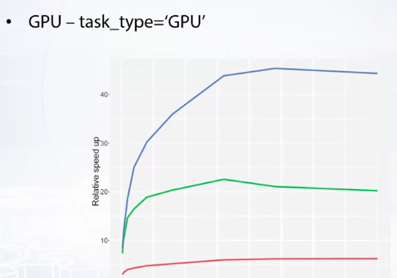

To use GPU training, you need to set parameter task type of the feed function to GPU. CatBoost GPU training is about two times faster than light GBM and 20 times faster than extra boost, and it is very easy to use.GPU training should be used for a large dataset. Here you can see how relative speedups changes with the amount of objects in a dataset. The larger the dataset, the more is the speedup. On key 40, speedup is up to six times, and on UR GPUs the speed-up is up to almost 50 times, so it will be much faster.

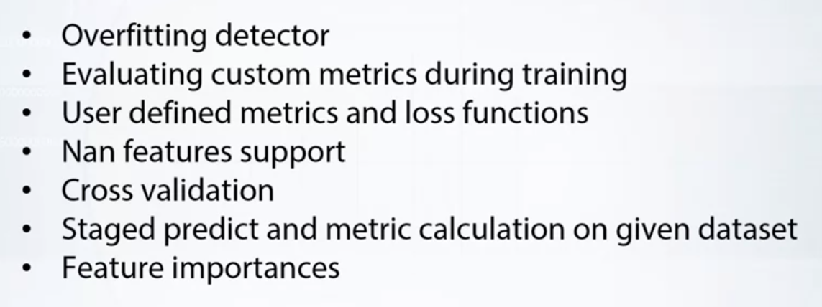

Let's now discuss some useful features of the library you should know about. The first one is the overfitting detector. Gradient boosting trains the model in an iterative fashion.During the training, the error reduces for your training dataset, but started for some iteration the generalization error will no longer reduce to detect when this happens, you need to have an eval data set. When the error starts growing on the eval dataset, you need to stop training and overfitting detector makes that for you. The second useful feature is custom metrics evaluation.During the training process, you can not only work on the values of the optimized flux function,but also on the wells of some other metrics which you can specify. For example, you could optimize will close for binary classification, and look on the various of accuracy and there you see.The nice thing is that you can configure the overfitting detector to use symmetric other than the optimized one. For example, you could again optimize log loss and stop training current AUC stops improving.

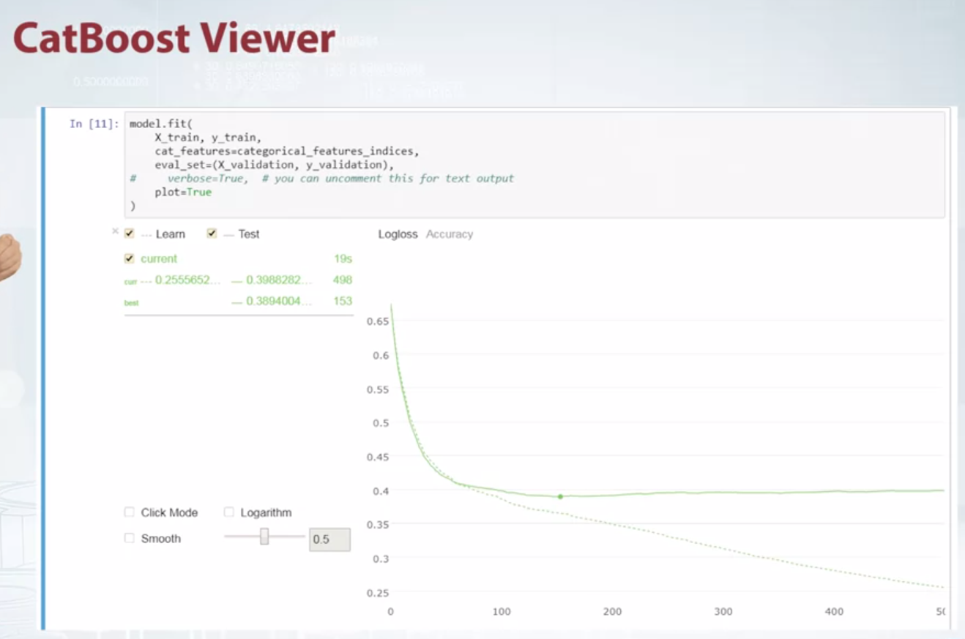

The values of the metrics of the optimized cost function can be also seen with CatBoost viewer. If you use Jupiter notebook. You could use plot equals true parameter to see them. You can see an example here. On this graph, the optimized loss function log loss is possible by default, but you can switch to a curious it up to see how it changes in the process of training.The best eval iteration is shown by a dot. Also, you can see pastime and estimated time left. It is possible for CatBoost to estimate the time of training because it goes trees of similar size on each iteration. Visualization support zooming moving to logarithmic scale. If you are experimenting using R or command-line utility, you could use a standalone CatBoost viewer tool. This tool has the same functionality, but opens in a separate browser tab. Same graphs can be plotted using TensorBoard. This also possible to write your own metric or loss function in Python or C plus plus.It is more efficient to write it in C plus plus.

It is more efficient to write it in C plus plus. Our GitHub.repo contains tutorials for that. Next important thing to know about, is non-feature values support. A very common situation is that your data has some missing feature values. The algorithm can deal with this in the following way.For categorical features non-values are treated as a separate category. For numeric features non-values are substituted with the variable that is either greater, or less than all other values, and it is guaranteed that when using internal split selection procedure, the algorithm will consider putting the objects with non-values in a separate leaf. The library also implements cross validation. What you need to know is that it allows for early stopping of the training with overfitting detector when the average evolved error among all four stops improving. Another useful feature is stage predict and metric evaluation mode. The stage predict calculates the variance of the model on every iteration for a given dataset, and the measure calculation mode calculates the metric values on every iteration for this dataset. In CatBoost, there are several ways to explore the feature importances. First of all, it is possible to see which features are the most important in the model.You also can see which features are the most influential for given objects or for a given set of objects. Finally, you can look on future interaction for previous features.

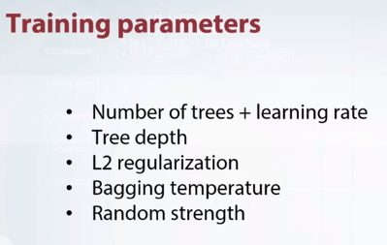

The first one is learning rate. The rule is the following. The least is the learning rate the more iterations you need to and the better the quality you get in the end. The second parameter is the depth of the tree. But the default value is six and it is a good value, but for some datasets you need deeper trees. L2 regularization is also important, you can play with it to reduce overfitting. The next parameter controls bagging intensity. The higher the temperature, the more aggressive the sampling is. You can also change the bootstrap type. Finally, there is a parameter that is called random strength, it is also important for model quality. When selecting best split for tree algorithm uses some randomness. This helps to reduce overfitting. The perimeter can regulate how much randomness should be used. To forbid randomness, you can set this parameter to zero.

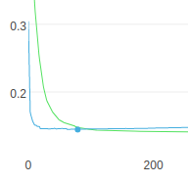 the point shows the best value of the whole graph.

**CATBOOST NOTEBOOK. VERY IMPORTANT AND PERFECT TO MASTER THE LIBRARY.**

from IPython.core.display import display, HTML

display(HTML("<style>.container { width:100% !important; }</style>"))

THE ABOVE CODE CAN BE USED IN ANY JUPYTER NOTEBOOK TO INCREASE THE CELL WIDTH TO 100 PERCENT

Also then increase the row di

WHILE DOING CROSS VAL K FOLD VALIDATION

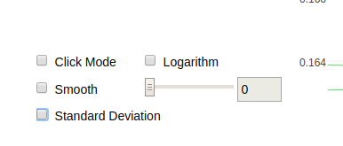

During plot you can turn std dev off to see the values of all the k fold line plots.

Else it shows the standard deviation of all the plots.

[ShapValues](https://catboost.ai/docs/concepts/shap-values.html): A vector with contributions of each feature to the prediction for every input object and the expected value of the model prediction for the object (average prediction given no knowledge about the object). The last column of every row has this expected value

# How They Work[¶](https://www.kaggle.com/dansbecker/shap-values#How-They-Work)

SHAP values interpret the impact of having a certain value for a given feature in comparison to the prediction we'd make if that feature took some baseline value.

An example is helpful, and we'll continue the soccer/football example from the [permutation importance](https://www.kaggle.com/dansbecker/permutation-importance) and [partial dependence plots](https://www.kaggle.com/dansbecker/partial-plots) lessons.

In these tutorials, we predicted whether a team would have a player win the *Man of the Match* award.

We could ask:

* How much was a prediction driven by the fact that the team scored 3 goals?

But it's easier to give a concrete, numeric answer if we restate this as:

* How much was a prediction driven by the fact that the team scored 3 goals, **instead of some baseline number of goals.**

Of course, each team has many features. So if we answer this question for number of goals, we could repeat the process for all other features.

SHAP values do this in a way that guarantees a nice property. Specifically, you decompose a prediction with the following equation:

sum(SHAP values for all features) = pred_for_team - pred_for_baseline_values

That is, the SHAP values of all features sum up to explain why my prediction was different from the baseline. This allows us to decompose a prediction in a graph like this:

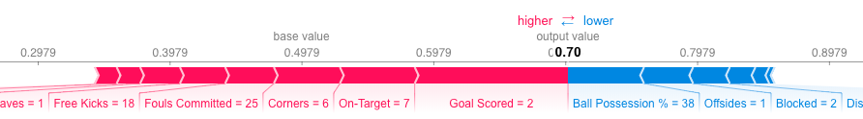

_________________________________________________________________________

Awesome blog for interpreting feature importance and the importance of SHAP values.

How do you interpret this?

We predicted 0.7, whereas the base_value is 0.4979. Feature values causing increased predictions are in pink, and their visual size shows the magnitude of the feature's effect. Feature values decreasing the prediction are in blue. The biggest impact comes from Goal Scored being 2. Though the ball possession value has a meaningful effect decreasing the prediction.

If you subtract the length of the blue bars from the length of the pink bars, it equals the distance from the base value to the output.

There is some complexity to the technique, to ensure that the baseline plus the sum of individual effects adds up to the prediction (which isn't as straightforward as it sounds).

THIS feature importance can also be found on the whole dataset, which we will see in the following blog.

# Interpretable Machine Learning with XGBoost

# This is a story about the danger of interpreting your machine learning model incorrectly, and the value of interpreting it correctly. If you have found the robust accuracy of ensemble tree models such as gradient boosting machines or random forests attractive, but also need to interpret them, then I hope you find this informative and helpful.

Imagine we are tasked with predicting a person’s financial status for a bank. The more accurate our model, the more money the bank makes, but since this prediction is used for loan applications we are also legally required to provide an explanation for why a prediction was made. After experimenting with several model types, we find that gradient boosted trees as implemented in XGBoost give the best accuracy. Unfortunately, explaining why XGBoost made a prediction seems hard, so we are left with the choice of retreating to a linear model, or figuring out how to interpret our XGBoost model. No data scientist wants to give up on accuracy…so we decide to attempt the latter, and interpret the complex XGBoost model (which happens to have 1,247 depth 6 trees).

# **Classic global feature importance measures**

The first obvious choice is to use the plot_importance() method in the Python XGBoost interface. It gives an attractively simple bar-chart representing the importance of each feature in our dataset: (code to reproduce this article is in a [Jupyter notebook](https://slundberg.github.io/shap/notebooks/Census%20income%20classification%20with%20XGBoost.html))

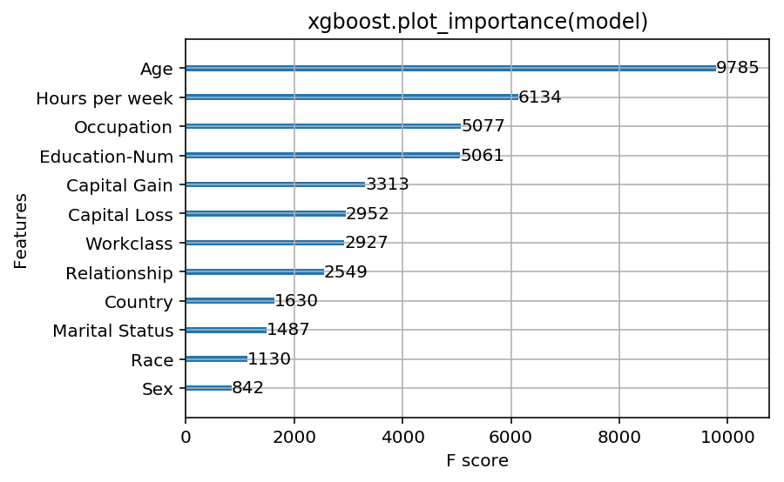

Results of running xgboost.plot_importance(model) for a model trained to predict if people will report over $50k of income from the classic “adult” census dataset (using a logistic loss).

If we look at the feature importances returned by XGBoost we see that *age*dominates the other features, clearly standing out as the most important predictor of income. We could stop here and report to our manager the intuitively satisfying answer that *age* is the most important feature, followed by *hours worked per week* and *education level*. But being good data scientists…we take a look at the docs and see there are three options for measuring feature importance in XGBoost:

1. **Weight.** The number of times a feature is used to split the data across all trees.
2. **Cover.** The number of times a feature is used to split the data across all trees weighted by the number of training data points that go through those splits.
3. **Gain.** The average training loss reduction gained when using a feature for splitting.

These are typical importance measures that we might find in any tree-based modeling package. Weight was the default option so we decide to give the other two approaches a try to see if they make a difference:

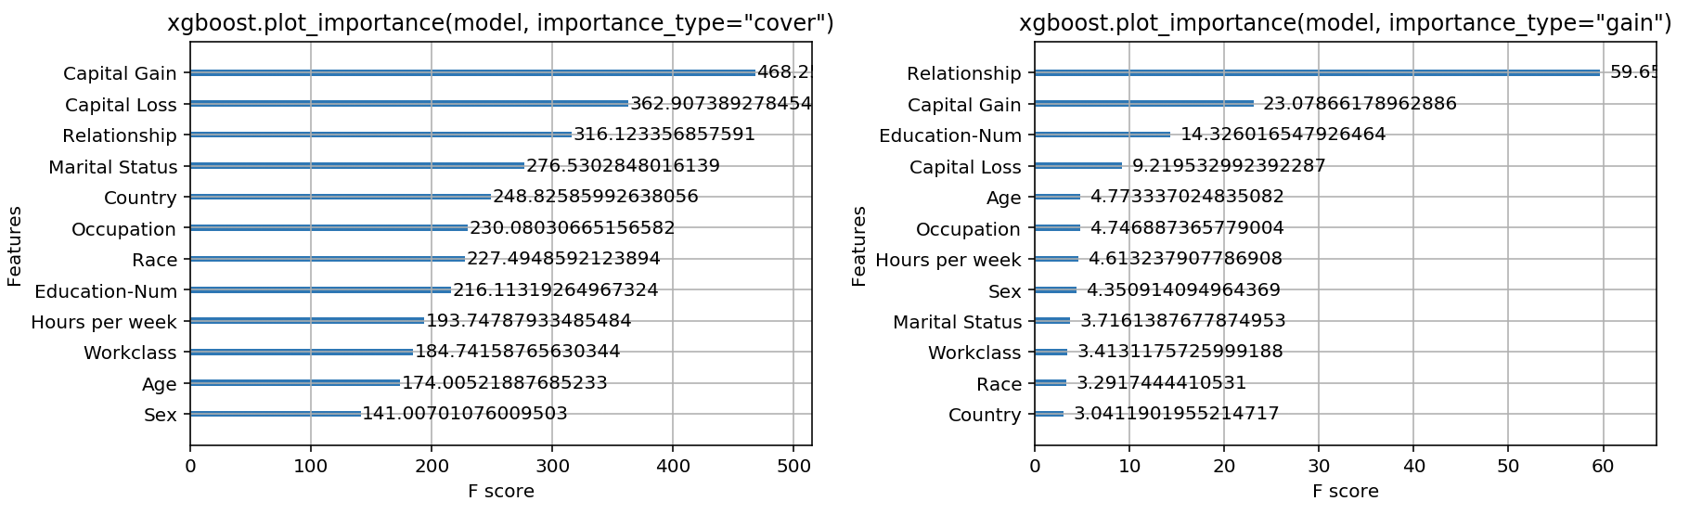

Results of running xgboost.plot_importance with both importance_type=”cover” and importance_type=”gain”.

**To our dismay we see that the feature importance orderings are very different for each of the three options provided by XGBoost!** For the cover method it seems like the *capital gain* feature is most predictive of income, while for the gain method the *relationship status* feature dominates all the others. This should make us very uncomfortable about relying on these measures for reporting feature importance without knowing which method is best.

# **What makes a measure of feature importance good or bad?**

It not obvious how to compare one feature attribution method to another. We could measure end-user performance for each method on tasks such as data-cleaning, bias detection, etc. But these tasks are only indirect measures of the quality of a feature attribution method. Here, we will instead define two properties that we think any good feature attribution method should follow:

1. **Consistency.** Whenever we change a model such that it relies more on a feature, then the attributed importance for that feature should not decrease.
2. **Accuracy.** The sum of all the feature importances should sum up to the total importance of the model. (For example if importance is measured by the R² value then the attribution to each feature should sum to the R² of the full model)

If consistency fails to hold, then we can’t compare the attributed feature importances between any two models, because *then* *having a higher assigned attribution doesn’t mean the model actually relies more on that feature*.

If accuracy fails to hold then we don’t know how the attributions of each feature combine to represent the output of the whole model. We can’t just normalize the attributions after the method is done since this might break the consistency of the method.

# **Are current attribution methods consistent and accurate?**

Back to our work as bank data scientists…we realize that consistency and accuracy are important to us. In fact if a method is not consistent we have no guarantee that the feature with the highest attribution is actually the most important. So we decide to the check the consistency of each method using two very simple tree models that are unrelated to our task at the bank:

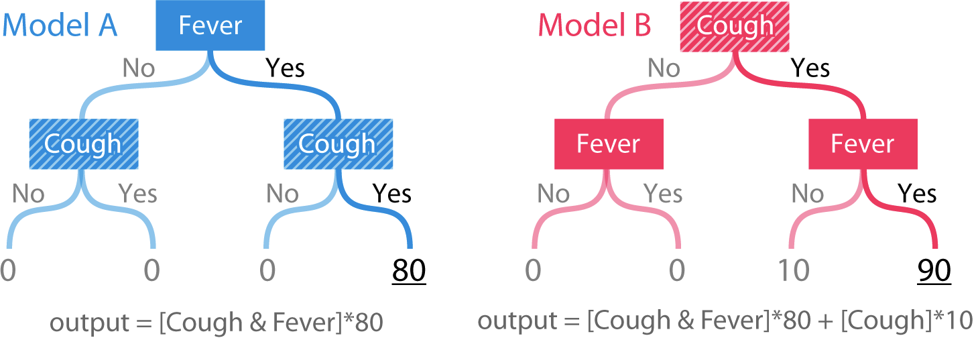

Simple tree models over two features. Cough is clearly more important in model B than model A.

The output of the models is a risk score based on a person’s symptoms. Model A is just a simple “and” function for the binary features *fever* and*cough*. Model B is the same function but with +10 whenever *cough* is yes. To check consistency we must define “importance”. Here we will define importance two ways: 1) as the change in the model’s expected *accuracy*when we remove a set of features. 2) as the change in the model’s expected*output* when we remove a set of features.

The first definition of importance measures the global impact of features on the model. While the second definition measures the individualized impact of features on a single prediction. In our simple tree models the *cough*feature is clearly more important in model B, both for global importance and for the importance of the individual prediction when both *fever* and*cough* are yes.

The *weight*, *cover*, and *gain* methods above are all global feature attribution methods. But when we deploy our model in the bank we will also need individualized explanations for each customer. To check for consistency we run five different feature attribution methods on our simple tree models:

1. **Tree SHAP.** A new individualized method we are proposing.
2. **Saabas.** An individualized heuristic feature attribution method.
3. **mean(|Tree SHAP|).** A global attribution method based on the average magnitude of the individualized Tree SHAP attributions.
4. **Gain.** The same method used above in XGBoost, and also equivalent to the Gini importance measure used in scikit-learn tree models.
5. **Split count.** Represents both the closely related “weight” and “cover” methods in XGBoost, but is computed using the “weight” method.
6. **Permutation.** The resulting drop in accuracy of the model when a single feature is randomly permuted in the test data set.

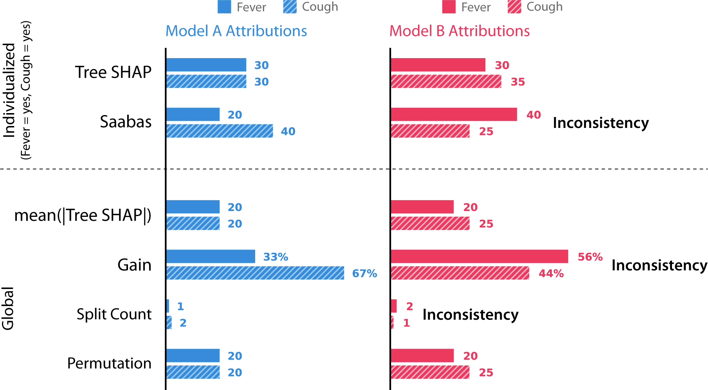

Feature attributions for model A and model B using six different methods. As far we can tell, these methods represent all the tree-specific feature attribution methods in the literature.

**All the previous methods other than feature permutation are inconsistent!** This is because they assign less importance to cough in model B than in model A. Inconsistent methods cannot be trusted to correctly assign more importance to the most influential features. The astute reader will notice that this inconsistency was already on display earlier when the classic feature attribution methods we examined contradicted each other on the same model. What about the accuracy property? It turns out Tree SHAP, Sabaas, and Gain are all accurate as defined earlier, while feature permutation and split count are not.

It is perhaps surprising that such a widely used method as gain (gini importance) can lead to such clear inconsistency results. To better understand why this happens let’s examine how gain gets computed for model A and model B. To make this simple we will assume that 25% of our data set falls into each leaf, and that the datasets for each model have labels that exactly match the output of the models.

If we consider mean squared error (MSE) as our loss function, then we start with an MSE of 1200 before doing any splits in model A. This is the error from the constant mean prediction of 20. After splitting on *fever* in model A the MSE drops to 800, so the gain method attributes this drop of 400 to the*fever* feature. Splitting again on the *cough* feature then leads to an MSE of 0, and the gain method attributes this drop of 800 to the *cough* feature. In model B the same process leads to an importance of 800 assigned to the fever feature and 625 to the *cough* feature:

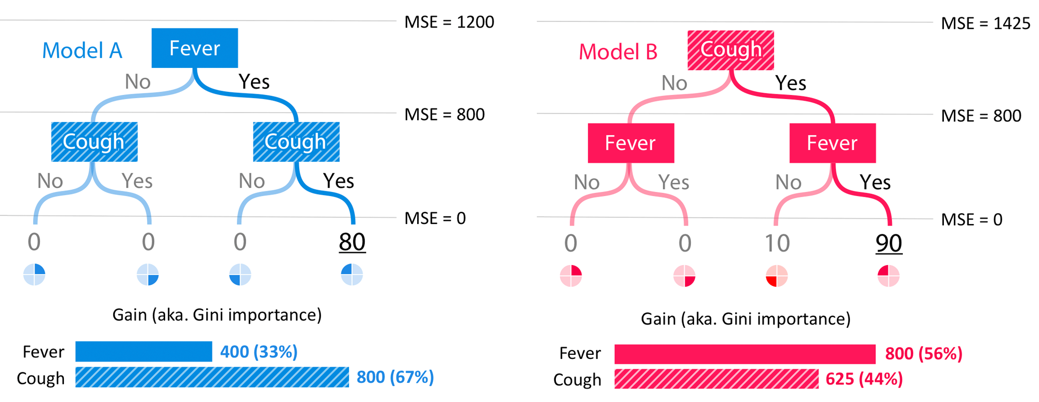

Computation of the gain (aka. Gini importance) scores for model A and model B.

Typically we expect features near the root of the tree to be more important than features split on near the leaves (since trees are constructed greedily). Yet the gain method is biased to attribute more importance to lower splits. This bias leads to an inconsistency, where when *cough* becomes more important (and it hence is split on at the root) its attributed importance actually drops. The individualized Saabas method (used by the[treeinterpreter](https://github.com/andosa/treeinterpreter) package) calculates differences in predictions as we descend the tree, and so it also suffers from the same bias towards splits lower in the tree. As trees get deeper, this bias only grows. In contrast the Tree SHAP method is mathematically equivalent to averaging differences in predictions over all possible orderings of the features, rather than just the ordering specified by their position in the tree.

It is not a coincidence that only Tree SHAP is both consistent and accurate. Given that we want a method that is both consistent and accurate, it turns out there is only one way to allocate feature importances. The details are in our recent [NIPS paper](http://papers.nips.cc/paper/7062-a-unified-approach-to-interpreting-model-predictions), but the summary is that a proof from game theory on the fair allocation of profits leads to a uniqueness result for feature attribution methods in machine learning. These unique values are called Shapley values, after Lloyd Shapley who derived them in the 1950’s. The SHAP values we use here result from a unification of several individualized model interpretation methods connected to Shapley values. Tree SHAP is a fast algorithm that can exactly compute SHAP values for trees in polynomial time instead of the classical exponential runtime (see [arXiv](https://arxiv.org/abs/1802.03888)).

# **Interpreting our model with confidence**

The combination of a solid theoretical justification and a fast practical algorithm makes SHAP values a powerful tool for confidently interpreting tree models such as XGBoost’s gradient boosting machines. Armed with this new approach we return to the task of interpreting our bank XGBoost model:

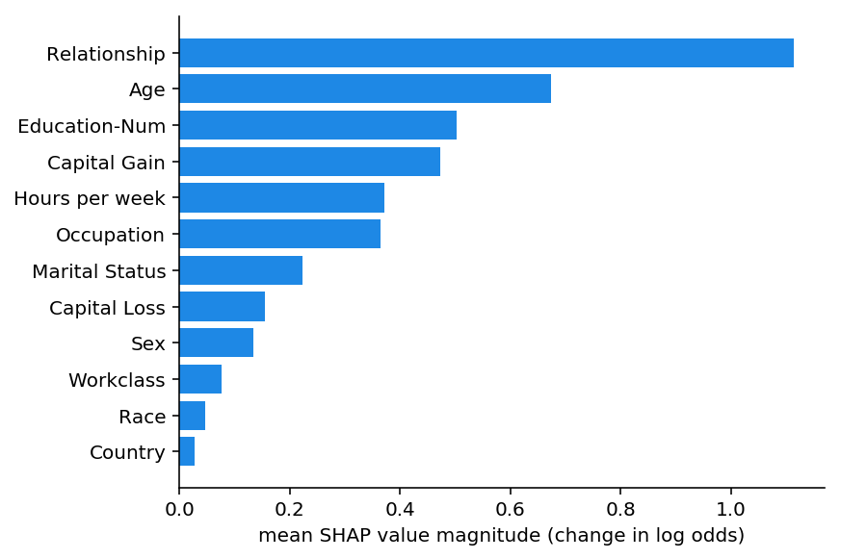

The global mean(|Tree SHAP|) method applied to the income prediction model. The x-axis is essentially the average magnitude change in model output when a feature is “hidden” from the model (for this model the output has log-odds units). See [papers](https://github.com/slundberg/shap) for details, but “hidden” means integrating the variable out of the model. Since the impact of hiding a feature changes depending on what other features are also hidden, Shapley values are used to enforce consistency and accuracy.

We can see that the *relationship* feature is actually the most important, followed by the *age* feature. Since SHAP values have guaranteed consistency we don’t need to worry about the kinds of contradictions we found before using the gain, or split count methods. However, since we now have individualized explanations for every person, we can do more than just make a bar chart. We can plot the feature importance for every customer in our data set. The [shap Python package](https://github.com/slundberg/shap) makes this easy. We first call shap.TreeExplainer(model).shap_values(X) to explain every prediction, then call shap.summary_plot(shap_values, X) to plot these explanations:

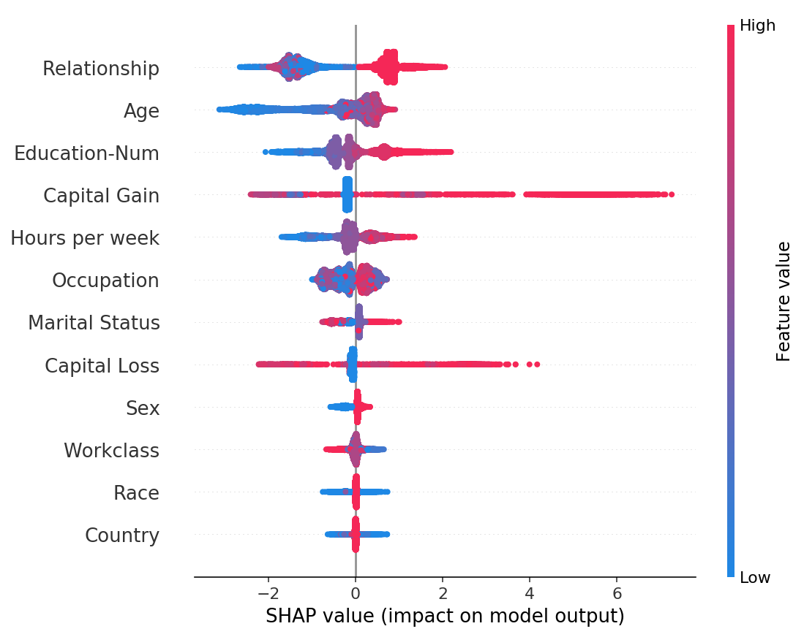

Every customer has one dot on each row. The x position of the dot is the impact of that feature on the model’s prediction for the customer, and the color of the dot represents the value of that feature for the customer. Dots that don’t fit on the row pile up to show density (there are 32,561 customers in this example). Since the XGBoost model has a logistic loss the x-axis has units of log-odds (Tree SHAP explains the change in the margin output of the model).

The features are sorted by mean(|Tree SHAP|) and so we again see the*relationship* feature as the strongest predictor of making over $50K annually. By plotting the impact of a feature on every sample we can also see important outlier effects. For example, while capital gain is not the most important feature globally, it is by far the most important feature for a subset of customers. The coloring by feature value shows us patterns such as how being younger lowers your chance of making over $50K, while higher education increases your chance of making over $50K.

We could stop here and show this plot to our boss, but let’s instead dig a bit deeper into some of these features. We can do that for the *age* feature by plotting the age SHAP values (changes in log odds) vs. the age feature values:

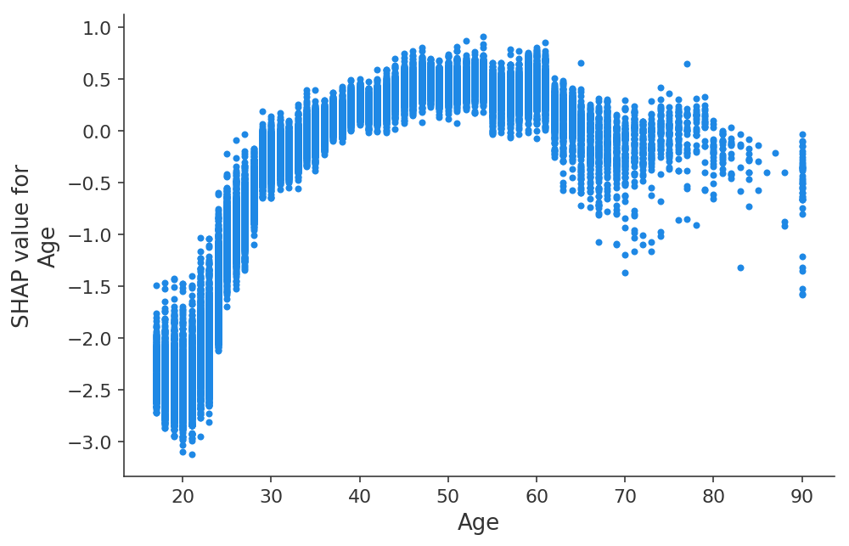

The y-axis is how much the age feature changes the log odds of making over $50K annually. The x-axis is the age of the customer. Each dot represents a single customer from the data set.

Here we see the clear impact of age on earning potential as captured by the XGBoost model. Note that unlike traditional partial dependence plots (which show the average model output when changing a feature’s value) these SHAP dependence plots show interaction effects. Even though many people in the data set are 20 years old, how much their age impacts their prediction differs as shown by the vertical dispersion of dots at age 20. This means other features are impacting the importance of age. To see what feature might be part of this effect we color the dots by the number of years of education and see that a high level of education lowers the effect of age in your 20’s, but raises it in your 30's:

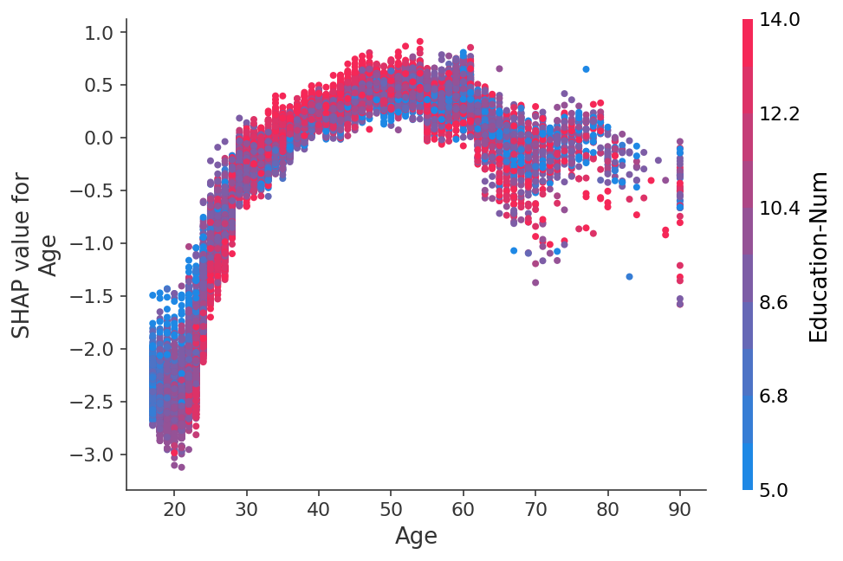

The y-axis is how much the age feature changes the log odds of making over $50K annually. The x-axis is the age of the customer. Education-Num is the number of years of education the customer has completed.

If we make another dependence plot for the number of hours worked per week we see that the benefit of working more plateaus at about 50 hrs/week, and working extra is less likely to indicate high earnings if you are married:

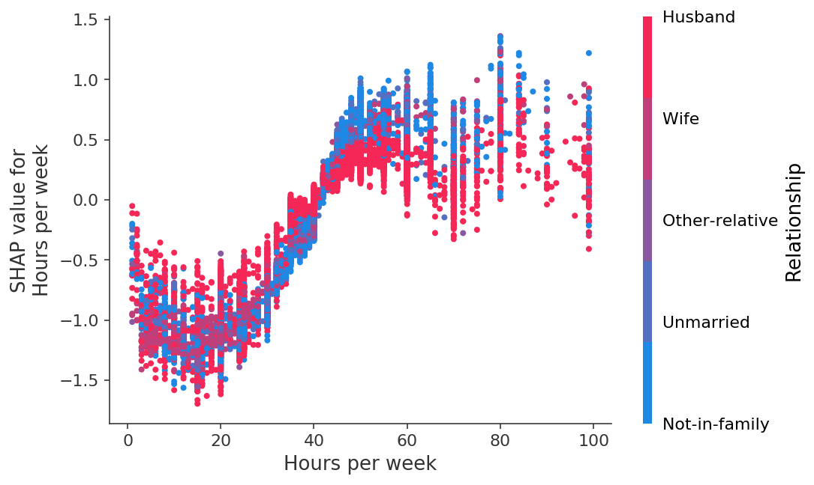

Hours worked per week vs. the impact of the number of hours worked on earning potential.

# **Interpreting your own model**

This simple walk-through was meant to mirror the process you might go through when designing and deploying your own models. The [shap package](https://github.com/slundberg/shap) is easy to install through pip, and we hope it helps you explore your models with confidence. It includes more than what this article touched on, including SHAP interaction values, model agnostic SHAP value estimation, and additional visualizations. Notebooks are available that illustrate all these features on various interesting datasets. For example you can check out the top reasons you will die based on your health checkup in a [notebook](https://slundberg.github.io/shap/notebooks/NHANES%20I%20Survival%20Model.html)

<https://slundberg.github.io/shap/notebooks/NHANES%20I%20Survival%20Model.html>

The notebook is also amazing. Just this only with some extra plots. explaining an XGBoost model of mortality. For languages other than Python, Tree SHAP has also been merged directly into the core XGBoost and LightGBM packages.

_________________________________________________________